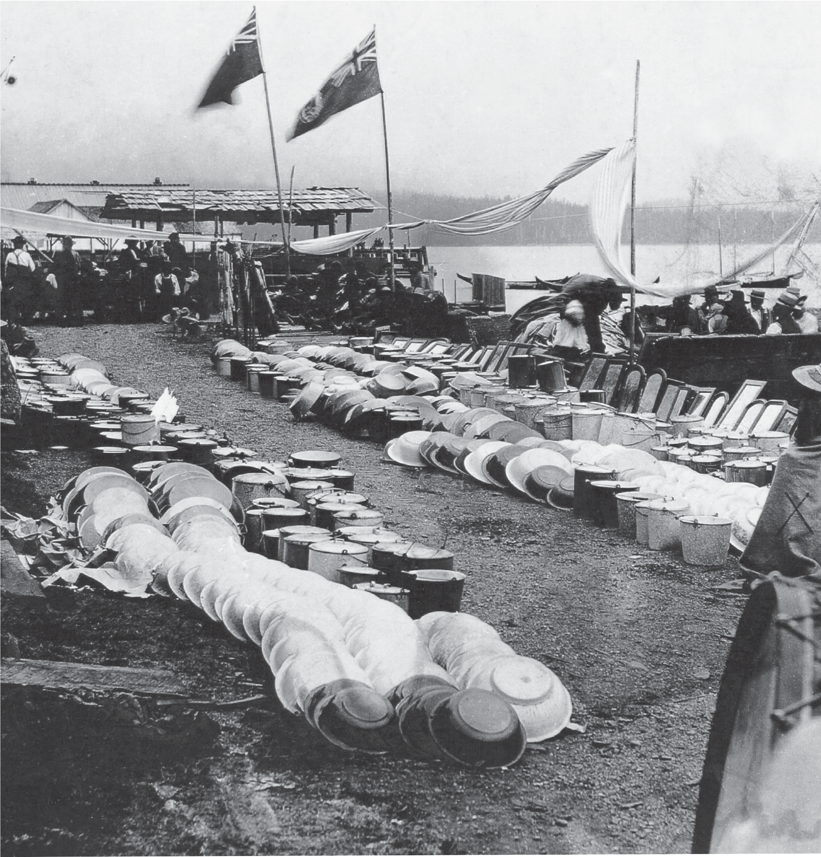

Great Bear Rainforest

Sharing the Land and Resources

Sharing the Land and Resources
The First Nations of British Columbia were self-sufficient and used the resources of their territories to produce the goods they needed. However, they did not live in isolation. They traded with neighbouring villages and with more distant nations, exchanging surplus food and materials for items they could not obtain locally.
Through trade, people were also able to interact culturally with their trading partners, exchanging knowledge and ideas. Often, trade was strengthened through marriage.
This section looks at trade economies, the importance of the potlatch in sharing resources, and how First Nations education taught each generation the uses of the resources from the land.

Trade Economies
The First Nations of B.C. are believed to have been the most active and expert traders of their time in North America. A number of factors contributed to their highly developed trade economies, which have existed for thousands of years. The wealth created by the salmon harvest allowed many tribes to participate in trade. Because the resources available on the coast and in the interior were significantly different, demand for items unavailable locally led to trade.
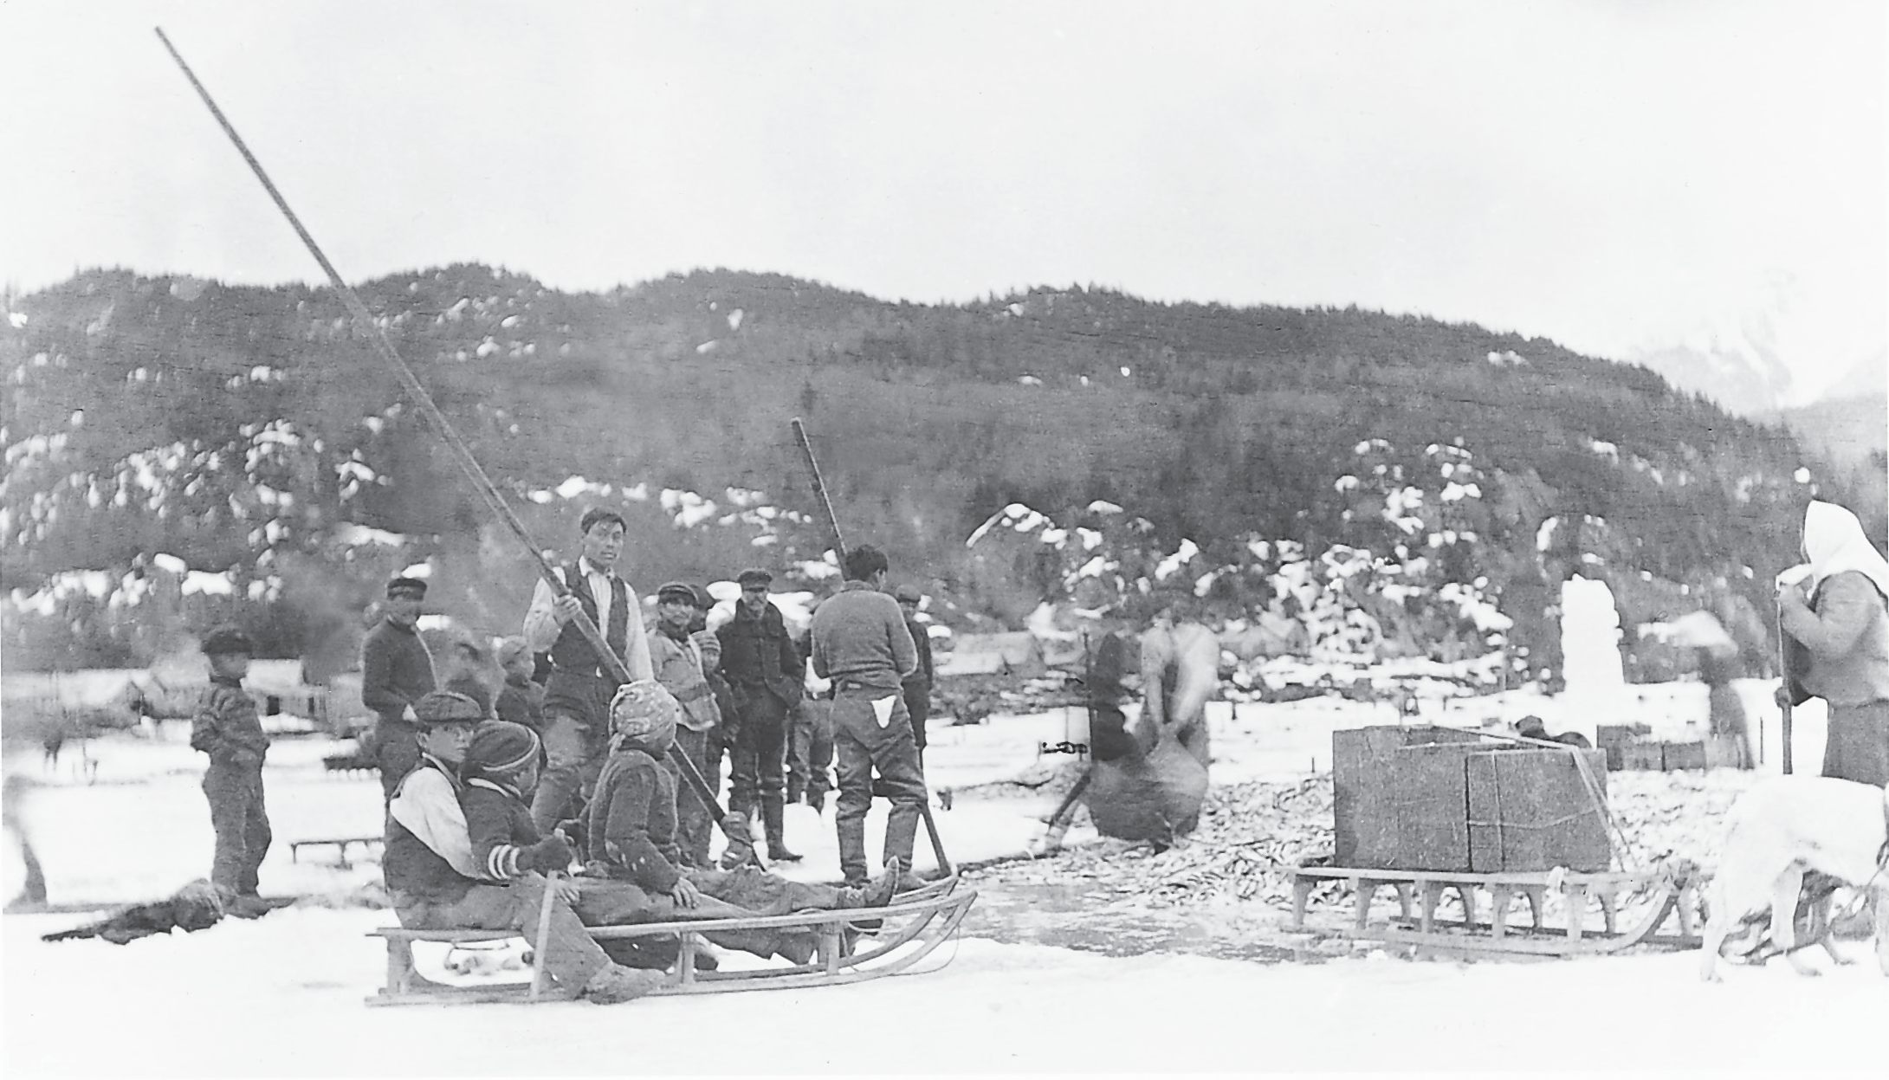
One of the most important trade items that was carried from the coast to the interior was oolichan grease, which was extracted from the fish in a lengthy process. Because of its importance, major trading routes were called Grease Trails. People travelled in large numbers over the trails to trade for the grease. In recognition of their importance, these trails were constantly maintained and were often two metres or more wide. Photo RBCM PN 5028, courtesy of the Royal BC Museum and Archives

The First Nations trade economy involved more than gathering the resources. Considerable labour went into many of the products that were traded. For example, cedar canoes, an important trade item for coastal people such as the Haida and
the Heiltsuk, required a great deal of work from the felling of the tree and the steaming of the hollowed-out shape, to the finishing of the surface. Likewise, fibres were woven into baskets for trade, and furs had to be treated before they could be exchanged.
Oolichan fishery at Ts’im K’ol’hl Da oots’ip or Fishery Bay, on the Nass River, circa 1884. The Nisga’a and their neighbours have fished oolichans and processed oolichan grease here for untold centuries. Here the small fish have been caught in funnel-shaped nets and are being packed in large bentwood boxes and transported by sled to the cooking bins to be made into valuable grease.
Goods were often traded from group to group through one or more intermediaries, so a product’s final destination was often a long distance from its origin. For example, the Secwepemc who lived along the Fraser River south of Williams Lake were able to produce a great quantity of dried salmon and salmon oil. They traded the salmon with neighbouring Secwepemc tribes who lived farther to the east.
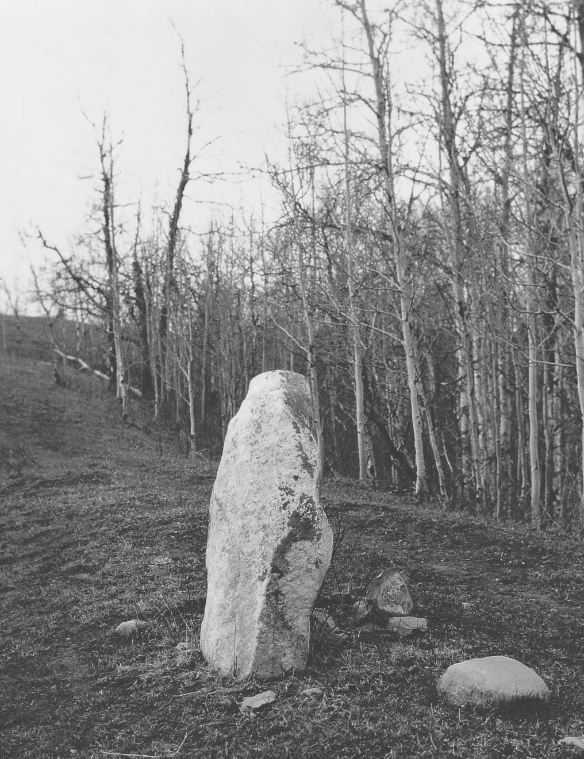
These people in turn traded the dried salmon with the Cree of the Plains.

Landmarks such as this “trading rock” near Hazelton marked places where First Nations people met for trade. Photo RBCM PN 3249, courtesy of the Royal BC Museum and Archives

One unique trade good, obsidian, helps us understand the age and extent of the trade economy. Obsidian is a glass-like volcanic rock which was highly prized in cutting tools. Tiny, razor-sharp pieces of obsidian, called microblades, were fixed in handles of wood, bone, or antler to make efficient knives and projectiles. What makes obsidian such a useful marker for understanding the past is that there were only three main sources of obsidian available to the First Nations of British Columbia. Two are in British Columbia: Mt. Edziza in Tahltan territory and Anahim
Peak in the Ulkatcho. The third is in Oregon. Scientists can analyze obsidian samples and identify the source of obsidian found in archeological sites. With carbon
dating, they can tell when the rock was traded and how far it travelled. The study of obsidian tells us that goods have been traded throughout British Columbia for 8,000 years.
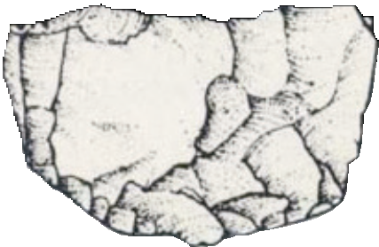

Microblade Core Microblade
Microblades are thin, sharp blades created from obsidian, agate or other hard stone using a sophisticated technology. A chunk of the stone, called a core, was struck in just the right way to break off a thin wafer 2 to 3 cm long. This technique produced two extremely sharp edges, and was the most efficient way of making blades. The blades were set into grooves in wood, bone, or antler to make cutting tools or hunting spears. People stopped using microblade technology several thousand years ago.

Obsidian
Obsidian is a volcanic glass, prized for its ability to be honed to an extremely sharp edge. It was used for knives, arrowheads, and other tools. Each obsidian source is unique, so scientists can identify the source of an artifact wherever it is found. Today it is sometimes used as the blade for a surgeon’s scalpel.

Most trade was probably between neighbouring nations for items that were less accessible or unavailable in their home territories. For example, the Nuu-chah-nulth traded dried halibut, herring, and cedar baskets to the Coast Salish of Vancouver Island in exchange for camas bulbs and swamp rushes for mats. The soapberry
or soopolallie, a common plant in the interior but non-existent on the coast, was frequently traded. The berries can be whipped into a froth that makes a treat sometimes referred to as “Indian ice cream.” The berry and other parts of the plant are also important herbal medicines. So soapberries were, and still are, traded by interior people for foods from the sea, such as dried cockles or herring spawn.
The plant called “Indian hemp” or hemp dogbane was the most important source of fibre for people of the interior. It was spun into a strong twine used for nets, traps, baskets, and many other purposes. It is not, however, a common plant. It grows in dry climates such as the Okanagan and the East Kootenay. Thus, it was a valuable trade item throughout the southern interior. The Okanagan people traded it with the Nlaka’pamux for salmon and animal skins and also made trading journeys to the coast where they traded the fibres for items such as seafood and dentalium.
With such complex trading networks and diverse commodities, the process of trade among First Nations went beyond simple barter. In some situations, mediums of exchange were used as a standard for trade. For instance, on the North Coast and the Skeena region, groundhog skins and elk skins were a kind of currency. The shell dentalium was widely used as currency across what are now western Canada and the United States.

Trading for Status Goods
Trade goods can be divided into two types, items of provision and items of prestige or status. Prestige items required great wealth to purchase. While all goods that were unavailable locally had some prestige associated with them, there were certain objects whose value made them desirable as symbols of wealth. One such object was dentalium, a small tusk-like shell which is found only in sub-tidal waters on the west coast of Vancouver Island in Nuu-chah-nulth and Kwakwaka’wakw territory. For thousands of years it has been traded to people as far away as
the sub-Arctic and the Plains. Dentalium was often strung on twine in two- metre lengths. Sometimes the whole shell was used as decoration, which would
demonstrate great wealth. More often, the shells were sliced to make small beads.
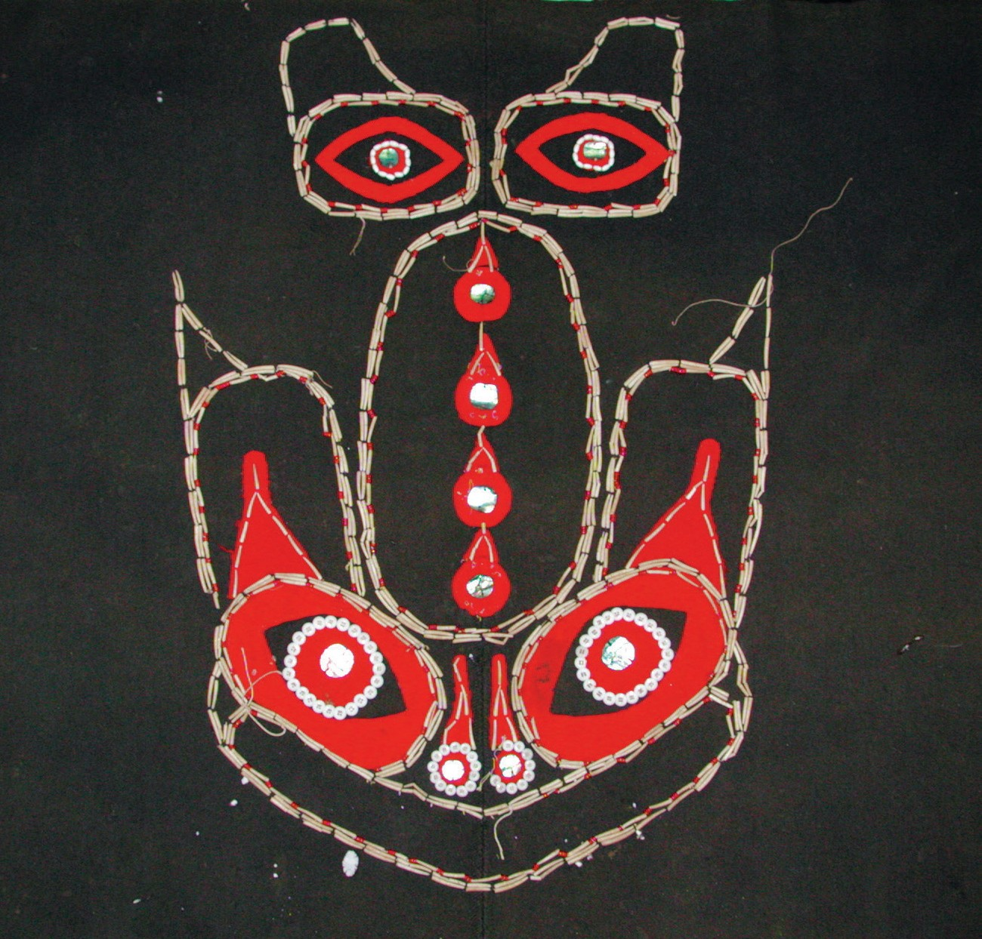
Dentalium, shown here on a Haida blanket, is a small, cylindrical mollusc that only grows in deep water off the west coast of Vancouver Island. Because it is rare, it was highly sought after for decoration and as a form of currency. Photo courtesy of the Museum of Anthropology/University of British Columbia.

Copper was a rare and extremely valuable resource because it is soft enough to be easily shaped. There was, however, only one source for B.C. First Nations and that was the Copper River in the interior of Alaska.
The Tlingit, who live on the Alaskan panhandle, were the intermediaries in the copper trade along the coast. The ore is called native copper because it can be taken out of the ground and used without being processed. It was used to decorate carvings such as masks. However, its most important use was for the large
shield-like objects called coppers. These were the ultimate symbol of wealth for the Northwest Coast tribes. They were displayed and given away at potlatches.
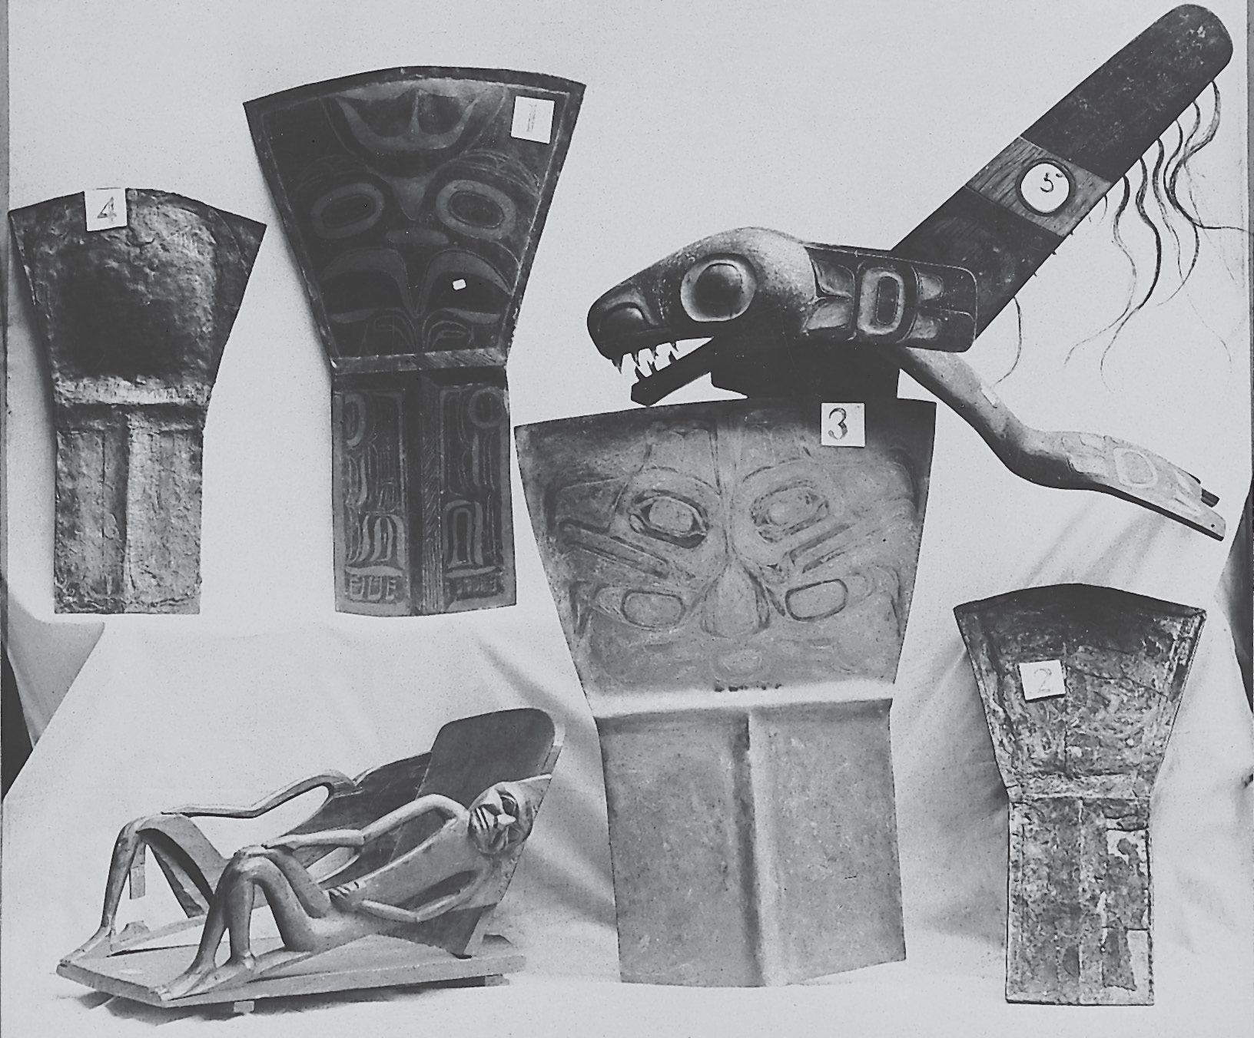

Copper was the key symbol of wealth on the Northwest Coast. Shield-like objects called coppers, seen here in objects 1–4, were originally hammered out of copper nuggets. Later they were made from copper sheets manufactured in Europe. Photo RBCM PN 11791, courtesy of the Royal BC Museum and Archives

Slaves were part of the highly structured societies on the coast. They added to the labour force and in many cases contributed to the wealth of a chief. They allowed the high-class members of a community more time for preparing for the many social activities such as potlatches, feasts, and winter ceremonials. Slaves were captured during warfare, and sometimes the slaves acquired this way were traded.

Controlling the Trade
Some groups became well known as traders rather than producers. They could spend less time gathering and processing food and materials than most groups. Those with access to large quantities of salmon had an advantage. This included most coastal people and some strategically located interior groups. For instance, the four Secwepemc bands who lived on the lower Chilcotin River had a very rich supply of salmon. Their key location at the border between Secwepemc and Tsilhqot’in territories gave them control of trade between the two nations. They
developed a specialized role as intermediaries in the trading networks. They were also known as peacemakers between two groups when conflict threatened to disrupt the trade.
In some parts of the province, the trading systems became quite complex as certain chiefs gained control of trade routes. They were able to increase their wealth, power, and prestige by controlling the flow of goods. Sometimes this control meant that neighbouring people had to pay for passing through a chief’s territory. In other cases, however, control was exerted by building an armed fort at a river canyon or mountain pass. Trade alliances were also formed, sometimes through marriage.
In other circumstances, two tribes might agree on a trade monopoly. This was the case, for example, with the Tsimshian and the Gitxsan. These two nations are
neighbours who share the Skeena River watershed. The Tsimshian have territories on the ocean, near the mouth of the Skeena, and also along the lower reaches
of the river. The Gitxsan occupy the upper Skeena River in the interior. The most powerful Tsimshian chief, Ligeex, and his tribe the Gispaxlo’ots, held a monopoly on trade with the Gitxsan. However, another Tsimshian group, the Kitselas, controlled a strategic narrow canyon on the Skeena at the border of Tsimshian and Gitxsan territories. Ligeex was forced to maintain a partnership with the Kitselas people to ensure his safe passage through the strategic canyon.

First Nations Voices
Matthew Johnson, Gispaxlo’ots tribe, Tsimshian
Well now, Ligeex he was the one who had the power all along the Skeena and there was no one who would go up the Skeena without first getting the permission of the chief Ligeex. Now it was the Gispaxlo’ots (gis-pac- lawts), Ligeex’s tribe, who were the ones who could go up the Skeena. And if they did so they most certainly gave a gift to the chief for going up the Skeena. It was he who was the chief over all the Skeena River. And if any other tribe, any relatives of the Gispaxlo’ots tribe went in the canoes of the Gixpaxlo’ots they first gave a passage fee to the chief. And when they returned then they gave a trading fee for anything they had been able to get while upriver. And if they didn’t do so then Ligeex’s spokesman went to demand payment. And all of the different tribes greatly respected the powers of the chief of the Gispaxlo’ots. Although there were many tribes living along the Skeena downriver from the Canyon, none of them had ever gone upriver beyond the Canyon, and there was not one of them who traded with the Gitxsan. Only Ligeex. He was the one who made the law that he alone should trade with the Gitxsan.
And all the tribes knew this.1

Education: Learning About Values and Resource Use
First Nations education was part of the fabric of the society through which values and skills for using and preserving the land and its resources were transmitted.
Children were regarded as gifts to the community and keepers of the culture. In order for the whole community to prosper, it was a communal responsibility to pass on collective knowledge. The community worked together to support each member, and thereby, the whole group.
As the 1996 Report of the Royal Commission on Aboriginal Peoples stated,

“In Aboriginal educational tradition, the individual is viewed as a whole person with intellectual, spiritual, emotional and physical dimensions. Each of these aspects must be addressed in the learning process. Holistic education is the term used to describe the kind of education traditionally used by Aboriginal peoples.” 2
For First Nations people learning is viewed as cyclical and a life-long endeavour. Training begins at birth and proceeds through the stages of life. As people mature, they take on more responsibilities in teaching.

The extended family took responsibility for caring for children and encouraging them to discover and learn about life. In most First Nations societies, children were raised in an atmosphere of tolerance, without criticism or direct control of the child’s behaviour. In this way, young children learned to think independently and become self-sufficient.
As soon as they were physically able, children participated in the activities of daily life, learning by observation and practice. As they grew older, more formal training might be given in specific skills and knowledge. For example, a child learned about trapping by being involved in the entire process. Play around the camp gave way to assisting in setting up and cleaning tools, then helping to scrape the skins. As soon as the child was ready, he or she accompanied the parents on the trapline and was trained to recognize the tracks and other signs of the different animals.
Youth was a time of apprenticeship when young people prepared to take on the jobs and responsibilities of adulthood. They learned their specific roles and
understood the value of the unique contributions men and women made to the community. Having been active participants in daily life from infancy, they had by this time internalized the morals and behaviours that were expected of them.
The transition from adolescence into adulthood was marked by special ceremonies and rites. An important step in the education of young people from most
First Nations societies was the vision quest. Young men moved away from the community for days or weeks, surviving on their own and seeking spiritual guidance through visions or dreams. In many societies, the person on the vision quest acquired a spiritual guardian. Usually this was restricted to young men, but in
some societies women could also seek a spiritual guide. More often, teenage girls received important teachings about womanhood when they began menstruation. They were secluded from the rest of the community at that time for several days or even weeks, while they were nurtured and instructed by their close relatives or Elders.
Young men faced rigorous and disciplined training for roles that required strength, stamina, and spiritual power. To be successful hunters or warriors, they learned to fast and follow the rituals that connected them with the spiritual dimension of their endeavour.
Another crucial area of knowledge for all members of a group was full understanding about the land and its resources, including which territories belonged to their family and which belonged to others. Along with this came the knowledge of who your ancestors were, and how their connection with the land was passed down. Children learned much about the land and resources by experience as they travelled with their families between the seasonal camps. This information was repeated year after year and was also reinforced through oral traditions, where Elders passed on the history of the extended family through stories.

Case Study: Trade Routes of the Nuxalk— The Ulkatcho Region
The Ulkatcho region of the West Chilcotin is a place of marvelous diversity. The name means “fat of the land,” reflecting the variety of resources available in the different habitats found in the region. There are more different plants growing here than in most other regions of British Columbia. It is an ancient land. Some areas have been free from ice for 14,000 years, much longer than most parts of the province. Cultural diversity is significant here, too. The Ulkatcho lies at the borders of people from three different language groups, the Dakehl (or, as they are often still known, the Carrier), the Nuxalk, and the Tsilhqot’in. Today Ulkatcho
territory is one of the remotest areas of the province. For centuries, however, it was the meeting place for many different First Nations. Major transportation routes called Grease Trails passed through, and it is home to one of two major sources of obsidian in the province.
The Ulkatcho people belong to the Dakelh (Carrier) language family, but their presence at the borders of the Nuxalk of the Bella Coola Valley and the Tsilhqot’in of the Chilcotin plateau has influenced them. Elements of the three different cultures have been incorporated into the Ulkatcho traditional lifestyle. Even the name Newchote’en, given to them by their Kluskus and Nazko neighbours, reflects this.
It means “Carrier people mixed with Chilcotin.” Today community members have relatives in all three nations and many of their customs blend ceremonies and ways of life from these nations as well.
The numerous river systems that flow through Ulkatcho territory create a network of travel corridors. Travel was a way of life for the Ulkatcho people. With a cold winter climate and short summer season, they needed to access a large area to find all the resources they required. They had to move frequently, so it was important
to build and maintain good travel routes. As they moved, they came into contact with people from neighbouring cultures. Each family had its own area where it hunted and harvested plants. The use of these territories was flexible, and they were shared with neighbouring families. At certain times of the year, individual families congregated, working cooperatively to harvest and process resources. One such location was Ulkatcho Village, on the shores of Gatcho Lake where people met in the winter. The village is near the headwaters of three rivers, the Blackwater running east, the Entiako going north, and tributaries of the Dean River to the south. Large groups of people worked together to hunt and process caribou.

The Ulkatcho shared territories with neighbouring tribes as well. For example, they had traditional salmon fishing sites within Nuxalk territory on the Bella Coola River. They made several trips a year to Bella Coola, a three-day walk from
Ulkatcho Village along the major grease trail. The Nuxalk, in turn, shared some sites within Ulkatcho territory, including soapberry grounds and salmon fishing spots.
One important fishing place is called Salmon House Falls on the Dean River. Here Ulkatcho, Nuxalk, and Tsilhqot’in families gathered to smoke salmon.
Their first trip of the year to the coast, after the snow had melted from the trails, was to trade oolichan grease from trading centres at the mouths of the Bella Coola, Dean, and Kimsquit rivers. They exchanged grease for items such as buckskin,
furs, obsidian, and caribou meat. On their return journey, people were laden with bentwood cedar boxes or tightly woven spruce root baskets containing the valuable oolichan oil or grease. They stopped at Ulkatcho Village, which was an important trading hub. Grease trails brought Dakelh from the north and the east, and Tsilhqot’in from the south. The Ulkatcho were the middlemen in the trading economy based on oolichan grease.
South of Ulkatcho Village is another feature that adds to the uniqueness of this territory and the complexity of the trading economy that operated here for thousands of years. Out of the rolling plateau land rise the Rainbow Mountains, and principal among them is Besbut’a (Anahim Peak). At the base of Besbut’a, the Ulkatcho excavated valuable obsidian. Blades made from Besbut’a obsidian have been found in Alberta, Washington, and south-central British Columbia. As in every
other interaction with the natural world, the people have a spiritual connection with the mountain. They show respect by introducing themselves when they approach, and give thanks for the use of this unique resource.
Some of the customs of the people of Ulkatcho illustrate the sharing of different cultures that was common for people living near borders. Many gathering sites had a longhouse for holding potlatches. These were special feasting buildings, not
used for living in. They were only used on special occasions. While winter villages on the coast were made up of many longhouses, here the people lived in smaller pit houses. The presence of potlatch houses in the Ulkatcho territory shows how ideas and customs were shared between the interior and coastal people.

The Potlatch
The potlatch integrates the spiritual, political, economic, and social dimensions of a community’s life. It is a complex institution based on the idea of giving. In fact, the word potlatch comes from the Nuu-chah-nulth word meaning “to give,” which in turn was borrowed by the Chinook language. Each First Nation has its own word or words to describe its ceremonies. While different nations conduct potlatches in ways unique to their cultures, they have some common features.
A potlatch is always initiated for a specific purpose, usually to mark an essential milestone in the life of the family or clan, such as a boy’s first kill, a marriage, the completion of a canoe, or the raising of a totem pole. Depending on the purpose and the importance of the host and the guests, some potlatches included just the extended family while at others, one clan or kin group would invite all the others who shared the same winter village. The most impressive and costly potlatches were those where chiefs from neighbouring villages or nations were invited.
A potlatch is never an individual endeavour. Once a person has decided to hold a feast, he or she calls the kin groups, extended family, or clan which will assist. The host explains to the gathered relatives the purpose of the potlatch and asks for their agreement in going ahead with the event. Once they approve, planning
and preparation begin. This may take several weeks or months, or in the case of a memorial feast to a high-ranking chief, several years.
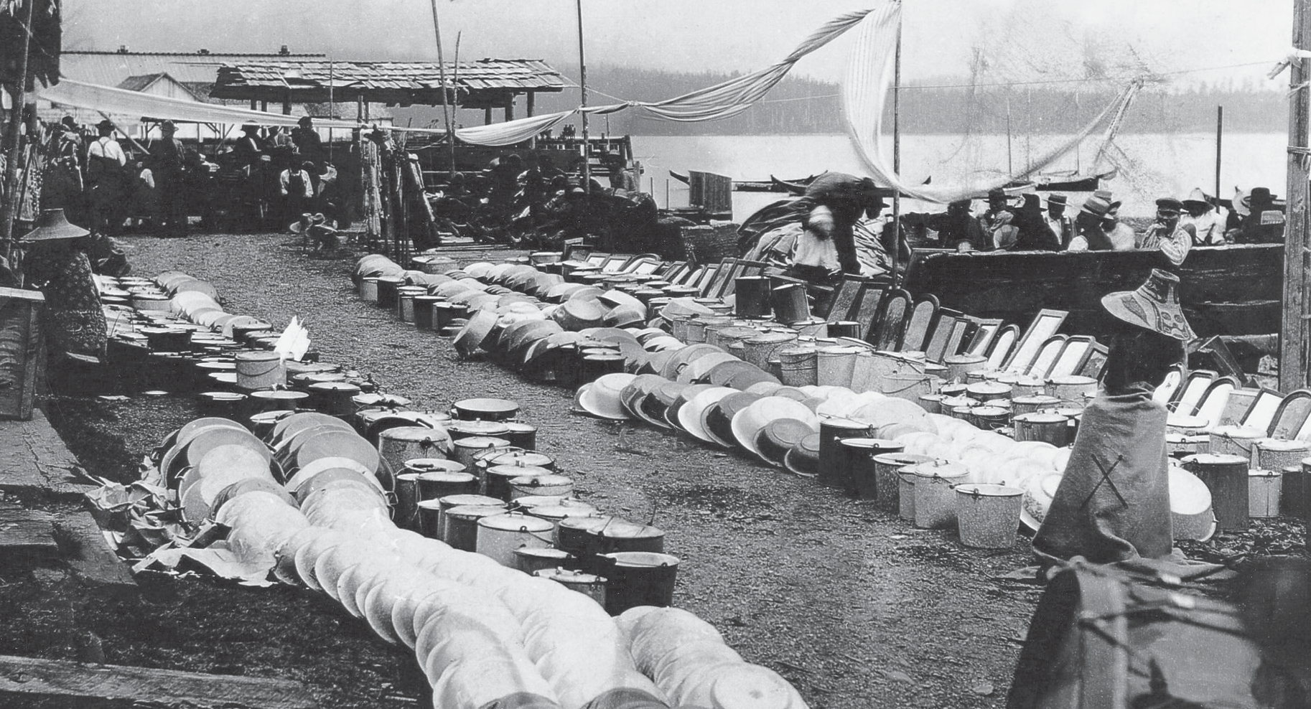

Household and other goods are assembled in preparation for a potlatch in Alert Bay in approximately 1910. When a chief distributes gifts, he is publicly repaying his debts, while at the same time he is investing for the future. A chief who gives away resources can fully expect to receive the same value back with interest at another feast held in the future. Photo BCA F-04182, courtesy of the Royal BC Museum and Archives

The feast will draw upon the economic resources of the kin group, especially if the guests will include chiefs from other villages or nations. They pool the food and material goods which they have collected from their territories, or which they have earned in trade. (Today many family members contribute money as well as food.) The success of the potlatch and the esteem of the host and kin group will depend on the wealth that they are able to give away.
When the time of the potlatch is nearing, guests are formally invited. People are delegated to travel to the guests’ homes, be they in the village or at a great distance. This is an important step with strict attention to protocol.
The form of the potlatch itself varies from place to place, of course, but usually a potlatch begins with welcoming ceremonies followed by a meal where food from the hosts’ territories is shared with the guests. Following this, what might be termed the business side of the potlatch takes place. The hosts validate their inherited rights through dances, songs, and oral histories. Often names will be passed on
or certain ceremonies related to the reason for the potlatch will be conducted. Speeches related to the purpose of the potlatch will be given in grand oratorial style by trained speakers. They will often tell what territories the different foods in the meal came from, and who provided them. Then the collected wealth of the kin group is given away to the guests in the form of material goods such as furs in the past and blankets today.
Higher-ranking people receive more valuable gifts. The giving and receiving of gifts is a key event in the potlatch. Not only is the host group giving away its possessions, the guests are accepting them. By doing so, they acknowledge the validity and correctness of the proceedings which they have witnessed. This is reaffirmed by concluding speeches made by the guests, who respond to the speeches, gifts, and food shared by the hosts.
There are many reasons why the potlatch is so crucial to the cultures which practice it. It can be a bank, life insurance, and a pension fund combined. Business is conducted in a very formal and open way and will be remembered by all who witness it.
The potlatch also serves a function in managing the resources of the kin group’s territory by reinforcing its hereditary rights to use the various lands under its control. Stories and songs are performed about the group’s connection with the land, and robes, masks, and dancing paraphernalia illustrate the stories and songs.
Potlatches also have a broader social purpose. They bring people together, strengthening the bond of unity between kin groups and their neighbours. They are times where food, humour, and deeply held cultural values and beliefs are shared, and the importance of this sharing is reinforced.

Conflict between Nations
First Nations people value their relationships with each other, but conflict among nations is inevitable. Wars were fought for preservation of traditional territories, to expand upon existing territories, and to acquire goods or slaves.
Every First Nation was prepared to defend itself with trained warriors and special battle gear. However, some groups were much more aggressive than others, and were greatly feared. The Haida were known to travel great distances down the coast in their large canoes to raid villages for plunder, revenge, and the capture of slaves. Some people argue that these raids were not truly warfare, as their motivation was obtaining wealth rather than domination. The southern Kwakwaka’wakw group, the Lekwiltok, however, were definitely war-like, as they battled for territory with the Comox people, who originally inhabited central Vancouver Island from Salmon River to Cape Mudge. The Lekwiltok drove the Comox out of these territories, expanding southwards as far as Cape Mudge.
Before they went to battle, warriors often fasted and purified themselves, and while they were away, the women, children, and Elders supported their mission by keeping themselves pure, and in some societies, acting out a mock battle.
Wooden helmets and protective armour made of pleated elk skin, which was extremely resistant, were worn by some people. Many groups built defensive sites as places of refuge during attack. These were sometimes erected on high banks along a river or ocean coast, on an island, or on a hilltop. Some were fortified with log walls and had defensive weapons such as rocks, spears, or logs which could be dropped on the enemy.
When peace was finally negotiated, in many nations, the one that lost the fewest people had to make reparation to the other nation. Upon their return home, warriors underwent long periods of preparation for peace. To be fully integrated into society again they had to be clear of the psychic energy required for war.

Summary
First Nations groups used surplus resources to trade with other nations. Vast trading networks were established for thousands of years, utilizing trails that linked the coast with the Prairies and the sub-Arctic. Because oolichan grease was one
of the most valuable resources carried on these trails, they were often referred to as grease trails. Through trade, people exchanged not only goods, but also ideas, knowledge, and skills. The potlatch traditionally played a key role in resource distribution, as well as having broader social purposes. First Nations education was fundamentally about passing on values and teaching the skills for using the resources of the land.

Sources and Credits
- Mathew Johnson (Laans) quoted in Na Amwaaltga Ts’msiyeen: The Tsimshian, Trade, and the Northwest Coast Economy. Prince Rupert: School District #52, 1992. Used with permission of School District #52.

- Royal Commission on Aboriginal Peoples, Vol. 3, ch. 5, sec

