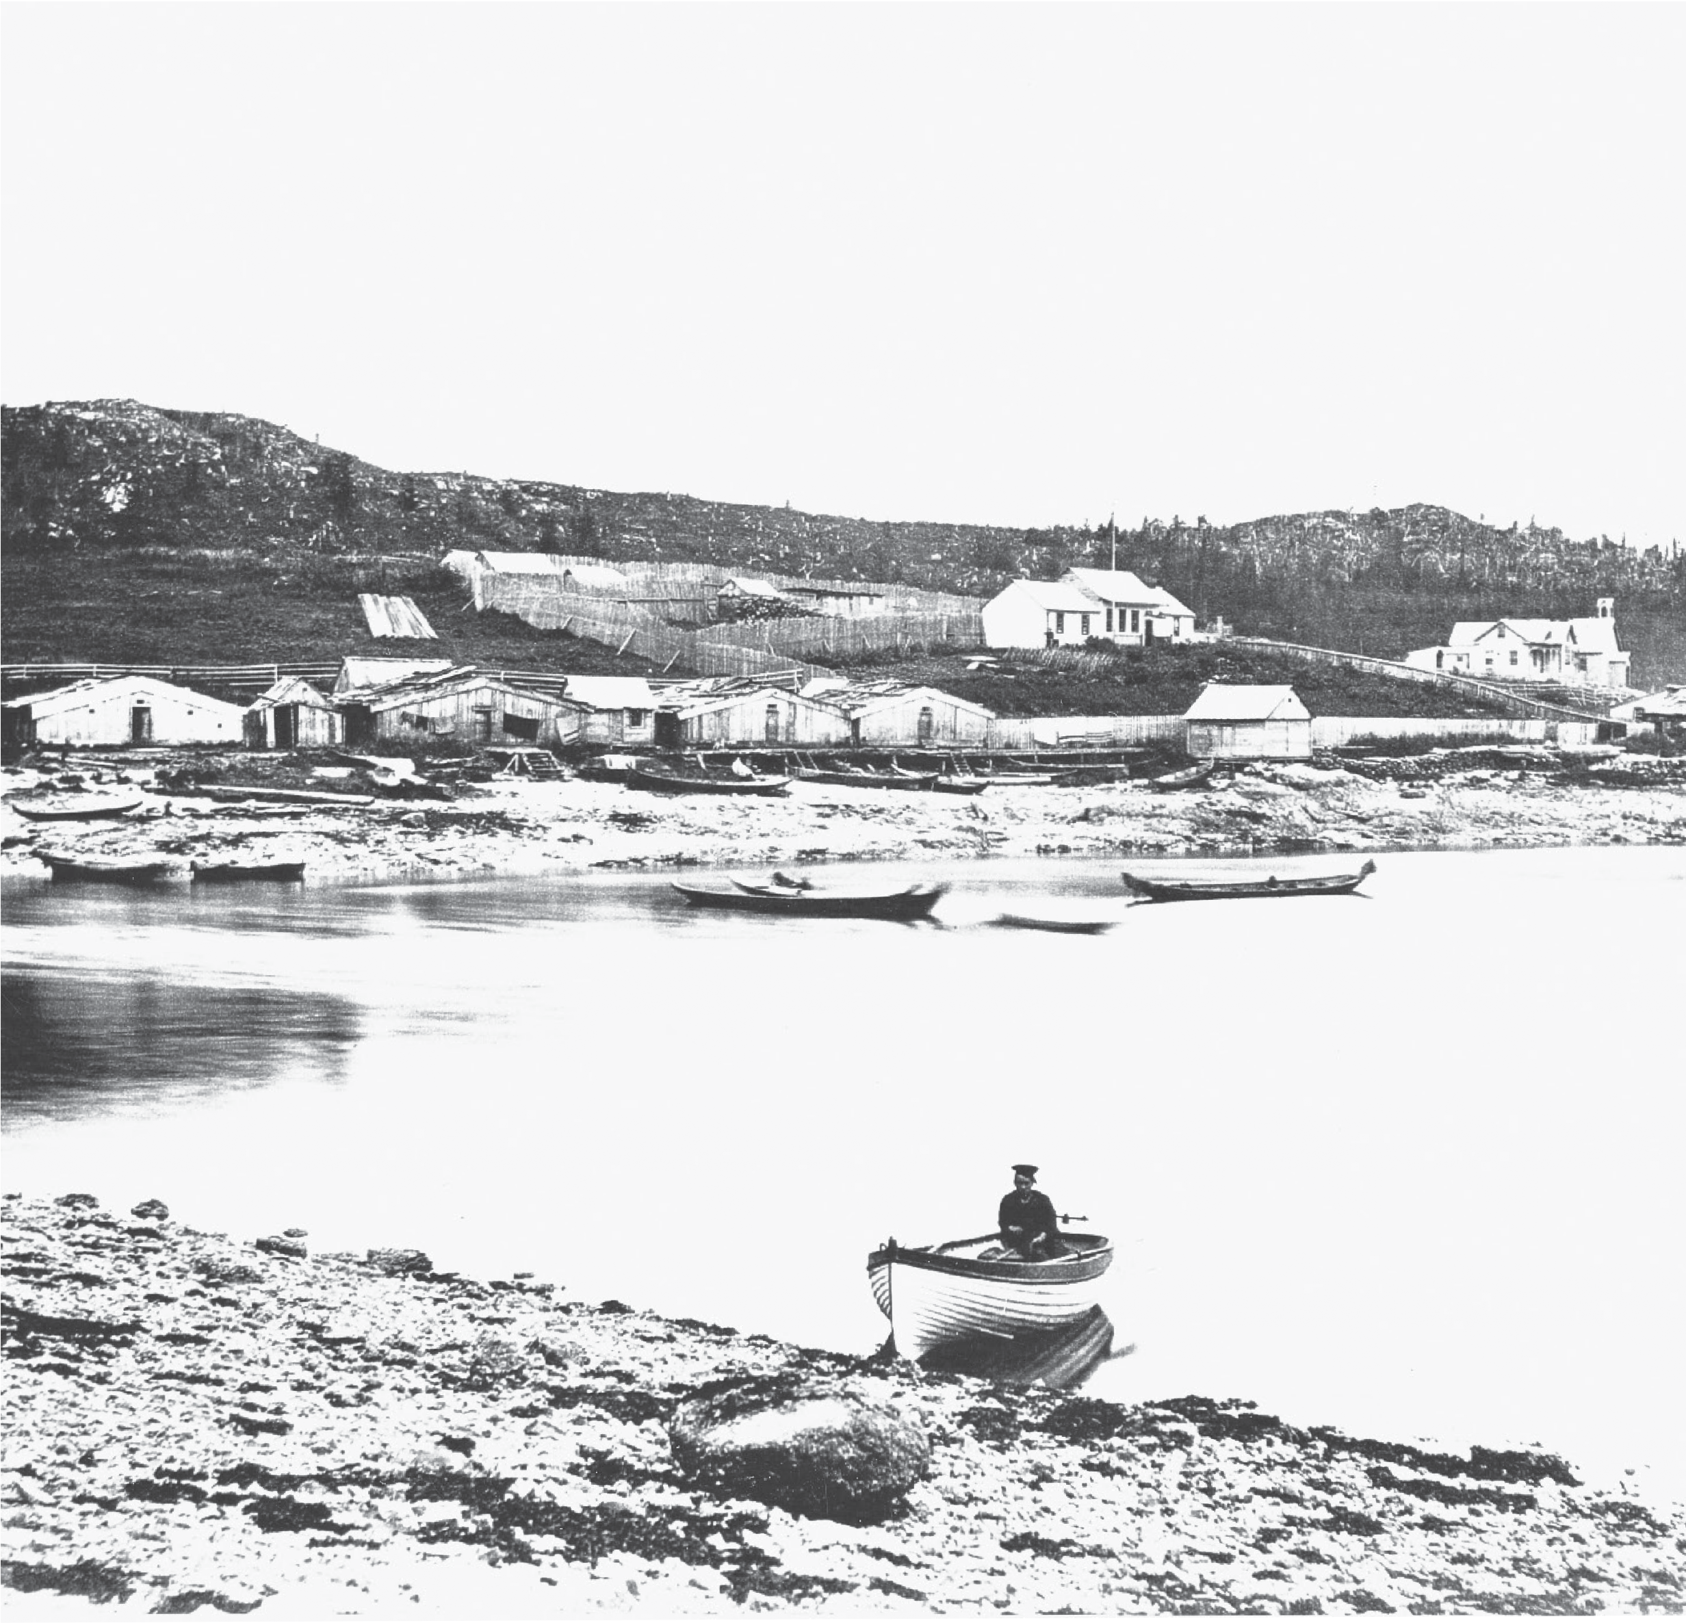

Great Bear Rainforest

The Fur Trade Era, 1770s–1849

The Fur Trade Era, 1770s–1849
The lives of First Nations people were irrevocably changed from the time the first European visitors came to their shores. The arrival of Captain Cook heralded the era of the fur trade and the first wave of newcomers into the future British Columbia who came from two directions in search of lucrative pelts. First came the sailors by ship across the Pacific Ocean in pursuit of sea otter, then soon after came the fort builders who crossed the continent from the east by canoe. These traders initiated an intense period of interaction between First Nations and European newcomers, lasting from the 1780s to the formation of the colony of Vancouver Island in 1849, when the business of trade was the main concern of both parties. During this era, the newcomers depended on First Nations communities not only for furs, but also for services such as guiding, carrying mail, and most importantly, supplying much of the food they required for daily survival. First Nations communities incorporated the newcomers into the fabric of their lives, utilizing the new trade goods in ways which enhanced their societies, such as using iron to replace stone axes and guns
to augment the bow and arrow. These enhancements, however, came at a terrible cost, for while the fur traders brought iron and guns, they also brought unknown diseases which resulted in massive depopulation of First Nations communities.

European Expansion
The northwest region of North America was one of the last areas of the globe to feel the advance of European colonialism. For three hundred years before first contact was made on the west coast, countries like Spain, Portugal, England, and France had colonized eastern North America and most of South and Central America. Early expansion began with the Spanish, who funded Christopher Columbus’ voyage in 1492. The following year Spain had claimed all of the Pacific
as its territory. England, Spain’s rival for imperial superiority, argued that a colonial power should at least visit a territory before claiming it. Thus began a brief northern push by mariners in the 1500s, although it is not clear if the Spanish or English sailed as far north as what we know today as British Columbia’s coast. Sir Francis Drake is known to have reached the Oregon coast in 1759, and some believe he
may have travelled farther north, although there is no concrete evidence to support this theory. A fabled Spanish expedition led by Juan de Fuca is said to have reached southern Vancouver Island in 1592, and even though no proof has been given that such claims are true, later sailors named the passage between Vancouver Island and Washington Juan de Fuca Strait.

By the 1700s Europeans had explored and colonized much of the rest of the world, and England and Spain were still rivals for supremacy in the Pacific. The focus of exploration was on finding better access to the lucrative Asian markets, particularly the search for what was called the Northwest Passage. In 1745 the British Parliament offered a reward of £20,000 to the first ship which could find a shortcut around or through North America. Ever since Juan de Fuca, Europeans had been certain there must be a westward route that would be faster than the known sea or land routes to Asia.
In addition to the search for the Northwest Passage, international rivalries came to a peak in the 1770s. The Spanish and English learned that the Russians had crossed the Bering Strait to begin colonizing the Aleutian Islands in northwest Alaska, and they were moving their influence southwards down the coast. The first recorded encounter between B.C. First Nations and Europeans was part of a Spanish spy mission under the command of Juan Perez to see what the Russians were up to.
In 1774 Juan Perez anchored his ship the Santiago off the northwestern tip of Haida Gwaii. A number of Haida people came out to the ship in canoes, too wary to board the strange vessel, but willing to trade some furs. Weather and illness aboard ship made Perez turn back soon after, and on the trip south, the Spanish made a short stop on the west coast of Vancouver Island, in Nuu-chah-nulth territory, at Yuquot. Perez noted that the Nuu-chah-nulth had iron and copper, proof that even though Europeans had never met First Nations of the coast face to face, their material goods had already reached British Columbia through trade.

The Maritime Fur Trade
In the twenty-five years following Cook’s stop on Vancouver Island, nearly two hundred ships came from Britain, Spain, and the United States to engage in the lucrative sea otter fur trade. When accounts of Cook’s voyages were published in 1784, people took note of the wealth of timber available in addition to furs. Many of the traders who followed Cook left not only with furs but also with boards and timber from the forests.
As they traded for furs, the European mariners followed their policy of claiming sovereignty
over the land. They did this in the name of their king or queen and their home nation.
The Russians and Americans proclaimed sovereignty, as did the Spanish and the British, who focused their energies on trying to claim settlement at Nootka Sound. However, after a short-lived international crisis in the 1790s, the imperial powers soon lost interest in the Northwest Coast and colonial power was left to the fur traders.

The European traders generally stayed on board their sailing ships, while the First Nations traders brought furs to the ships in their canoes. Sometimes the visitors were taken ashore and honoured with a feast, but they did not settle on the land. The First Nations integrated the European presence into their traditional social systems. They treated the visitors as they would chiefs from a visiting village, conducting welcoming ceremonies and blowing eagle down as a sign of peace.
The chiefs expected an exchange of gifts to begin the negotiations on a positive note. The European traders soon learned that the First Nations people were expert traders and hard bargainers. Often the women in the trading party had an important say in what the final price should be.
Probably the trade item most sought after by First Nations people was iron. Iron often came in the form of chisels and axes, but anything made of iron could be shaped into sharp tools that were easier to use than tools made of stone or shell. Firearms were also desired greatly since they could increase the number of furs a hunter could acquire, thus adding to his family’s wealth. Copper and cloth were also in high demand. Copper was formed into shields that symbolized wealth, and cloth both replaced gifts of furs given at feasts and was made into clothing. Many other manufactured goods were traded, including clothing, buttons, mirrors, and dishes. Food items that could be stored for long periods, such as rice, molasses, and pilot biscuits, were also valued. As time passed, and competition between English and American traders became fierce, alcohol became a commonly traded commodity.

Sovereignty
Sovereignty refers to supreme power or authority over a land or state; the power of self-government, with independence from outside control; autonomy; freedom from outside interference and the right to self-government.

From ten to twenty ships a year traded on the B.C. coast during the peak years of the maritime fur trade between 1790 and 1812. The trade devastated the sea otter population, and by the 1840s the animals were scarce. By 1900, they were nearly extinct. Dwindling supplies of the principal commodity combined with increasing competition from the Hudson’s Bay Company resulted in the maritime trade declining after the 1820s, although a small number of ships continued to travel the coast into the 1860s.

Original Documents
Women’s Participation in Trade
From the Journal of Vancouver’s Voyage, 1793-1794:
Trading with the Kitkatla, 1793
In traficing for some furs & curiosities it was observed that neither of the men would close a bargain let it be ever so advantageous without first consulting the women, & if any of them gave a negative to it or made any objections, the things were instantly handed into the Ship.3
From Charles Bishop’s Log of the Ruby: Trading with the Haida, 1795

Seeing so many Women about the Ship one would Suppose nothing hostile was Intended, but it is to be remembered that the Eannas [women] are Kings, and Govern the men throughout these Islands, with a degree of dispotic Athority. What ever they Say the men must do. Nor dare the men Sell a Single fur without first shewing the Goods to Eanna.

The Land-Based Fur Trade
Soon after the maritime traders arrived by sea, other traders came overland from east of the Rocky Mountains. The North West Company (NWC) had for many years been making profits from trading furs in the vast interior of the continent and shipping them back to their headquarters in Montreal. Their rivals, the Hudson’s Bay Company (HBC), operated out of forts on Hudson Bay.
Three NWC traders pushed the range of their company beyond the mountain barrier. Alexander Mackenzie travelled the interior trail networks, reaching the ocean at Bella Coola in 1793. Simon Fraser and David Thompson ventured down their namesake rivers in the early 1800s. Fraser established the first forts in the interior region west of the Rockies, which was known as New Caledonia. Fort McLeod was built in 1805 and Fort St. James and Fort Fraser in 1806. The NWC

overextended itself, and facing financial ruin, merged with the Hudson’s Bay Company in 1821. The HBC continued European expansion into British Columbia, building posts throughout the future province.
While the maritime fur trade was based on the sea otter market in China, the land- based trade was built chiefly on European markets for beaver fur. Other animals such as mink, marten, muskrat, river otter, fox, and bear provided a broader range of resources. The type of European trade goods that could be carried by canoe through the interior was more limited than what a sailing ship could pack into its hold. Guns were important, but blankets became the principal item traded for furs. The distinctive Hudson’s Bay Company blankets, with their red, yellow, and green bands, became a medium of exchange. Other goods that were traded at the forts included foods such as sugar and flour, tobacco, and many household goods. The HBC men, like the maritime traders before them, recognized that the First Nations people were skilled and experienced traders who could drive hard bargains, refusing to trade if prices fell too low and demanding good quality items. They would sometimes spend hours or days negotiating a trade or would simply keep their furs, waiting for a better price.
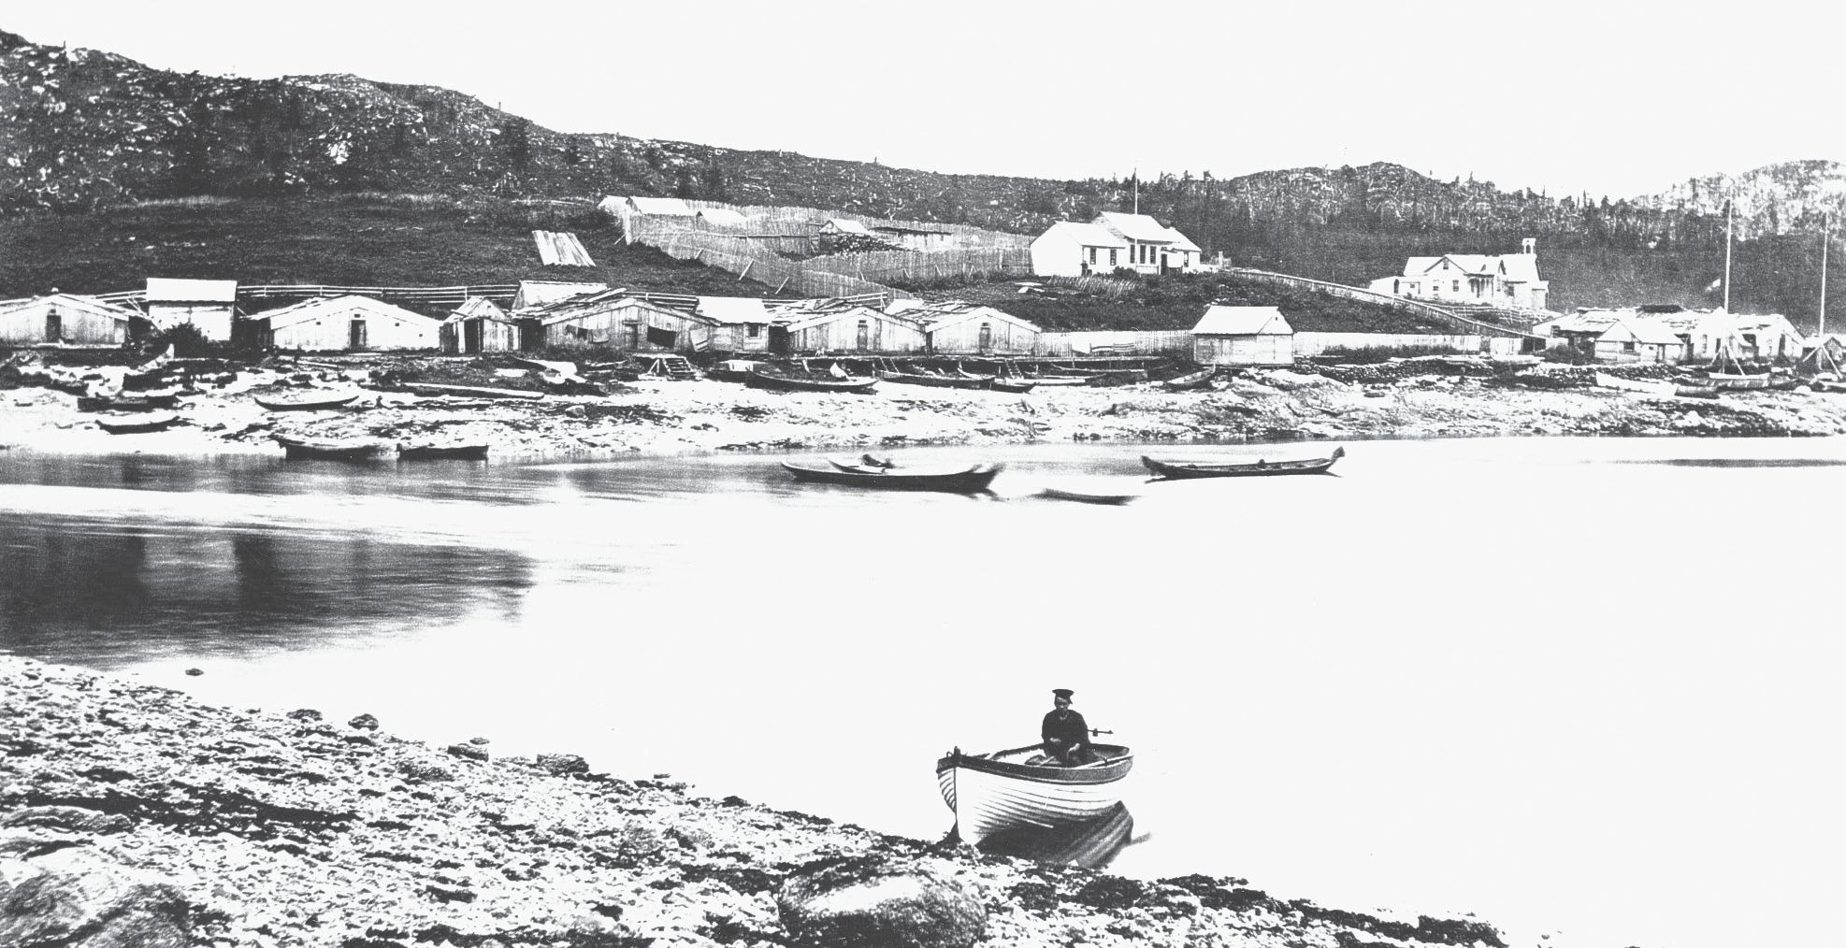
Bella Bella, in Heiltsuk territory, with Fort McLoughlin, 1880s. You can see the fence marking the Hudson’s Bay Company’s land. The original Fort McLoughlin stood there from 1833 to 1841. Shown here is a later company trading post without the fortified walls and bastions. The Heiltsuk tribes took advantage of the presence
of the fort, moving over time from their individual villages to amalgamate here. They traded furs with their neighbours to sell at the fort. The Nuxalk, at the mouth of the Bella Coola River, used their control of trading networks along the grease trails into the Chilcotin. They traded more furs at Fort McLoughlin than even the Heiltsuk. The fort was closed in 1841 and replaced by the steamer Beaver.
Photo BCA B-03570, courtesy of the Royal BC Museum and Archives

First Nations traders integrated the newcomers into their traditional trading systems. The people in the forts depended on First Nations people not only to supply furs, but also for their food. Fish and meat purchased from First Nations people frequently made up the main food supply for the Hudson’s Bay Company workers. Those tribes that controlled trade routes and resources before contact with Europeans often continued to exercise control.
However, the presence of a fort increased the local group’s status and power, and the people were able to act as intermediaries in a complex trading relationship with their neighbours. If local people did not choose to participate in the fur trade, the HBC had no choice but to abandon its post.
Forts were built along the coast, principally at Fort Langley on the Fraser River and Fort Simpson near the Skeena River. After 1846, when the Oregon Treaty defined the border between British and American territories, the HBC moved its
headquarters to Victoria, and after that, the brigade route followed the Fraser River instead of the Columbia.
The forts were built to be islands of protection in what the newcomers considered to be a potentially hostile environment. They were surrounded by high, thick
log walls, and had bastions armed with cannons in two opposite corners. Heavy wooden gates guarded the entrance, and often wary employees would admit only one or two people to trade at a time. This was not always the case, however, and sometimes a more relaxed atmosphere prevailed.

Medium of exchange
A medium of exchange is something that people agree has a value and can be used to exchange goods and services. It allows people to trade without the limitations of bartering. Today money is the most common medium of exchange.

Women in the Fur Trade
Women played an integral role in the fur trade, one that is often overlooked. While men usually took the lead in both the trapping and the trading, there were other dimensions to the functioning of the fur trade in which women were key. At home, often the women of a village were left to provide for their families on their own while the men were away for extended periods in pursuit of the increasingly
scarce furs. More time was required to prepare the furs, which was often the job of women, increasing their workload. Similarly, for many groups, trading salmon with the Euro-Canadians was as important as trading furs, and the extra work needed to clean and dry the salmon was largely the women’s task.
However, it was their participation in the social structure of fort life which marked women’s most significant contribution to the fur trade, and also to the future population of British Columbia. First Nations women frequently married company employees and they and their children lived inside the fort, becoming bound up in complex social, economic, and political relationships. In some cases, especially in the more structured societies of the coast, marriages were considered to be
alliances between high-ranking families and the officers of the trading post, forging a political and economic bond between the two sides. For example, Dr. John Kennedy, chief trader at Fort Simpson on the Nass River, married the daughter of Ligeex (Legaic), the highest-ranking chief of the Tsimshian. Partly because of this marriage, the Hudson’s Bay Company moved Fort Simpson from Nisga’a territory south to Ligeex’s traditional land.
Most marriages, however, operated at a more personal level. Aboriginal women offered companionship for the employees and a family environment, but they also relieved the men of domestic duties. As was the case in most societies throughout the world, women were not considered equal to men, and this belief certainly held true in these marriages. They suffered further from racial discrimination; there are accounts of a man’s wife and children being hustled out of the parlour when visitors arrived.

The quality of the relationships which the women had when they lived inside the forts varied a great deal. Some had happy and loving marriages, and their partners shared in traditional culture and interacted with their families. Aboriginal women brought many strengths to these partnerships, but also gave up a great deal in
the process. In some cases they were able to bridge two cultures and share skills and knowledge between them, such as those involved in food preparation. Euro- Canadian objects, such as chairs and tables, were often viewed with suspicion by the older members of their families, but women were often able to demonstrate their utility and demystify these items. In the same way, they were able to bring an understanding of their culture to the men of the fort and break down at least some racial barriers.

Impacts of the Fur Trade
The fur trade changed the daily lives of the First Nations people. Although they continued traditional hunting and gathering practices through the seasons, the amount of time they spent on seasonal activities changed. Men spent more of their time hunting and trapping to supply the fur trade. Women, who did most of the work preparing the skins, often found themselves much busier. These trade- oriented activities replaced traditional food harvesting and preparation, creating a dependency on European supplies that had not existed previously.
The First Nations used the trade goods they received in different ways. Some objects simply made life easier. Owning a factory-made woollen blanket meant a household didn’t need to spend so much time weaving cedar bark capes. Using coins and thimbles to replace deer hooves or bird beaks on dancing aprons also saved time. Iron tools increased a carver’s output. These objects also came to increase the status of users. Guns had an even greater effect on status and power. They could make hunting easier, although hunters often found the bow and arrow to be superior to the unreliable musket. Guns could always be counted on, however, to shift the balance of power in warfare with other groups.
By trading with the Europeans, coastal chiefs increased their wealth and power substantially. In many ways, traditional social patterns were enhanced by the new objects and ideas brought by the sailors. However, these sailors also brought silent agents that were to have devastating effects on First Nations societies—unknown diseases like measles, influenza, and smallpox.

Devastation by Disease
Probably the most devastating result of the European influx was the vast depopulation that occurred because of disease epidemics. The statistics tell the story. Although it is extremely difficult to determine an accurate figure, it is
estimated that when Europeans arrived in the late eighteenth century, there were between 200,000 and 400,000 First Nations people living in British Columbia. By 1900, this figure had dropped to around 25,000. In little more than a century, the population had been slashed by 90 or 95 per cent.

First Nations Voices
The Haida Encounter Europeans
The name of the person who gave this description of the first encounter between the Haida and the Europeans is not known. John Swanton, who recorded the narrative in 1905, says only that it was a person from the village of Kaisun.
All the people who moved from Skidegate Inlet to Tc!a’al [Chaatl] were dead, and their children growing old, when the first ship appeared. When it came in sight, they thought it was the spirit of the Pestilence, and, dancing on the shore, they waved their palms towards the new-comers to turn back. When the whites landed, they sent down to them their old men, who had few years to live, anyhow, expecting they
would fall dead; but when the new arrivals began buying their furs, the younger ones went down too, trading for axes and iron the marten and land-otter skins they wore
. . .When one of the white men shot with a gun, some of the natives said he did so by striking it on the side; another, that he blew through it; and a third, that a little bird sat on top and made it go off. 6
Clearly the Haida associated the Europeans with terrible disease even before they had encountered them directly. They had already been infected with smallpox when the first European ship arrived at Haida Gwaii. Sending some elderly men to meet the sailors first in case they brought disease was a characteristic gesture among many First Nations because it protected the younger generation from any potential danger.2

The diseases that arrived with the Europeans— measles and smallpox, in particular—were unknown in British Columbia, so First Nations people had no immunity to them. These diseases usually broke out in epidemics, sweeping through a village or even throughout the province. The first epidemic occurred in the 1770s, when smallpox broke out. It is likely that the smallpox virus was
carried to Tlingit territory in Alaska by the Spanish. From there, the disease spread southward to the Haida and Tsimshian people.
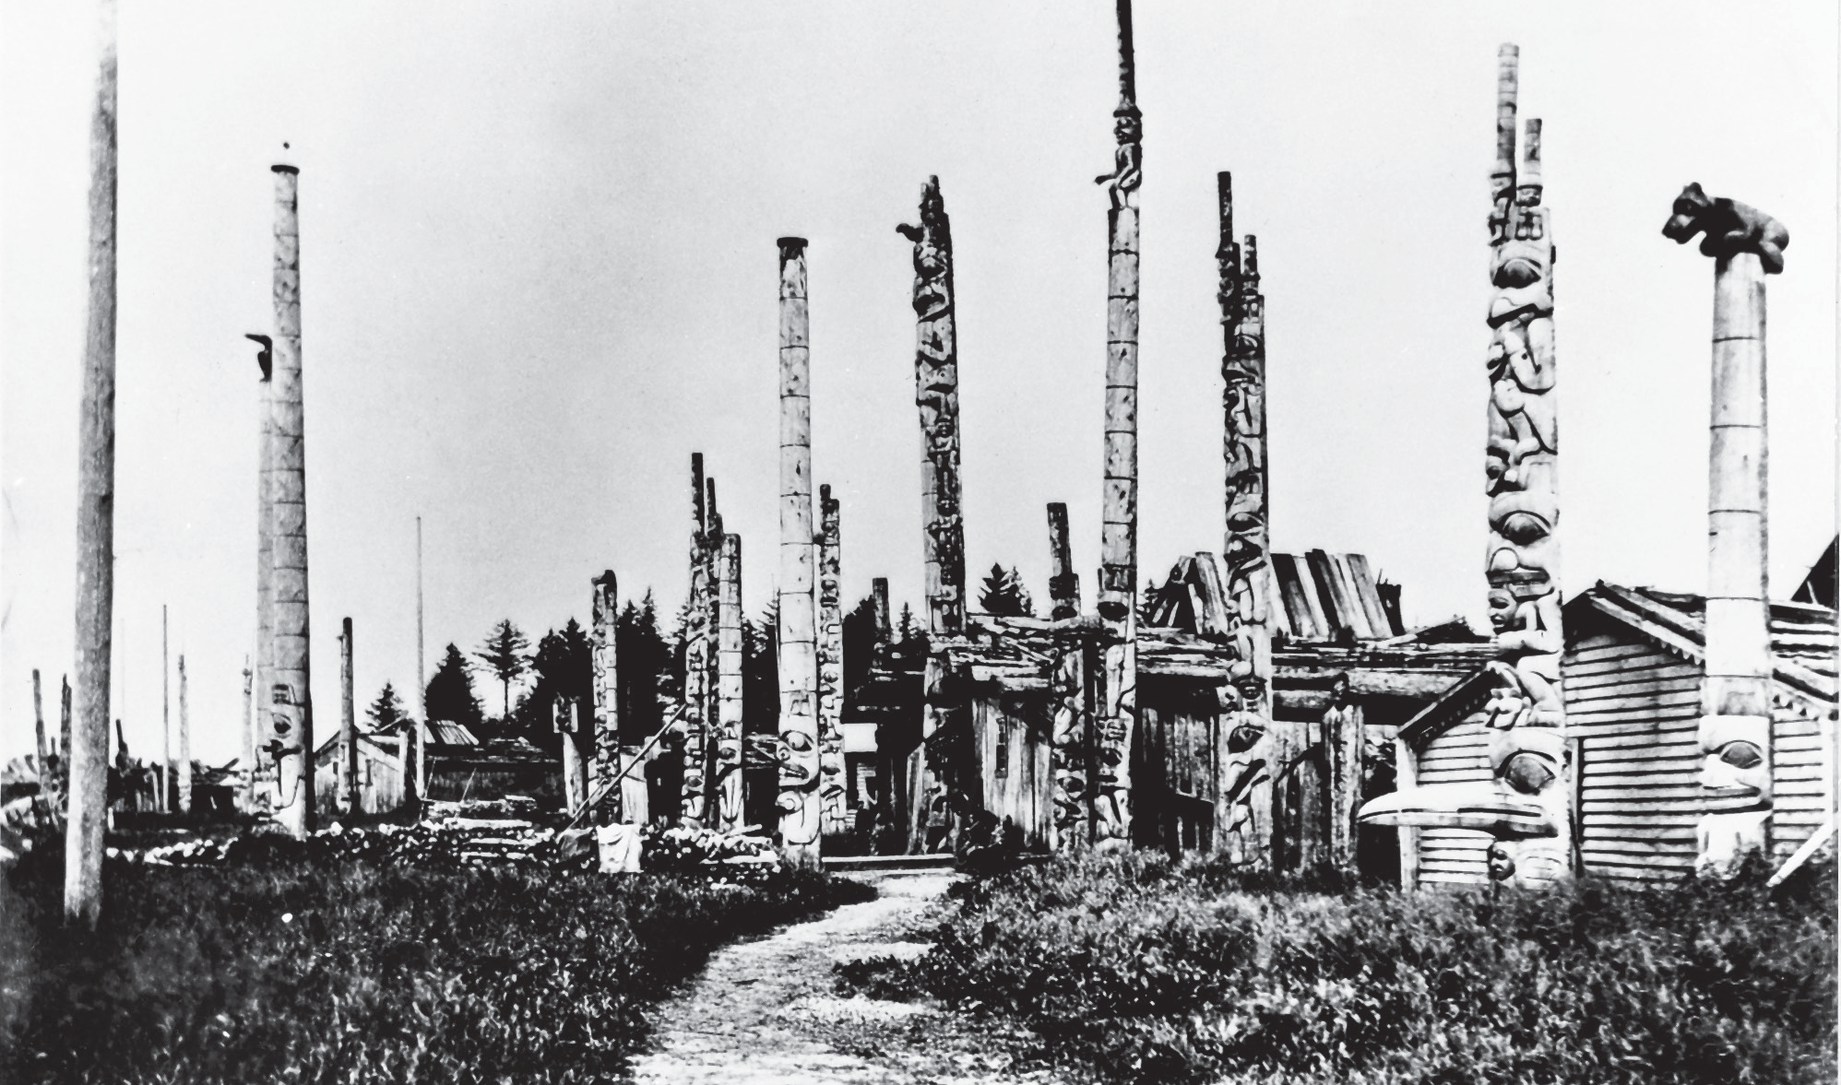

Skidegate, 1880s. Smallpox left many Haida villages with too few people to survive. Many of the people from the southern villages had already moved to Skidegate by the time this picture was taken. Twenty years later, there were only two Haida communities, Skidegate and Masset.
Photo BCA B-3588, courtesy of the Royal BC Museum and Archives
Other epidemics and smaller outbreaks of diseases occurred during the nineteenth century. In the 1840s, a measles outbreak spread to most of the First Nations of B.C., taking two years to do so. The measles outbreaks could be traced along the trading routes of the fur traders. At first they appeared along the Fraser River. Then an infected person aboard the Beaver carried the disease to Fort Simpson, and from there, measles spread along the trade networks into the interior, attacking people as far inland as Fort St. James and Fort George.
The last major smallpox epidemic did not take nearly as long to affect most of the province. This was the worst single epidemic, killing as many as 70 percent of First Nations people. It began in 1862 in the bustling colonial capital of Victoria. Many

First Nations from the north coast—Haida, Tsimshian, Tlingit, Stikine, Heiltsuk, and Kwakwaka’wakw —had travelled to Victoria to work and trade. They lived in an area on Victoria harbour called “the Northerners’ Encampment.” A population count
in 1859 showed that out of more than 2,200 people living there, 25 per cent were Haida and 45 per cent were Tsimshian.
Soon after this population count, those numbers were to plunge terribly. On March 13, 1862, a passenger aboard the ship Brother John, arriving from San Francisco, had smallpox. Apparently, the destruction that followed originated from that one man. A month later the fearsome disease had taken hold in the Northerners’ camp. Conditions became terrible as people became ill and died. Neither the First Nations people nor the colonial officials were prepared for such an epidemic. They could not cope with the overwhelming number of bodies and people too ill to move.
Newspaper reports suggest that there were more than a thousand bodies of people from the northern tribes piled on open ground near the camps. The reaction of
the colonial police was to order the northern people to leave Victoria. When they protested, the gunboats moved in and aimed their cannons at them, giving them no choice but to load up their canoes and head north.
One report in the Daily British Colonist gives only the briefest suggestion of the horror the Northerners faced:
“Forty out of sixty Hydahs who left Victoria for the North about a month ago, had died. The sick and dead with their canoes, blankets, guns, etc. were left along the coast. In one encampment, about twelve miles from Nanaimo, Capt. Osgood counted twelve dead Indians—the bodies festering in the noonday sun.” 7
The epidemic hit the northern people harder than any cannon fire could have. For example, the estimated population of the Haida nation before the epidemic was about 5,700 and after, about 1,600, a loss of 4,100 people, or over 70 per cent of the population.
But the epidemic did not end on the coast. Through trading networks the disease was carried far into the interior, until within two years, hardly a corner of British Columbia was left unscathed. Complete villages were wiped out in some cases, while in others sixty to ninety per cent of the people died. Imagine the impact on the families and the communities they lived in: they would be grieving, leadership would be destroyed, and people would have to use all their energies simply to cope and survive.

Summary
Europeans came to the West Coast in the 1770s, hundreds of years after first contact occurred in Canada. The search for the Northwest Passage to provide easier access to Asia brought the first ships to the Pacific coast, while others in search of new fur supplies came overland through the mountains. The maritime fur trade, which primarily sought sea otter for markets in Asia, was conducted from sailing ships which moved up and down the coast and stayed a short time. The land-based fur traders, first through the North West Company and later the Hudson’s Bay Company, built permanent forts and established transportation routes through much of the interior.
The era of the fur trade was a transitional stage in the colonization of British Columbia. First Nations people kept control over their lands and resources as the European newcomers relied on them to provide furs and food supplies. The fur trade era had both positive and negative effects on First Nations societies. The new European goods that resulted from trade, such as iron and copper, made some aspects of First Nations people’s lives easier, and increased the wealth and prestige of those who could control the trade. However, devastating effects of smallpox
and other diseases obliterated any positive effects: as many as 90 per cent of the Aboriginal population died in the period of a few decades.

Sources and Credits
- Charles Bishop, The Journal and Letters of Captain Charles Bishop on the North-West Coast of America, in the Pacific and in New South Wales 1794–1799. London: Hakluyt Society, 1967.

- John Reed Swanton, Contributions to the Ethnology of the Haida. Reprint of the 1905 ed. New York: AMS Press, 1975, p. 105.

