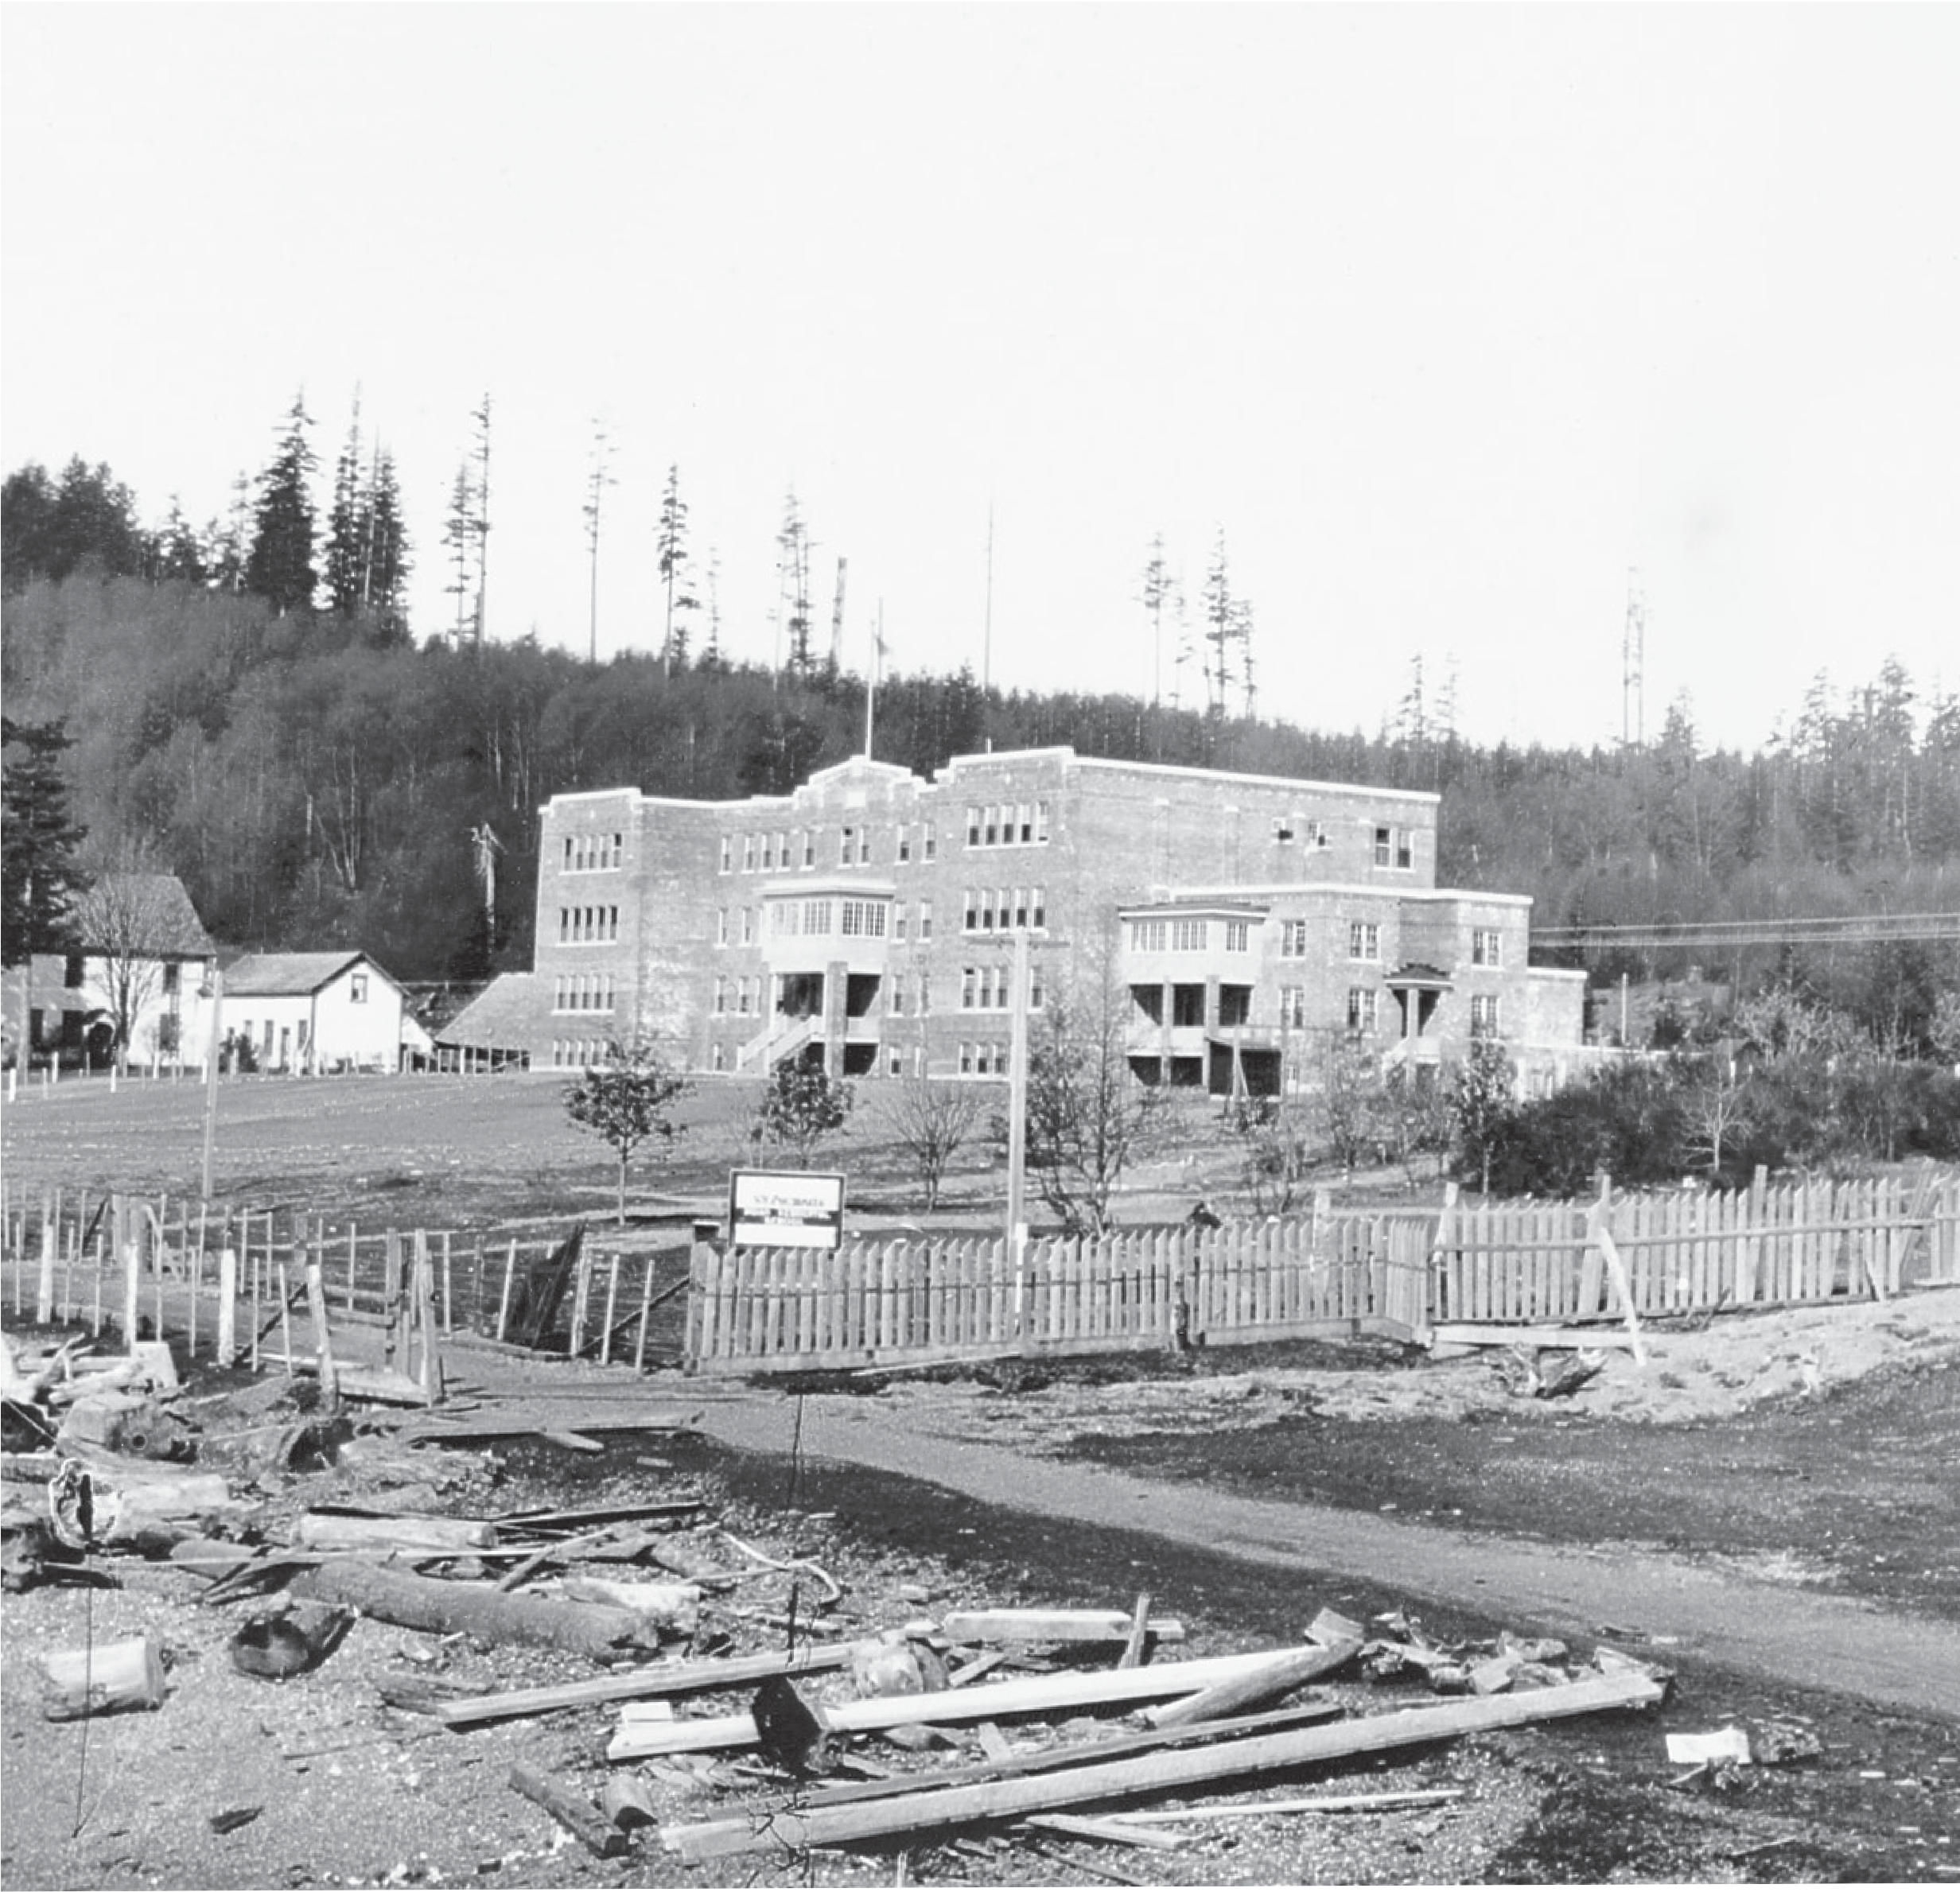

Great Bear Rainforest

Canada Takes Control, 1871–1911

Canada Takes Control, 1871–1911
Under the colonial government of British Columbia, First Nations first experienced the loss of control of their lands and resources, but when B.C. became part of Canada, they found nearly every aspect of their lives dominated by the laws of the new government. This section first describes the politics behind the Terms of Union, which established the relationships among First Nations people, Canada, and British Columbia. Next the Department of Indian Affairs and the Indian Act are discussed, showing the extent of control exerted over Aboriginal people, in an explicit attempt to assimilate them into mainstream society. Specific features of this control are identified, including the setting up of Indian reserves, the banning of important cultural institutions such as the potlatch, and the implementation of residential schools. These attacks on the Aboriginal world had devastating effects, but they were not imposed without resistance. From the outset, First Nations leaders, supported by their communities, protested the creation of reserves and the stripping away of Aboriginal rights. They used peaceful means to try to make
their arguments, meeting with politicians at every level. The section concludes with an important meeting of protest in 1911 which united First Nations from many communities around the province for the first time.

Joining Canada
When Canada became a country in 1867, the British North America Act (BNA Act, now called the Constitution Act of 1867) continued the colonial policy of discriminating against First Nations people by enforcing government control. The BNA Act divided this control between two levels of government. The federal government took overall responsibility for “Indian affairs”—meaning the governance of First Nations communities and lives. The provinces, however,
controlled the land and natural resources, which gave them the power to regulate land uses such as hunting, trapping, and forestry, and to ignore Aboriginal resource management systems. Furthermore, the provinces determined which lands were used for reserves. This basic division of power split control of the lives of First Nations people and their lands between two often antagonistic parties in a way that was foreign to their holistic world view. British Columbia was still a colony when Canada was formed, however, and followed its own policies for administering First Nations affairs. Under the direction of Joseph Trutch, Minister of Lands and Works,
Aboriginal title to the land was denied. The provisions of the Royal Proclamation of 1763 were ignored or dismissed as irrelevant to British Columbia. The colonial government refused to negotiate treaties. Its policies formed the basis of B.C.’s relationship with First Nations for more than a century.
Title
Title is a legal term that means the right to the possession of land or property. “Aboriginal title” is based on Aboriginal people’s long-standing use and occupancy of the land as descendants of the original inhabitants of North America.

By 1870, most B.C. politicians were in favour of joining the new country of Canada, since the costs of running the colony as a separate territory were becoming too great. Although there were more First Nations people than Europeans in the colony, they had no part in the negotiations regarding entry to Confederation.
Trutch, in fact, decided on most of the Terms of Union. Joseph Trutch, R.W. Carrall, and Dr. John Helmcken travelled to Ottawa in June 1870 to discuss B.C.’s entry into Confederation. Trutch was content to omit First Nations people from the agreement, but the federal politicians insisted on including them, and Section
13 was added. Federal politicians did not understand clearly the conditions experienced by First Nations people in British Columbia. They assumed their situation to be similar to that of the First Nations of Ontario, who had signed treaties by 1850 with land allocations of eighty acres of land per family. The federal officials mistakenly believed that treaties had been negotiated in B.C., freeing up the land for settlement. It is not clear what the B.C. representatives told Ottawa about their policies regarding First Nations people. Dr. Helmcken wrote in his diary: “The clause about Indians was very fully discussed. The Ministers thought our system better than theirs in some respects, but what system would be adopted remained for the future to determine.”
Obviously the delegates described some type of system, but the details of how the new system would operate under Confederation were left up in the air. Helmcken’s diary continues with the note: “I asked about Indian Wars and Sir G. Cartier said that it depended upon the severity, as a rule the expense would have to be borne by the Dominion Govt.” This is a reference to the armed resistance by the Métis at Red River in Manitoba in 1869–1870. Often called the Riel Rebellion or Red River Rebellion, this was a pivotal episode in Canadian history. It was undoubtedly on the minds of the B.C. politicians, and they wanted to ensure that they would not be liable to pay the costs of quelling any “Indian Wars.”
The Terms of Union make no mention of Aboriginal title to the land, or the need for treaties to be negotiated in the future. They do state that B.C. will transfer lands
to the federal government for Indian reserves, but the language used is vague. The administration of reserve lands was to be, in the words of the Terms of Union, “as liberal as that hitherto pursued,” and the reserves were to be parcelled out
“as it has hitherto been the practice of the British Columbia Government.” Federal politicians apparently assumed this reserve allotment was comparable to the eighty acres given to First Nations families in Ontario. Trutch and the B.C. politicians, however, felt it confirmed the ten-acre allotments that the colonial administration had previously distributed. British Columbia joined Canada in 1871 and Joseph Trutch became the new province’s first lieutenant-governor. A Superintendent of Indian Affairs for B.C. was also appointed by Ottawa. Dr. Israel Powell was the first superintendent, beginning in November 1871. He divided the province into regions called “Agencies,” each administered by an Indian Agent. He also had the task of

determining what reserve lands had been allocated for the First Nations before Confederation. Further, he had the job of continuing to assign Indian reserve land. He found himself caught in the middle of the conflict between the policies of the Department of Indian Affairs in Ottawa and the provincial government in Victoria, which was reluctant to implement federal policies.
In 1873, for example, Ottawa passed an Order-in-Council stating that reserves in
B.C. should be eighty acres per family, just as they were in Ontario. Powell dutifully told the provincial officials of Ottawa’s resolution. He received a letter back from the province stating “This quantity is greatly in excess of what has been found to be sufficient by previous Governments, and the Government has decided that throughout the Province the land to be reserved for Indians should not exceed
20 acres of land for each head of family of five persons.” This increase from ten to twenty acres a family was never put into practice. In the 1870s, Treaties 1 to 7 were signed with First Nations on the Prairies, allotting 160 acres or more to
each family. First Nations leaders in B.C. hoped that treaties would also be signed with them, for although the terms of the treaties were often less than favourable, they nevertheless established that Aboriginal title existed, and that the original inhabitants were compensated for the lands they surrendered. However, British Columbia continued to deny the existence of Aboriginal title and First Nations communities were restricted to tiny reserves, remnants of their traditional territories.

Original Documents
Article 13, Terms of Union,1871
The following is an excerpt from the agreement by which the colony of British Columbia joined Canada in 1871. It defines the responsibilities of the province and the federal government with regard to First Nations people.
The charge of the Indians and the trusteeship and management of the lands reserved for their use and benefit, shall be assumed by the Dominion Government, and
a policy as liberal as that hitherto pursued by the British Columbia Government shall be continued by the Dominion Government after the Union. To carry out such policy, tracts of land of such extent as it has hitherto been the practice of the British Columbia Government to appropriate for that purpose, shall from time to time be conveyed by the local Government to the Dominion Government in trust for the use
and benefit of the Indians on application of the Dominion Government; and in case of disagreement between the two Governments respecting the quantity of such tracts of land to be so granted, the matter shall be referred for the decision of the Secretary of State for the Colonies.

The Indian Act
When Canada became a country, the Department of Indian Affairs (DIA) was created to administer policies regarding First Nations. In 1876, the Indian Act was passed. This act gave legal power to government to control the lives of First Nations communities across the country. The Indian Act combined earlier colonial and federal laws into one act, and included clauses about land, Indian status, and local government.
The Indian Act defines who is considered a “Status Indian.” Individuals who qualify as “Status Indians” are wards of the government, meaning that the act treats them as if they were children in need of parental care. Before 1951, Status Indians were not deemed to be “people” under the laws of Canada, and therefore were denied certain rights that other Canadians enjoyed. Status Indians could only become “persons” by voluntary enfranchisement—by relinquishing their Indian status.
Only then would they be allowed to vote, own property, or have the rights of other Canadian citizens.
The Indian Act provided for reserve land to be set aside for the use of Status Indians, and specified who could live on the reserves. Government officials exercised considerable power over people living on reserves. Among other things, they could dictate when and where children would go to school.
The Indian Act infringed on personal behavior in its discriminatory laws regarding alcohol use. It was a crime for anyone falling under the act to own or consume alcohol, and an inebriated person could be thrown in jail immediately and fined in court the next day. It was against the law for anyone to sell alcohol to Status Indians, and such suppliers were frequently given harsh fines. These paternalistic
laws were intended for the people’s own good, in the eyes of Canadian law-makers, but they only served to push the use of alcohol underground and became a major factor in one of the most serious issues that First Nations have had to face: alcohol abuse.
Although little control remained in the hands of local communities, the Indian Act dictated the structure of local government. Ignoring the traditional First Nations forms of governance, local government was modelled after the Euro-Canadian elected town council. In this model, the government was formed by a band council, led by a chief councillor rather than a mayor. This band council usually replaced,
or sometimes co-existed with, traditional forms of government. In traditional governance, leadership was usually hereditary. In many cases, the hereditary chiefs were elected to the band council positions. Imposing this electoral system on First Nations created a major disruption within First Nations societies.

The Department of Indian Affairs developed a complex bureaucracy, from the Superintendent of Indian Affairs in Ottawa down to the Indian Agents located throughout the country. The DIA kept extensive files of all their correspondence, memos, and other documents. These are available on microfilm today and are valuable resources for researchers, especially for those researching land claims.

First Nations Voices
Chief Neeshot, Tsimshian
Chief Neeshot (Albert Nelson), Gitsaxlal tribe, Tsimshian Nation, addressing the first Indian Agent for the Northwest Agency, James McKay, at Port Simpson in 1883.
We are living in peace for this reason, that this Tsimshian tribe belongs to no government. God has put us here Himself. That is why our minds are at peace, for we know God is the only one who governs us. We have heard that the government has appointed you here. You have told us yourself that the land belongs to us the Tsimshians. That the council will have to make a law to divide the lands; so you have said. We do not see what the council has to do this for, as the land belonged to us years ago. What the people of this place want they will let you know; what they do not want they will let you know also. Well Sir, Mr. McKay, this is all I will say. I will not trouble you yourself. This thing we want is not a small thing, it is a great thing.

Originally there were a hundred clauses in the Indian Act; today, because of amendments that have been made in response to changing conditions, there are almost two hundred. In many cases, powers that were originally assigned to the DIA have been transferred back to local communities, but the Minister of Indian Affairs still holds the legal ability to interfere in many aspects of the lives of First Nations people. Although the act gives some benefits to Aboriginal people, these have been outweighed by the discrimination and oppression embedded in it.
Enfranchisement
Enfranchisement gives people the right to vote in elections. For First Nations people, however, it has meant more than this. Until 1949 provincially, and 1960 federally, First Nations people could only vote if they relinquished their Indian status. This meant cutting themselves off in many ways from their reserve communities.

Indian Reserves
Once the Indian Act was passed, First Nations people were not permitted to own land because they had become wards of the state. This shocked the First Nations, who had always had stewardship over their territories. In many areas of B.C., moreover, the First Nations had demonstrated generosity and a willingness to share their territories with the newcomers. For instance, Chief Pelka-mu-lox of the Okanagan stated, “You are my white children and I do not want to lose you. I want you to live in my territory. I have a big country, big enough for all of us. I have plenty of everything, enough for all of us, for our children and for our children’s children.”
Instead of living on their traditional territories, the First Nations were now to live on reserves. The idea of reserves was so foreign to First Nations people that many did not fully understand what their impact would be until surveyors arrived to physically mark them out.
Indian reserves were meant to be temporary, lasting only until First Nations people were assimilated into mainstream society and could buy property like other Canadians. The reservation of lands that had started in the colonial era continued once B.C. became a province. An Indian Reserve Commissioner was appointed
to oversee this process. The first commissioner, G.M. Sproat, lived among the Nuu-chah-nulth people and was sympathetic to First Nations people. He was as generous as he could be in allotting reserves. In 1880, he was forced to resign and
Peter O’Reilly, Trutch’s brother-in-law, assumed his position instead. It comes as no surprise that O’Reilly immediately reduced the size of many reserves that Sproat had set out. Through the 1880s and 1890s, O’Reilly travelled across B.C., consulting First Nations communities and decreeing where reserves should be made.
Wherever he went, he was met with resistance and the call for treaties to recognize Aboriginal title.

Early Resistance
From the beginning of their relationship with incoming Europeans, First Nations people resisted the alienation of their lands and protested the loss of their rights. Although protests have occasionally turned violent, First Nations protests have usually been peaceful and non-violent. Once the First Nations had unwittingly became part of Canada and come under the control of the Indian Act, First Nations communities organized to resist their new status and to advance the recognition of Aboriginal title and land claims.
First Nations protests generally followed a pattern that placed great importance on community consultation. Everyone in the village, and sometimes the whole nation, would meet to discuss the action they wanted to take. The strongest speakers were appointed to present their claims to politicians, and accompanied by chiefs, they

travelled to meet Euro-Canadian leaders face to face, in some cases all the way to England. Once the advocates returned, they reported the proceedings at another meeting of their community.
Sometimes First Nations people requested assistance from local missionaries, who, with their command of the English language, transcribed letters and petitions which reflected the spoken word of the leaders. Often these missionaries were accused by government officials and newspapers of interfering in First Nations-government relationships. Sometimes the missionaries were accused of supporting protests for their own gain.

Original Documents
Petition to the Government, 1874
The following are excerpts from a petition to the Indian Commissioner for the province of British Columbia.
The petition of the undersigned, chiefs of Douglas Portage, of Lower Fraser, and of the other tribes on the seashore of the mainland to Bute Inlet, humbly sheweth:
That your petitioners view with a great anxiety the standing question of the quantity of land to be reserved for the use of each Indian family.
That we are fully aware that the government of Canada has always taken good care of the Indians, and treated them liberally, allowing more than 100 acres per family; and we have been at a loss to understand the views of the local government of British Columbia, in curtailing our land so much as to leave in many instances but few acres of land per family.
Our hearts have been wounded by the arbitrary way the local government of British Columbia have dealt with us in locating and dividing our Reserves. . .
For many years we have been complaining of the land left us being too small. We have laid our complaints before the government officials nearer to us. They sent us to some others; so we had no redress up to the present; and we have felt like men trampled on, and are commencing to believe that the aim of the white men is to exterminate us as soon as they can, although we have always been quiet, obedient, kind, and friendly to the whites . . .
We consider that eighty acres per family is absolutely necessary for our support, and for the future welfare of our children. We declare that 20 or 30 acres of land per family will not give satisfaction, but will create ill feelings, irritation among our people, and we cannot say what will be the consequence.1

One of the earliest protests was made by the Stó:lø people of the lower Fraser River at New Westminster in 1874 in hopes that the government of Canada could redress land issues that dated back to the colonial era. In 1864, shortly before he retired, Douglas directed that fourteen reserves in the Fraser Valley be surveyed, averaging eighteen hectares (forty-five acres) per person. Before the reserves could be officially registered, however, Trutch had taken over the administration of Aboriginal affairs. In his opinion these reserves were much too large for the needs of the Stó:lø, so in 1865 he slashed the size of the reserves by eighty per
cent. Individual reserves were cut by even more. For example, the Matsqui reserve, which was originally 3,887 hectares, was reduced by Trutch to only 60 hectares.
The Stó:lø wrote letters and petitions to various officials hoping to have these cuts reversed. In 1874, more than fifty chiefs and hundreds of other First Nations people gathered in New Westminster to protest in front of the provincial land registry office. They presented a petition to Indian Superintendent Israel Powell requesting that their reserves be increased and that they be compensated for the land outside the reserves. According to government records, this petition caused
officials in the Indian Affairs department in Ottawa to realize that treaties had never been signed in British Columbia. However, the relationship between Canada and British Columbia was fragile at that point because the possibility existed that the new province might separate from Canada to join the United States. As a result, the federal government ignored the Stó:lø petitions.
The Nisga’a and Tsimshian were among the earliest First Nations to take action against the reserve surveyors and the Indian Agents. They fought for recognition of Aboriginal title to the land and consistently opposed the idea of Indian reserves. Their protests were based on their traditional ideas regarding land ownership, which made house groups stewards over their territories. They found support for their position in statements made by the colonizers themselves, for example, the Royal Proclamation of 1763 and a statement made by Lord Dufferin, Governor- General of Canada, when he visited Port Simpson and Metlakatla in 1876. Dufferin told the Tsimshian that the people of Canada recognized them “as the ancient inhabitants of the country.” He also made a speech to politicians and businessmen in Victoria, saying:
We must all admit that the condition of the Indian question in British Columbia is not satisfactory. Most unfortunately, as I think, there has been an initial error ever since Sir James Douglas quitted office . . . of British Columbia neglecting to recognize what is known as Indian title. In Canada this has always been done: no government, whether provincial or central, has failed to acknowledge that the original title to the land existed in the Indian tribes and communities that hunted or wandered over them . . . But in British Columbia, except [for the Douglas treaties] the Provincial Government has always assumed that the fee simple, as well as the sovereignty over
the land, resided in the Queen. Acting upon this principle, they have granted extensive grazing leases, and otherwise so dealt with various sections of the country as greatly to interfere with the prescriptive rights of the Queen’s Indian subjects . . . I consider that our Indian fellow subjects are entitled to exactly the same civil rights under the laws as are possessed by the white population.2

Original Documents

1887 Meeting in Victoria
The meeting between the Nisga’a and Tsimshian leaders was held at the premier’s house. Rev. Thomas Crosby was meant to be the interpreter, but since he was not permitted in the room, Nisga’a Chief Charles Barton, with some misgivings, was made interpreter. Following are some extracts from the transcript of this meeting.
Richard Wilson (Tsimshian): You have power to very easily settle what we want, which is, to be free as well as the whites. You know, if they catch a little bird they put it in a cage. Probably that cage will be very fine; but still the bird will not be free. It will be in bondage; and that is the way with us, and is what we have come to tell you. Can we be free under the laws of Queen Victoria on the top of our land? We have seen that it is not only ourselves who will be in bondage, but it will be worse on our children.
Now in this generation there are some who can read and write, who are educated. How much different the next generation will be from us we cannot say. I ask that you will always speak with the Indians just the same as we are speaking now together. Not by frightening us, or by a fuss, or making trouble to make it right, but to make it right with us by what in English you might call a treaty among the Indians. And that is all the world we ask you. This is all I have got to say, and hope that it will be settled. If it is not settled now, in what other way could we help ourselves?
Later, Nisga’a leader John Wesley spoke: Our reserve is very little. We have not got any timber land. Neither have we got our hunting grounds. These are what we want and what we came for. We want you to cut out a bigger reserve for us and what we want after that is a treaty.
Hon. Mr. Smithe: What do you mean by a treaty?
John Wesley: I have mentioned after a certain amount of land is cut out for the Indians...outside of that we want such a law as the law of England and the Dominion government which made a treaty with the Indians.
Hon. Mr. Smithe: Where did you hear that?
John Wesley: It is in the law books.
Hon. Mr. Smithe: Who told you so?
John Wesley: There are a good many Indians that can read and write, and they are the ones who say this themselves.
Hon. Mr. Smithe: And they told you this, did they?
John Wesley: Yes.
Hon. Mr. Smithe: Well, I should like them to produce this book that they read this in. I have never seen that book.

John Wesley: We could not tell you the book just now; but we can probably find it for you if you really want to see it.
Hon. Mr. Smithe: There is no such law either English or Dominion that I know of; and the Indians, or their friends, have been misled on that point.
Later in the meeting the Premier explained that the Nisga’a and Tsimshian should count themselves lucky.
Hon. Mr. Smithe: The Indians, indeed are specially favoured. When a white man comes into the country no land is given to him, no reserve is made for him, and he does not own a single inch until he has paid for it. The land all belongs to the Queen. The laws provide that if a white man requires a piece of land he must go to the Land Office and pay for it, and it is his. The Indian is placed in a better position. A reserve is given to each tribe, and they are not required to pay for it. It is the Queen’s land just the same, but the Queen gives it to her Indian children because they do not know so well how to make their own living, the same as a white man, and special indulgence is extended to them and special care shown. Thus, instead of being treated like a white man, the Indian is treated better. But it is the hope of everybody that in a little while the Indians will be so far advanced as to be the same as a white man in every respect. Do you understand what I say?
Charles Barton (Nisga’a): I understand. As I said before, we have come for nothing but to see about the land which we know is ours.3

The politicians in Victoria did not agree with Lord Dufferin, however, and continued to deny Aboriginal title and implement the reserve system. In the 1880s, the northern people began actively seeking answers to their land claims questions
by travelling to the seats of government. In 1881, Chief Mountain led a Nisga’a delegation to Victoria, and in 1885 three Tsimshian chiefs became the first First Nations delegation from British Columbia to travel to Ottawa. In 1886, Tsimshian and Nisga’a leaders decided to join political forces to present their case to the representatives of the provincial and federal governments. They travelled through winter storms to meet Premier Smithe and others in February 1887. Accompanying them were Methodist missionaries Rev. Thomas Crosby and Rev. A. Green. However, the premier would not allow the ministers into the meeting, presumably believing that the First Nations people on their own would be unable to speak for themselves. It is clear from the records of these meetings, however, that First Nations leaders were able to speak for themselves very eloquently.
At the meeting in Victoria, the Nisga’a and Tsimshian leaders made a case for a treaty. The officials, however, kept returning to the idea of Indian reserves. The premier even tried to make out that there was no such thing as a treaty in Canada. Finally, the northern leaders requested that the government officials visit their territories to talk with all members of their nations. The government agreed, and set into motion a Royal Commission that travelled to the north coast and met with people, but ultimately did nothing to settle land claims or the question of Aboriginal title.

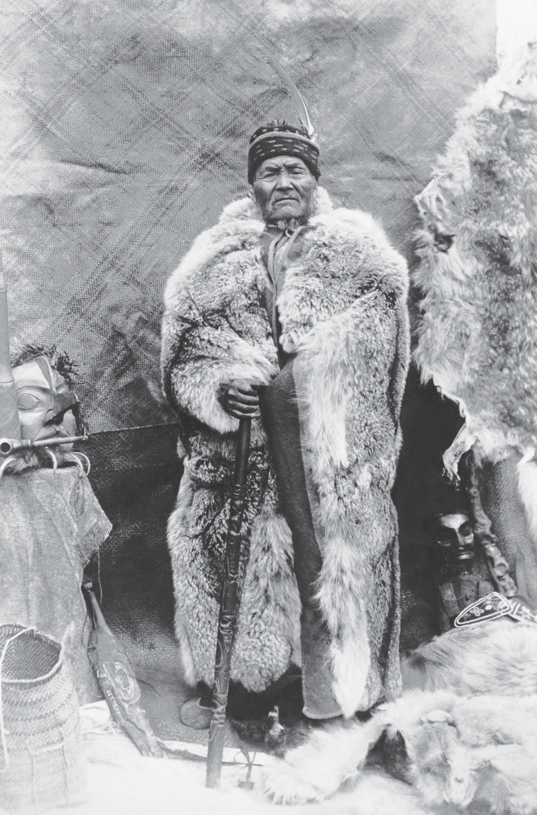
Potlatch Banned

Chief Israel Sgat’iin, also known as Chief Mountain, wearing a silver-tipped grizzly robe. He held hereditary rights to wear this rare fur. In the 1880s he was a leader in protesting reserves and once stopped government surveyors from entering Nisga’a lands.
Photo BCA HP-87678, courtesy of the Royal BC Museum and Archives

The sweeping law set out in the Indian Act of 1876 was not having the success that Indian Affairs officials thought it should. People were not choosing to enfranchise themselves, but were continuing their cultural practices, including their spiritual practices. Consequently, in 1884 the government attacked the central expression of Northwest Coast culture and banned the potlatch. An amendment was made to the Indian Act forbidding the potlatch and other customs involving dancing and singing. Banning the potlatch, which was central to the political, economic, social,
and spiritual life of many First Nations in British Columbia, was akin to some foreign power today banning all parliaments, libraries, banks, and churches.

Not all Euro-Canadians believed the potlatch should be banned, but the church and the state certainly did. All they could see were the external aspects of the potlatch, the giving away of great amounts of wealth, and the weeks of unproductive time involved. From the perspective of the capitalist work ethic, the whole affair was simply wasteful and, because they did not understand it, they could see no purpose to it.
Many communities simply ignored the law, while others, particularly those which had incorporated Christianity into their belief systems, continued to practise potlatches in other forms. Some called the get-togethers “dinners” but kept the overt potlatch practices to a minimum. In some communities organizations such as the Fireman’s Brigade or sports clubs brought people together for public sharing.
Indian Agents and missionaries, finding it impossible to enforce the potlatch ban, lobbied Indian Affairs to strengthen the law. This was done in 1895, when other cultural practices from other regions of the country were added. It effectively became illegal for a First Nations person to wear ceremonial articles or to dance in public.

State and Church Education
Original Documents
Section 3, The Indian Act
Every Indian or other person who engages in or assists in celebrating the Indian festival known as the “Potlatch” or in the Indian dance known as the “Tamanawas” is guilty of a misdemeanour, and shall be liable to imprisonment for a term of not more than six nor less than two months in any gaol or other place of confinement; and any Indian or other person who encourages, either directly or indirectly, an Indian or Indians to get up such a festival or dance, or to celebrate the same, or who shall assist in the celebration of same
is guilty of a like offense, and shall be liable to the same punishment.
One of the main tools of colonialism in British Columbia and throughout the world was the education system. The values and the language of the colonizing culture could be taught to the youngest generation through educational institutions. To make schools even more effective, the students were taken out of their home environment and isolated in a foreign environment.

In Canada, the education system for First Nations children was a partnership between the Department of Indian Affairs and the Christian churches. The missionaries shared the beliefs of government officials regarding First Nations people, and had operated their own schools since their arrival. In the words of Rev. Thomas Crosby, a Methodist missionary, “Our way to a heathen tribe was often through the school.”
Most reserve communities were aligned with one of the major Christian denominations, and children from the reserve went to schools operated by their local church, even though they might be a great distance away. Children from Methodist (later United Church) communities usually attended Coqualeetza at Sardis, near Chilliwack in the Fraser Valley. Some students from these communities also went to the United Church residential school in Port Alberni. Children from Anglican communities went to the residential school in Alert Bay or Lytton.
Catholics attended school at places such as Kuper Island near Chemainus and St. Mary’s at Mission.
Even though many students were eager to learn, these schools gave them little opportunity beyond the most basic academic and practical skills. They were only in class for half the school day; the other half they spent applying their practical skills to such tasks as cleaning and laundry. The students were required to work not only to maintain the institution, but also to produce the food they would eat. They spent time in the bakery, the dairy, or the garden. It is not surprising that many people who attended residential schools say they were like slaves, having to perform tasks that in any other situation would have been done by paid employees.
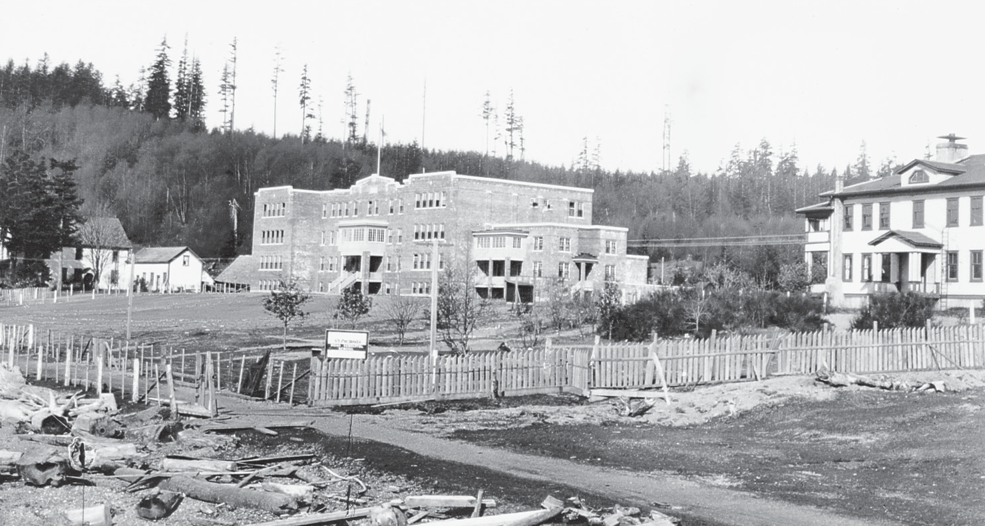
The Catholic, United, and Anglican churches ran 17 residential schools in B.C. This is St. Michael’s, the Anglican school in Alert Bay from 1929 to 1973.
Photo BCA H-04004, courtesy of the Royal BC Museum and Archives

One of the greatest wedges driven between the old and new ways was the enforced use of the English language. Students were not permitted to use their own languages at any time, and if they did, were often physically punished.
The state and the church knew very well that culture is transmitted by language, and by imposing the English language they could impose English culture. Not all First Nations children went to residential schools. Communities continued to have local schools called Indian Day Schools, which, at least until the 1950s, were run by local missionary teachers. By law, people with Indian status were not allowed to go to public schools until the Indian Act was revised to allow this in 1951.
In the end, residential schools did not accomplish what they and the Department of Indian Affairs had set out to do, that is, to assimilate First Nations people. They did, however, create extraordinary social problems for several generations of people who lost their language and their normal childhood. Some people had positive experiences at residential school, but for most, the loneliness, the regimentation, and the institutionalization left terrible memories. For many, the experience was much worse. Those who suffered physical, mental, or sexual abuse can only look back on residential schooling as a nightmare.

1911 Victoria Conference
One of the first attempts to organize all the First Nations in B.C. came in 1909 with the formation of a group called the Indian Tribes of the Province of British
Columbia. Around the same time, a number of ministers and other non-Aboriginal people formed the Committee of Friends of the Indians, with the goal of advancing the recognition of Aboriginal rights through public education and fundraising.
In March 1911, the Indian Tribes of B.C. held a conference in Victoria to discuss issues important to them and to meet with the premier of the day, Richard McBride. As they had been before, the clergy were accused not only of organizing the conference but also of inciting the First Nations people to militancy. “The entire course of the clerics,” wrote one paper, “is warmly criticised.”
At the opening of the conference, Rev. C.M. Tate, a minister and leader of the Committee of Friends, presented a draft of a petition for the group to sign. A young man jumped up. He spoke eloquently against signing Tate’s petition. The First Nations people needed to make their own statements, said Peter Kelly, the Haida representative from Skidegate. And when he spoke, the people listened.
Peter Kelly, only twenty-five years old, was educated both in the Haida community of Skidegate and at Coqualeetza Residential School in the Fraser Valley. He continued reading and studying on his own, until he understood constitutional

law and the matters relating to Aboriginal rights. When he was only eighteen, he became the teacher at the Skidegate school, and in 1910 was made the lay minister and teacher at the Tsimshian village of Hartley Bay.
At the Victoria Conference, he argued that instead of simply accepting Rev. Tate’s petition, the gathered leaders should discuss fully their intentions and their demands. He pointed out the folly of Section 13 of the Terms of Union which required Canada to continue the colonial policies with regard to land issues. But the colony had never established title to the land; it had only assumed it. It was this point, Kelly argued, that needed to be made to the premier. After three days of discussion, the leaders agreed, and appointed Peter Kelly to be their speaker.
On March 3, 1911, nearly one hundred chiefs and leaders from all parts of the province met Premier McBride. Chief Chiekleets of Douglas Lake headed the delegation. Peter Kelly read the unified statement of the chiefs, and spoke powerfully in favour of it. The premier, however, would not consider the question of Aboriginal title. He told the chiefs that he didn’t even know there was a problem until a few months earlier. “The question of title,” newspapers such as the Prince Rupert Empire reported him saying, “would never have been raised were it not for the pernicious activity of some white men who should have known better. If they had any legitimate grievances these should be presented to the Indian department at Ottawa, as they were the wards of the Dominion government.”5
The province had once again made its position clear. At the same time, other activities reflected the government’s policies in practice. Two days after the report of the Victoria Conference appeared in the Prince Rupert Empire, another article appeared, describing the anticipated arrival of five hundred men to mine and farm in the Nass valley. The headline unabashedly read, “To Exploit the Nass Valley.” One month after the Victoria Conference, Premier McBride purchased the reserve lands of the Songhees tribe on Victoria harbour. The headline read “Cold Cash for Songhees Indians.”
Similarly, in 1913, the Kitsilano people living on the shores of False Creek in Vancouver, after tremendous pressure, sold their reserve to the province. The deal, signed on a barge on the beach by the Attorney General of British Columbia, was highly questionable. The Indian Act was ignored, no surrender from Indian Affairs was obtained, nor did the federal government intervene on behalf of the Kitsilano people. In July 2000, after years of legal action, the Squamish Nation and Canada agreed on a settlement to compensate for the loss of these lands, which today include Vanier Park, roads to the Burrard Street Bridge, and a number of industries.

Summary
The division of powers at the time of Confederation was to have long-lasting repercussions on First Nations societies. The federal government assumed responsibility for First Nations people as wards of the government, while the province had control over crown lands. This, along with B.C.’s repeated refusal to recognize Aboriginal rights, has left the land claims issue in a stalemate since Confederation in 1871.
The Indian Act was passed in 1876, effectively taking control of many aspects of their lives away from First Nations individuals and communities. They were restricted to small fragments of their former territories by the establishment of
Indian reserves. They were banned from continuing important cultural practices such as the potlatch, and many of their children were taken away to residential schools where the continuity of family life and language learning were disrupted. The damage to families and communities has lasted for several generations, and First Nations are still in the process of healing from that devastation.
However, from the first, First Nations people resisted these discriminatory laws. They consistently maintained their right to Aboriginal title and sovereignty to the land of their ancestors. They always attempted to meet with political leaders on a nation-to-nation basis.
Ironically, Treaty 8 was signed with the First Nations of northeastern B.C., but due to unusual circumstances, the province was not a party to it. Until 1911, most resistance was undertaken by individual groups, but that year in Victoria, the
beginnings of a unified protest movement began when many First Nations gathered to present a petition to Premier Richard McBride. He resolutely rejected the notion of Aboriginal title.

Sources and Credits
- “Claims of the Allied Indian Tribes of British Columbia,” quoted in Appendix to the Journals of the Senate of Canada, Special Joint Committee of the Senate and House of Commons. Ottawa, 1927, pp.103–104.
- Dufferin quoted in Paul Tennant, Aboriginal Peoples and Politics: The Indian Land Question in British Columbia, 1849–1989. Vancouver: UBC Press, 1990, pp. 49–50
- Report on Conferences between the Provincial Government and Indian Delegates for Fort Simpson and Nass River, Victoria: Government Printer, 1887.
- The Empire (Prince Rupert), March 4, 1911.

