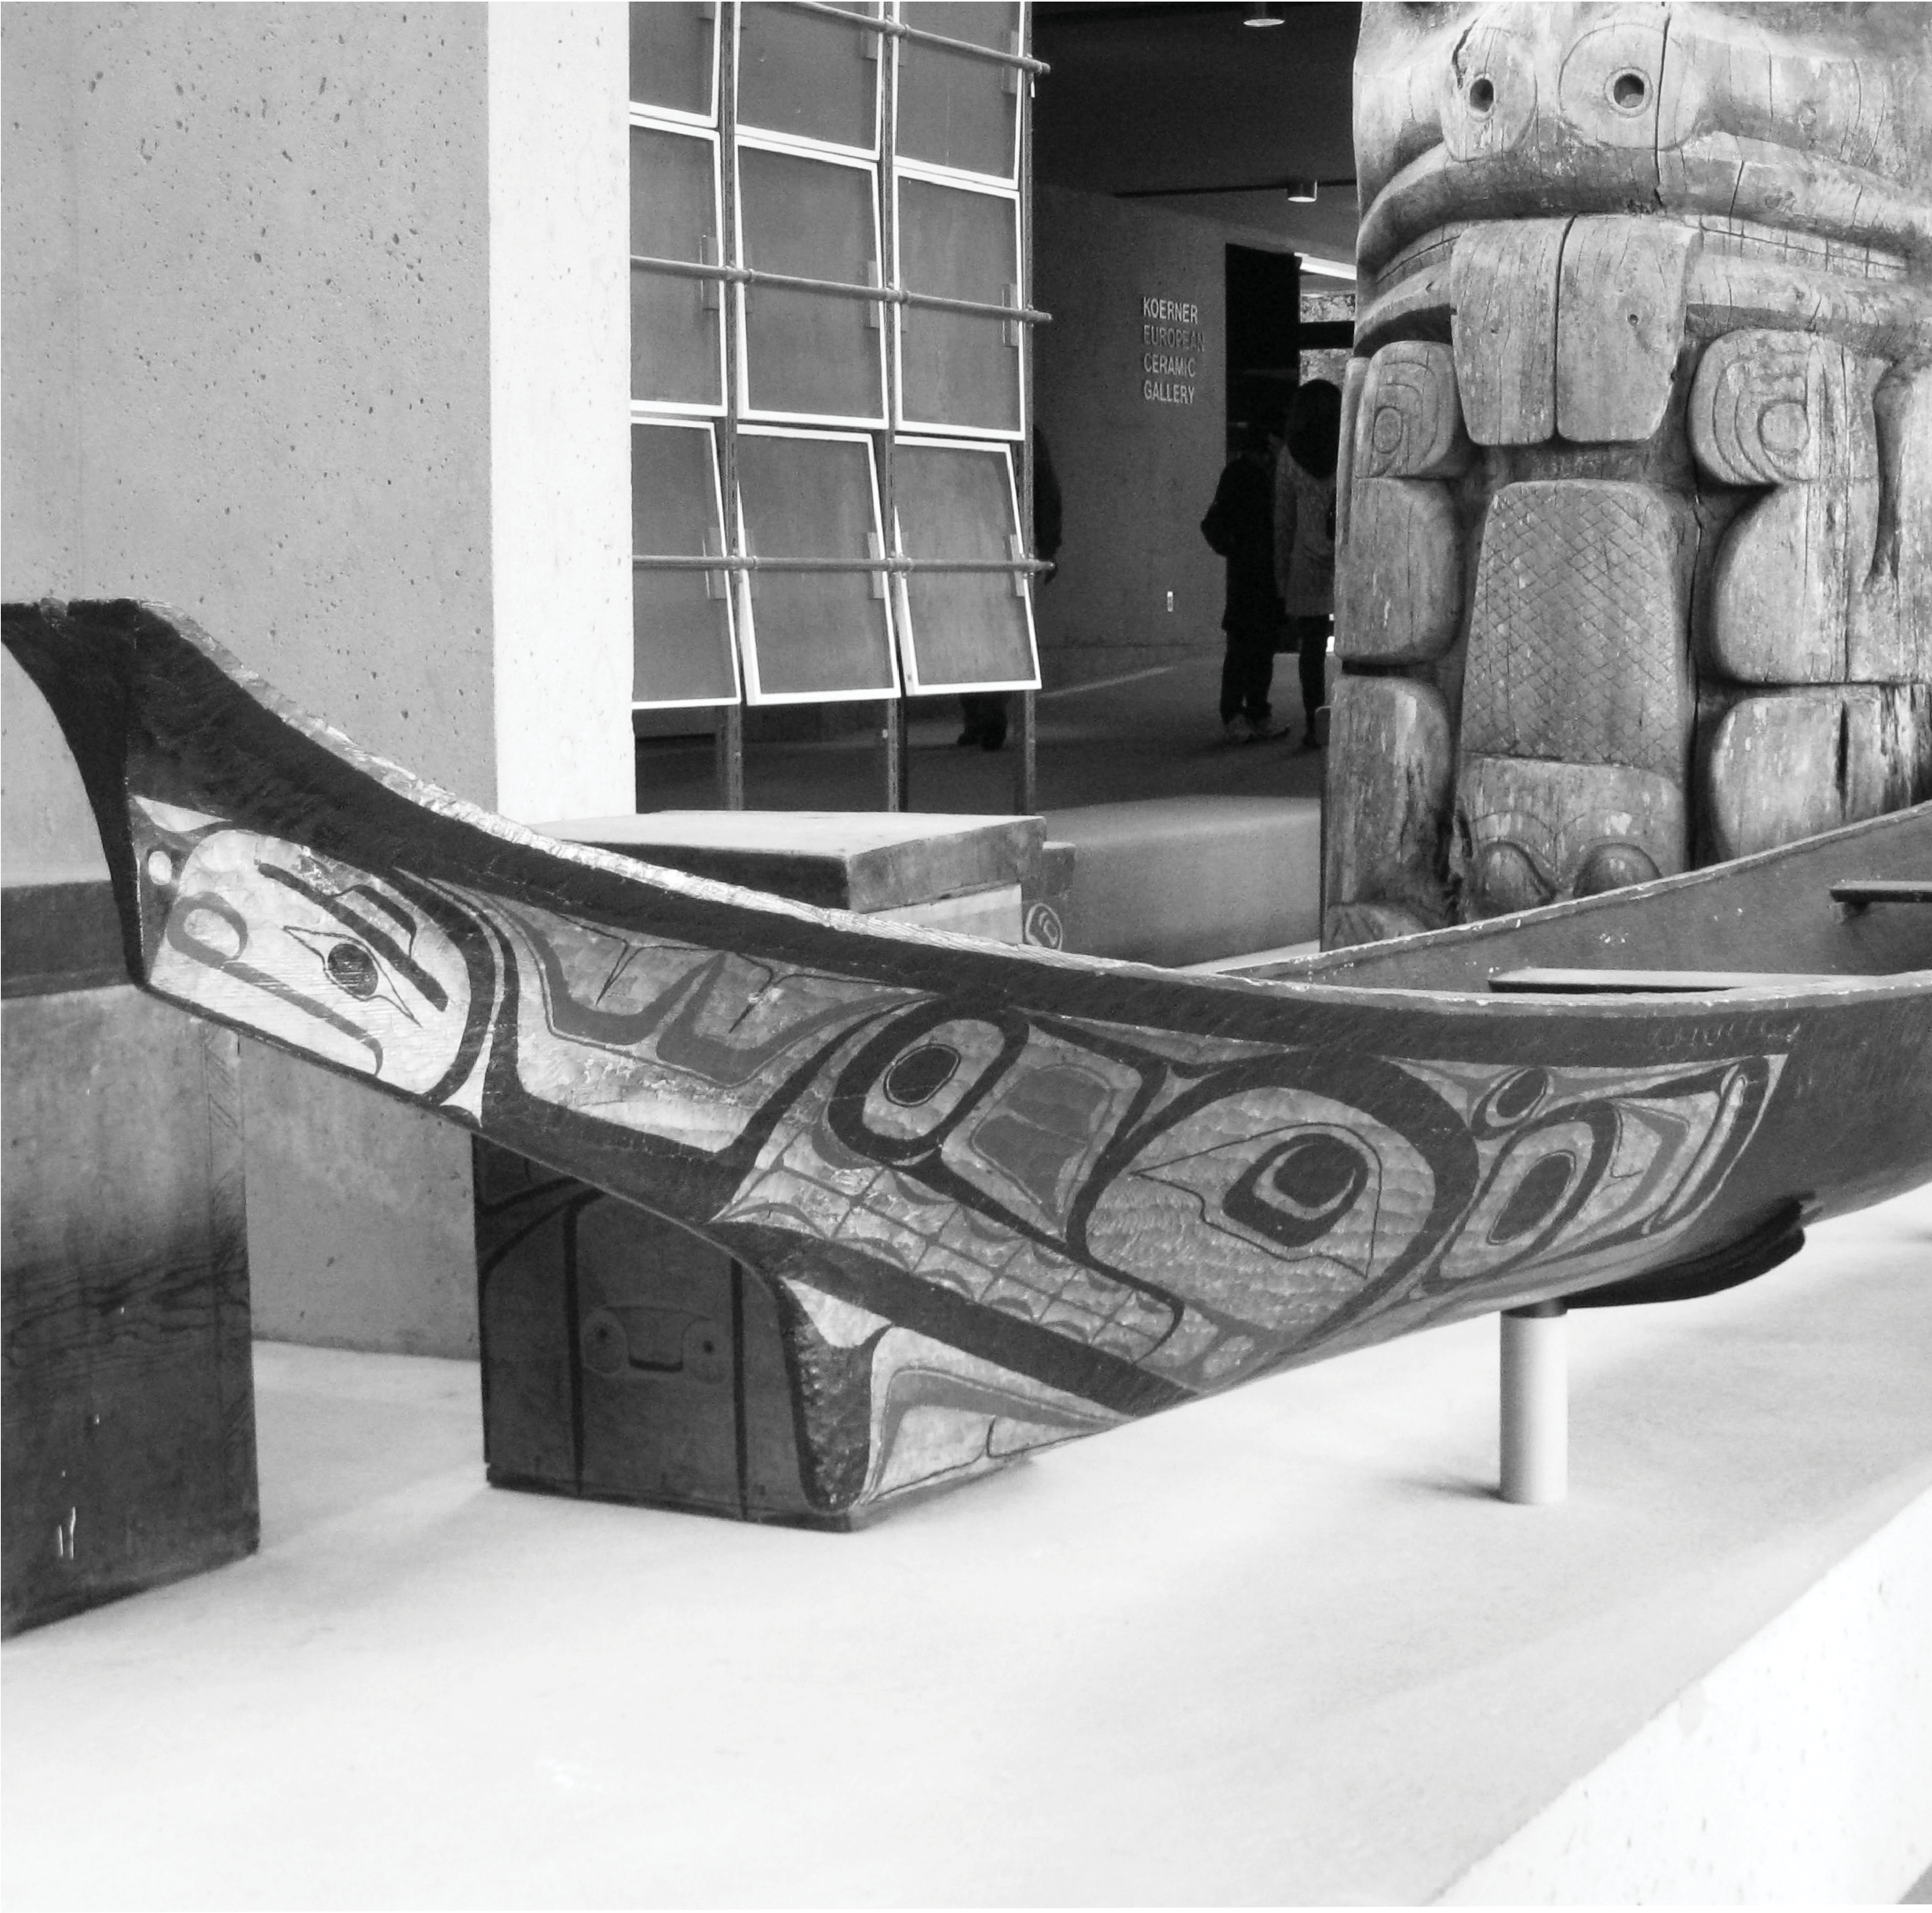

Great Bear Rainforest

Traditional Canoes for Traditional Reasons

Traditional Canoes for Traditional Reasons
We are now singing our traditional songs, which have been handed down to us through the generations. There are only a few songs that have survived, but there were enough to set a standard from which we can compose new songs, as our forefathers did. These new songs express who we are now. We now sing an old song called “Eagle Spirit.” The song is old, but we have created a new dance that expresses who we are today. The image and meaning of that dance are expressed through the red Eagle mask. The red symbolizes the love that we have for ourselves. It symbolizes the strength we are gaining as a people and the strength we need to reclaim our place in the world.
—Robert Davidson, speech delivered 7 July 1991, Massett, Haida Gwaii
In British Columbia, there are 23 distinct First Nations territories. Although there are similarities between the territories, each culture is also distinct from any other. There is a great deal of diversity between tribes within nations, and even between families within those tribes. This means that there were many traditional ways for First Nations people to survive in particular environments and societies, and many of those traditions continue to this day.
Traditional activities include:
- accumulating wealth
- contributing to the community
- feast-giving
- fishing
- gathering and preserving food
- gift-giving
- hunting
- performing a dance
- putting on a dramatic production
- self-conduct
- singing
- undergoing initiation rites
Culture includes all of those activities and beliefs practised by a specific group of people, which are systematically taught to subsequent generations. Traditional cultural activities were conducted for traditional reasons. Some of the approaches to these activities have changed over time, but the reasons for continuing the practices remain the same: the preservation of traditional First Nations knowledge and teachings.

In this resource, you will consider one aspect of traditional First Nations culture— that of transportation. One of the most common means of transportation in British Columbia was the canoe. You will first look at traditional approaches to canoe use, and will examine the reasons for these different approaches. There are two main types of canoes: bark canoes and dugout canoes.
Dugout Canoes
First Nations people of the Thompson area travelled in dugout cedar canoes that were made by the Lower Thompson First Nations, and traded upriver. Further upriver, bark canoes were sometimes made.
The Shuswap used bark canoes or cottonwood dugouts. Dugouts became more widely used with the availability of iron tools in the 1800s. Bark canoes were made of spruce bark or white pine bark. Smaller canoes were made of birch bark.
Dugout canoes were made of red cedar, cottonwood, or Sitka spruce. Canoes were the main means of transportation on the west coast of British
Columbia. It was easier for people to travel by water because the land was ridged with mountains and valleys; the main village sites of the Kwakwaka’wakw, the Nuu- chah-nulth, and the Coast Salish on Vancouver Island were located either on the ocean or on a river.
The Haida people would travel by canoe from their home territory, Haida Gwaii, also known as the Queen Charlotte Islands, to the southern coast of British Columbia—a round trip of more than 1600 kilometres. Different types of canoes were made for different purposes. Canoes were used for:
- children’s use
- fishing and hunting
- racing
- sealing
- trade
- transportation of people or freight
- war
- whaling
Freight canoes, also known as “moving canoes,” were used to move household goods and the housing planks for west coast houses. A marriage canoe was made by laying planks across two canoes to make a floating stage. The style of fishing, hunting, and transportation canoes would vary depending on whether they were used for ocean travel or river travel. Some canoes were designed to carry only one person, whereas others were designed to carry two people; some larger canoes carried many people.

The Four Basic Dugout Canoe Types
Hilary Stewart, who has studied west coast First Nations peoples and culture, notes that there are four identifiable basic canoe types: the river canoe, the Coast Salish canoe, the west coast canoe, and the northern canoe.

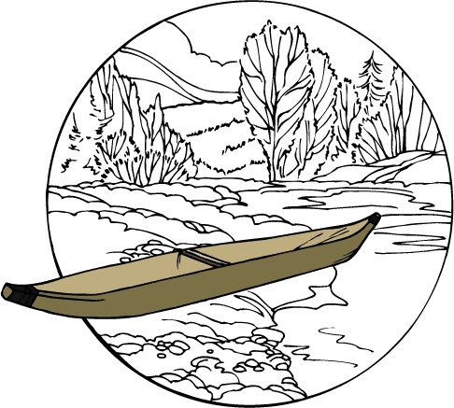
River Canoe

The river canoe is flat in the middle and at both ends. It is shallower than ocean-going canoes and has a rounded bottom.

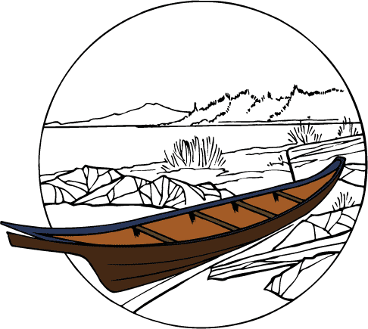
Coast Salish Canoe

The Coast Salish canoe has a bow that slopes more gently than the northern canoe, and it has a rounded bottom. The gunwales end in a concave flare.

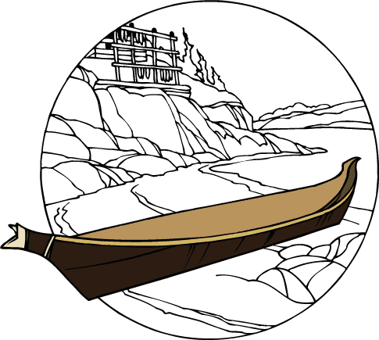
West Coast Canoe
The west coast canoe has a relatively flat bottom and a vertical stern. The flat gunwales sweep up at the bow, and a stylized bow piece that looks like a wolf head is added. The stern is also added separately. Nuu- chah-nulth canoes were a traditional trade item. A Nu-chah-nulth canoe might be traded to the Makah, the most southern Nuu-chah-nulth group in Washington State, and then to the Lower Chinook peoples.
Historically, canoes were made of whatever material was available. In addition, people with specific tools and specific training were needed to successfully build canoes. Canoes were also made for specific needs that included fishing, whaling, sealing, travelling, and for children to play in so that they could learn at the same time. On the West Coast, the whale hunt with its large canoes became a common theme in art, in story, in song, and in names. Images of whalers in a canoe hunting a whale are distinctive and whaling was a defining West Coast activity involving rituals, roles and rank in the preparation, the hunt, the whale’s arrival at the village, and the butchering and distribution of the whale meat.

Northern Canoe

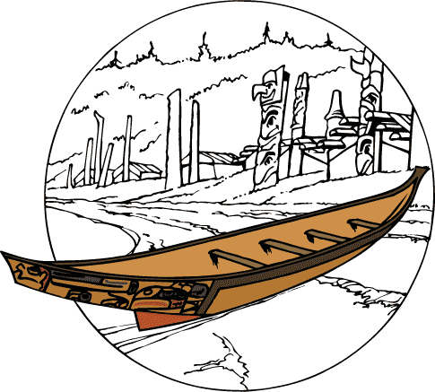

The northern canoe is large with a high prow and vertical cutwater—it has a sharp front, so it can cut through big waves. The sides are flared, and the bottom is rounded.
On the West Coast, canoes were made of cedar. Bill Reid, a renowned Haida artist, has described cedar as the ideal gift to the people of the West Coast from the Creator: it provided clothing, housing, household materials, fuel, and
transportation. The main body of the West Coast canoe was made from one log. Depending on its purpose and type, the canoe ranged in size from 5.5 metres to an impressive 17.1 metres.

Renewal of Traditional Activity
Today, canoes have been replaced with speedboats, fishing boats, cars, buses, and ferries. These modern modes of transportation have become more viable and more convenient. Canoes are still being made, but in different ways and for different purposes. For example, Bill Reid made a 15-metre Haida war canoe for Expo 86, the 1986 World Fair in Vancouver. He then made a fibreglass re-creation of the canoe for the Canadian Museum of Civilization; using fiberglass allowed the canoe to withstand fluctuations in climactic conditions. The purpose of this canoe was not transportation but to serve as a symbol of northwest coast culture.

The monumental bronze sculpture of a canoe carrying 13 figures, called The Spirit of Haida Gwaii, is another symbol of northwest coast culture created by Bill Reid. The sculpture, cast in 1991, is now housed in the lobby of the Canadian Embassy in Washington, D.C., U.S.A. The sculpture weighs almost 5000 kilograms and is considered Bill Reid’s master work. The Embassy’s architect had invited Bill Reid to create a dynamic piece of art to balance the building’s classic style.
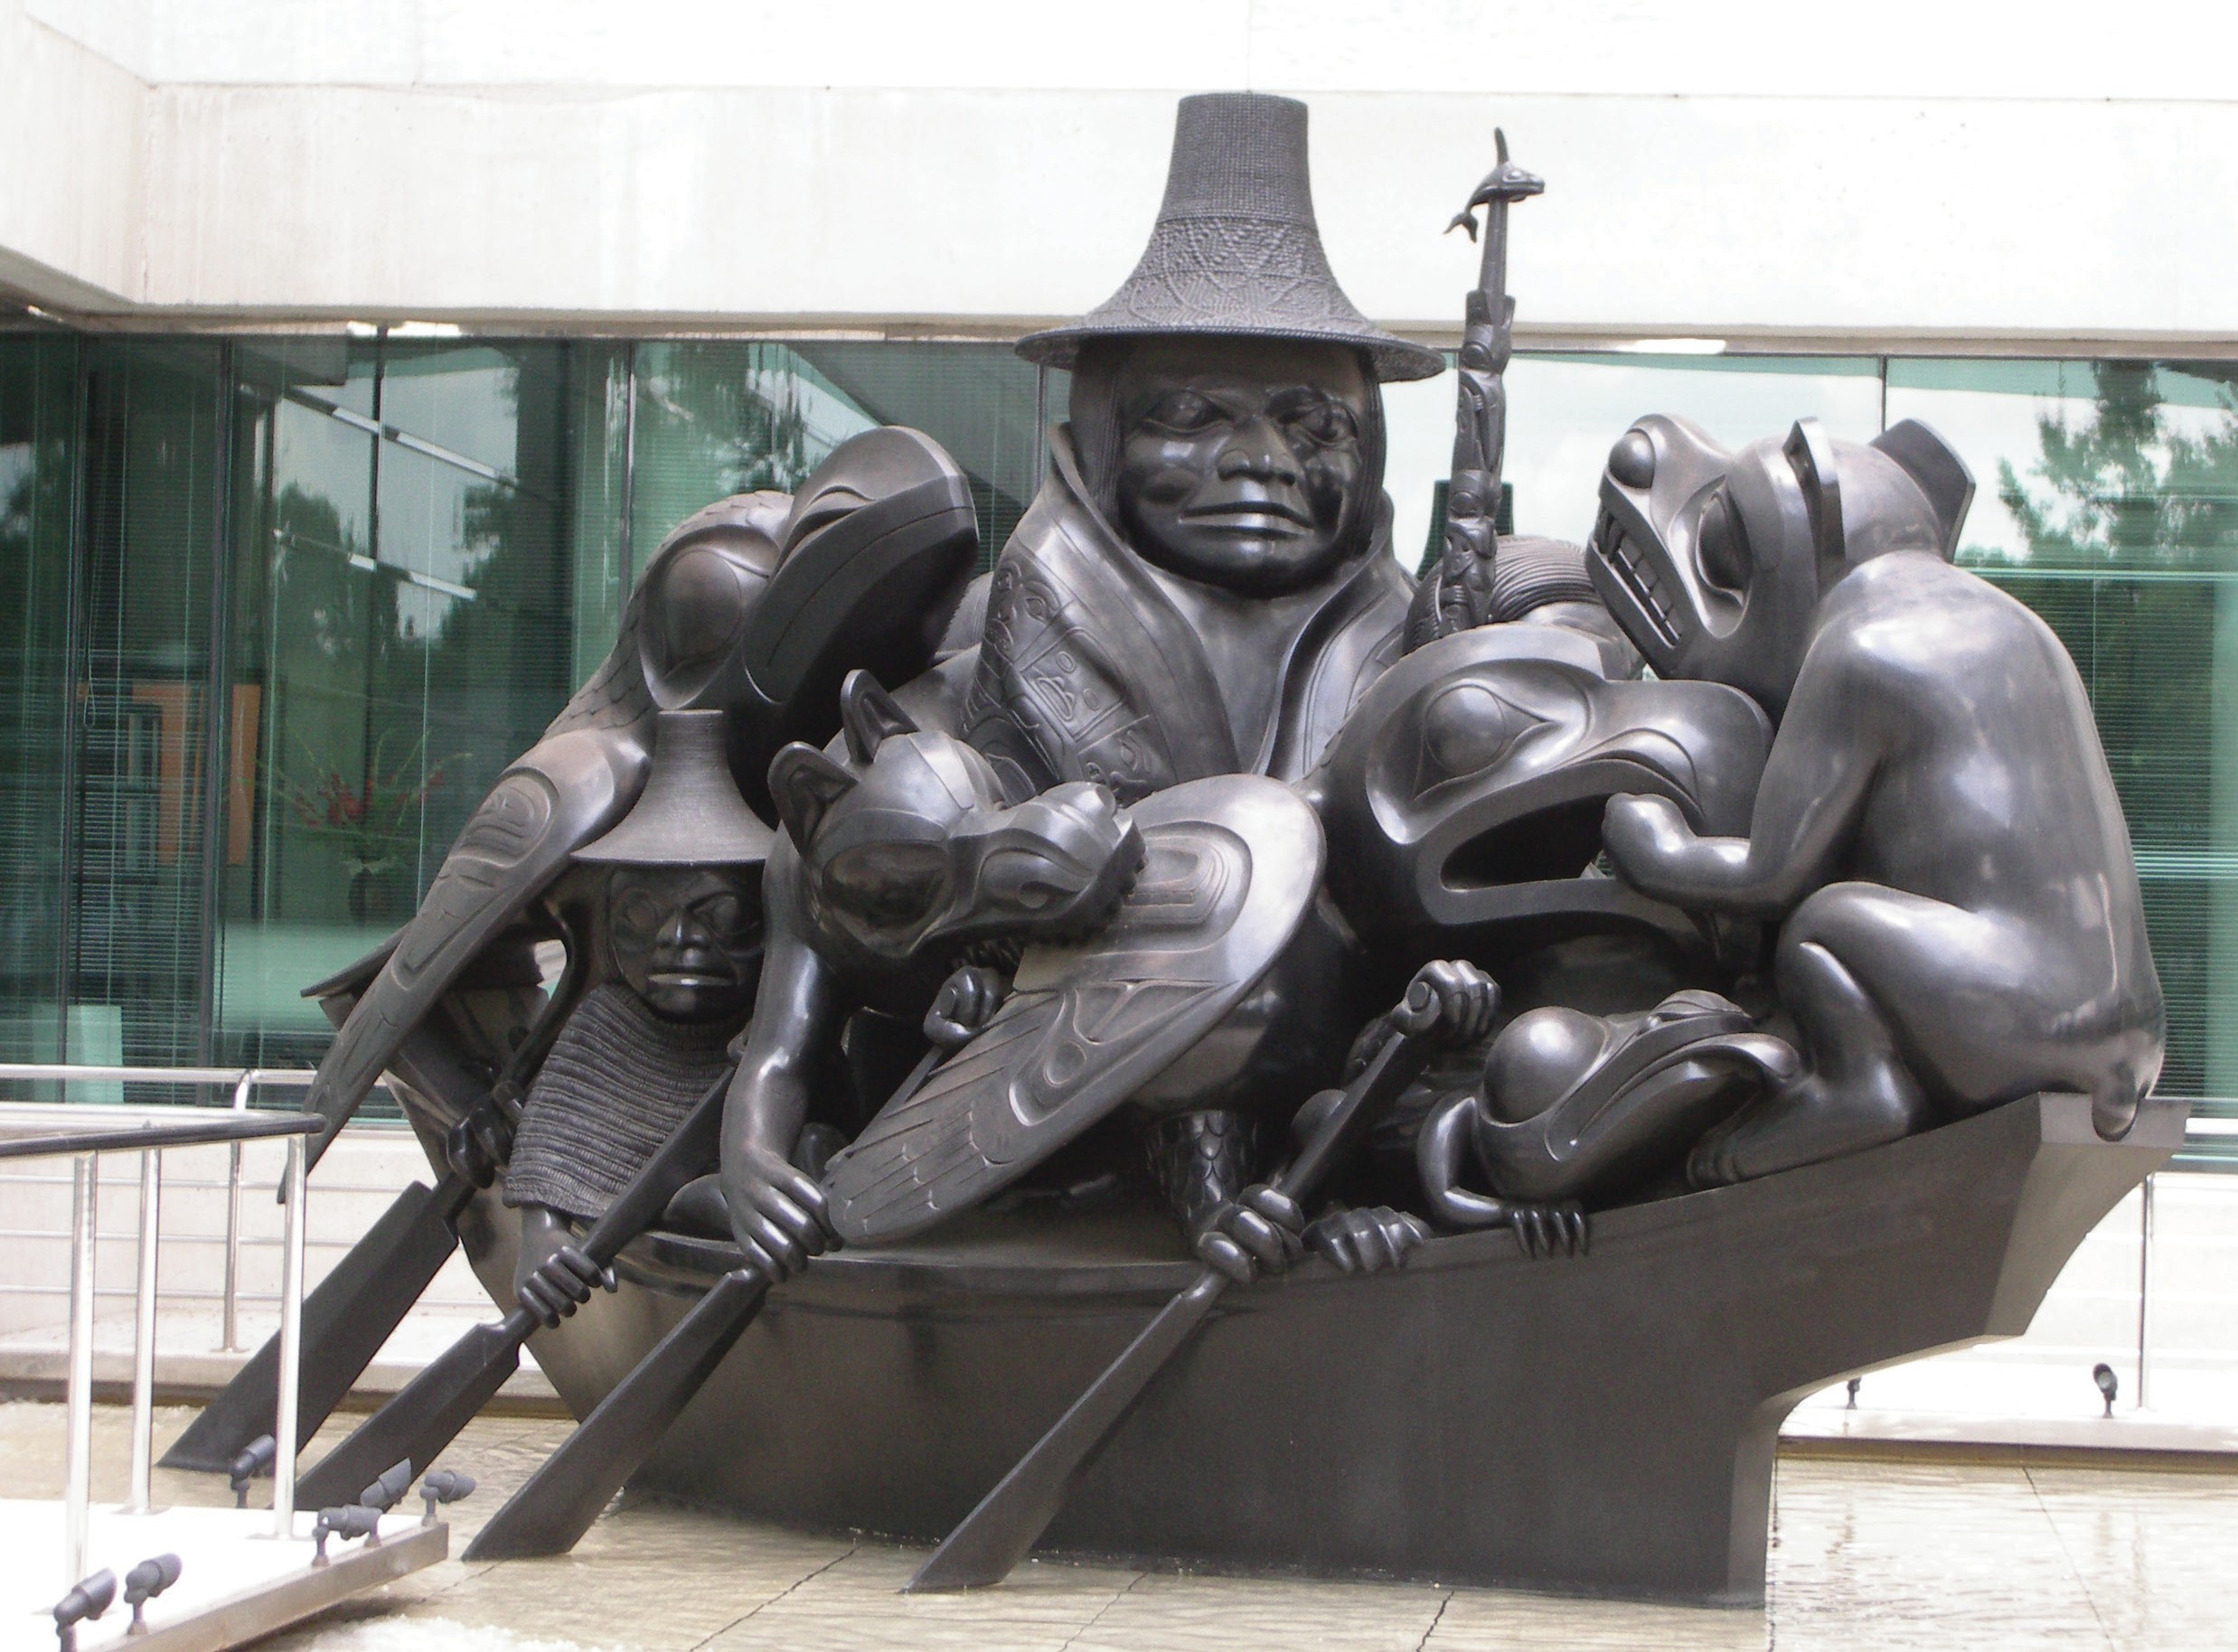

“The Spirit of Haida Gwaii” by Bill Reid. Image in the public domain
Canoes of cedar are still made and used for a variety of reasons. One particular use of canoes today is to reconnect First Nations people with their culture as a healing experience. Canoe making may have skipped a generation, but there are still First Nations people making canoes on the West Coast. Even before the modern revival of the canoe tradition, there were canoe makers in communities up and down the coast of British Columbia. When British Columbia hosted the world’s fair Expo ‘86 in Vancouver, the province wanted to showcase First Nations peoples and cultures. One of many events honouring this theme included a canoe sea voyage by a crew of Heiltsuk people who paddled from their home of Bella Bella to Vancouver. The journey was hundreds of kilometres and was conducted under the leadership of

Frank Brown, a Heiltsuk community member. Three years later, the Heiltsuk took up another challenge—to paddle to Seattle, Washington along with five other ocean- going nations, to join in celebration of Washington State’s 100th anniversary. At this event, Frank Brown invited all canoe nations to gather in Bella Bella in 1993. These nations joined together with other First Nations communities that built their first canoe in 100 years. Heiltsuk hosted 23 canoes in their community.
The Heiltuk’s canoe trip to Expo 86, the Paddle to Seattle event in 1989 and the Heiltsuk’s Quatuwas-People Gathering Together event have resulted in the annual event known as Tribal Journeys or Canoe Journeys, held during the summer months.
One community hosts the event and paddlers from other communities make the canoe journey to the location of the host. The host community welcomes approximately 5000 visitors and guests for about five days during the event. The
visitors take turns sharing traditional songs and dances. Tribal Journeys has been a deeply meaningful experience for those who participate, both young and old.
Another annual canoe event is called Pulling Together, in which people from law enforcement and Aboriginal communities join together for a canoe journey. The RCMP have taken part in this event since 1997. The purpose of this canoe journey is to build positive relationships between law enforcement officers and Aboriginal communities. First Nations youth, Elders, and law enforcement personnel paddle together and learn together.

Profile of Frank Brown
As a youth, Frank Brown got into trouble with the law. His aunt stepped in and recommended to the court that the community be allowed to employ a traditional First Nations consequence for the young man’s actions. Brown was banished from the community and was left alone on an isolated island for eight months. This was a life-changing experience for Brown. He has since become a cultural leader and a visionary within his community, spearheading the traditional canoe-making revival on the west coast of British Columbia.
The following is a list of some of his many achievements:

1986 | Undertook leadership of the canoe journey to Expo 86.
1989 | Conducted the Paddle to Seattle canoe trip, extended an invitation to canoe nations to gather in Bella Bella.
1990s | Founded Bella Bella Rediscovery program.
1993 | Helped his community to host the Qatuwas canoe festival
1994 | Paddled to Victoria’s Inner Harbour as part of the Commonwealth Games celebration.
1997 | Paddled to Victoria’s Inner Harbour as part of the North American Indigenous Games; was associate producer of award-winning video Qatuwas.
1998 | Canoe journey to Ahousaht.
1999 | - Frank’s business, SeeQuest Adventures, was selected as  a “Best Case” example of sustainable tourism by Simon Fraser University’s Tourism Policy and Research Centre.  - Nominated by the national media as one of the top 40 Canadians under 40 years of age.  - Received an award from the B.C. Ministry of Small Business, Tourism and Culture and Heritage B.C. for his work in traditional canoe resurgence.
Frank Brown married, and he and his wife Kathy have three daughters and a son. Frank has continued to participate in canoe traditions and gatherings annually since 1997. These annual gatherings are hosted alternately between Washington State and British Columbia. These canoe journeys have become a forum for healing, hope, happiness, honour, and hospitality.

The Canoe in Changing Times
The Heiltsuk made a canoe in 1986 for different reasons than canoes were made traditionally. The canoe is no longer necessary as a mode of transportation. To get to Vancouver these days, the Heiltsuk are more likely to travel by car and ferry, or to fly. The motivation behind making the canoe had to do with cultural revitalization and showing pride in their heritage as Heiltsuk people. The canoe
was built to revitalize traditional teachings, to re-teach protocol when visiting other communities, and to practice intergenerational teaching. The process empowered the current generation with teachings from past generations. There are people still living who remember when canoes were the traditional method of travelling, and who can recall the traditions of making canoes. They shared some of these memories with David Neel, who wrote the book, Canoe Journeys.

