In this activity, students explore a species from the Great Bear Rainforest and assess the impact of human activity on its ecology.

Great Bear Rainforest Activity Plan

In what ways (economically, socially, politically, environmentally) has the Great Bear Rainforest been affected by human activity?

Learning Objectives
Students will:
- Identify the ecological impacts of imperialism
- Understand the spectrum of threats to species from ecological imperialism
- Understand the cause and consequences of ecological imperialism
- Compare and contrast the various motivations of different groups during the time of imperialism (continuity and change)

Preparing for the Activity Plan
- This activity will require four 60 minute classes.
- Read the background information and preview the videos and websites.
- You might want to read “Aboriginal Peoples and Settlers,” Part 1 of An Environmental History of Canada by MacDowell (19 pages total).

Materials
- whiteboard
- computer and projector
- student computer / tablet / devices
- access to the Internet
- poster paper and markers
- coloured pencils, pen, pencils
- Blackline Master 1: Ecology
- Blackline Master 2: Ecological Footprint

Background Information and Resources

Videos:

Spirit Bears: A filmmaking family visits the home of rare white black bears
https://www.youtube.com/watch?v=iNnKi7u8hbY&t=2351s

Articles and Books
“Aboriginal Peoples and Settlers.” Part I of An Environmental History of Canada By Laurel Sefton MacDowell (19 pages total): Sample material provided by UBC Press https://www.ubcpress.ca/asset/9296/1/9780774821018.pdf

Ecological Imperialism
https://www.oxfordreference.com/view/10.1093/oi/authority.20110803095741676

The Columbian Exchange: A History of Disease, Food, and Ideas
https://web.viu.ca/davies/H131/ColumbianExchange.pdf

Informational Websites

Tackling Threats that Impact the Earth
https://www.worldwildlife.org/threats

Videos: Hakai Institute
https://www.hakai.org/video/

Biodiversity of the Central Coast
https://www.centralcoastbiodiversity.org

Other Resources

Central Coast Biodiversity app
See the links on the following page for download information. https://www.centralcoastbiodiversity.org

MaPP Marine Planning Portal
Marine Planning Partnership for the North Pacific Coast https://www.seasketch.org/#projecthomepage/50e58ab28aba4075183f8fc0

What is Your Ecological Footprint?
https://www.footprintcalculator.org/

Delivering the Activity Plan

Access Prior Knowledge
- On the board, write or display the term “ecology.” Hand out Blackline Master 1: Ecology.
- Have students follow a Think, Pair, and Share procedure as follows:
» Working individually, have individual students define “ecology” in their own words on the blackline master.
» Then, have students pair up to share their definitions and together come up with a definition of “ecology.”
» As a class, have each pair share their definitions and examples while you write them on the board.
» Together, generate a class definition of the term “ecology.”
- Students will need to gain an understanding of the ecology of the Great Bear Rainforest. As a hook to this activity plan, have the class watch the video Spirit Bears: A filmmaking family visits the home of rare white black bears.

Inquire
- As a class, discuss the question, “What is an ecological footprint?”. Come to a consensus definition.
- Review thinking critically in Social Studies using the ESPN model. See the Activity Plan “How can we best understand the multiple economic, social, political, environmental (ESPN) perspectives within the GBR?” for more information on the ESPN framework.
- Extend the discussion and brainstorm as a class on the board: What are some examples of threats faced by the spirit bear in the GBR that we saw in the CBC documentary Spirit Bears?
- Work together as a class to answer the question: In what ways (economically, socially, politically, environmentally) has human activity left ecological footprints in the Great Bear Rainforest?
- For Grades 11/12 students, you should extend the inquiry to a discussion of the term “ecological imperialism,” and provide examples of it in Canada’s history of contact and colonization, such as:
» decreases in the beaver population due to the fur trade, and
» decreases in the buffalo population due to unsustainable hunting practices.

Experience
- As a class, experience the biodiversity of coastal BC in three to four videos featuring different animal species, selected by the teacher from the Videos page of the Hakai Institute at Videos: Hakai Institute.
- Give students 10–15 minutes to browse on their own and experience the biodiversity of the Great Bear Rainforest via the Biodiversity of the Central Coast website or by downloading the app.
- Alternatively, assign students in work in groups and research a specific category of life in the Great Bear Rainforest; e.g., marine life, mammals, birds, plants, or trees.
- Have students choose a species that they’re interested in, and then research its significance in the Great Bear Rainforest. Have students explain their findings on a poster that they share with the class.

Explore
- Distribute Blackline Master 2: Ecological Footprint. Inform students that they will now conduct a further exploration of the ecology of their chosen species and determine how its environment is impacted by human activity.
- Direct students to explore the ecological environment of their chosen species ecological environment using the interactive map on the MaPP Marine Planning Portal.
- To see the ecological environment of the species they chose on the map, students should check off the category of their species under “MARINE ENVIRONMENT.”
- On the map on Blackline Master 2, students should colour in the ecological environment of their chosen species in one colour.
- Now, direct the students to explore how their chosen species’ environment is impacted by human activity by checking off relevant activities under “USES AND ACTIVITIES.”
- Remind the students to critically consider which types of human activities listed under “USES AND ACTIVITIES” could impact their chosen species. Encourage students to access prior knowledge of the ESPN of Social Studies.
- On the map on Blackline Master 2, students should now colour in the areas of human activity of their chosen species in another colour and indicate the use(s).

Reflect and Connect
- Have students examine their coloured maps and consider the overlap between their chosen species’ ecology with the area of human use/activity.
- Have students pair up again to share and compare their research.
- Ask students to consider the question, “How are humans impacting their chosen species in the Great Bear Rainforest region?”

Assess
- Have students fill out the graphic organizer on Blackline Master 2 to reflect on the question, “In what ways (economically, socially, politically, environmentally) has human activity left footprints in the ecology of your chosen species?”.

Go Beyond
- Have students complete the calculator at What is Your Ecological Footprint? and reflect on their results in a journal entry.
- Have Grades 11/12 students use their completed Blackline Master 2: Ecological Footprint as an outline, and compose an essay on the effects of ecological imperialism on their chosen species in the Great Bear Rainforest.

Blackline Master 1
Ecology

Define “ecology”
Define “ecological footprint”
Spectrum of threats faced by the spirit bear in Great Bear Rainforest
Human Impact on the Great Bear Rainforest
Consider: In what ways (economically, socially, politically, environmentally) has human activity left footprints in this ecology?

ECONOMIC IMPACT | SOCIAL IMPACT
POLITICAL IMPACT | ENVIRONMENTAL IMPACT

Blackline Master 2

Ecological Footprint

Chosen Species:

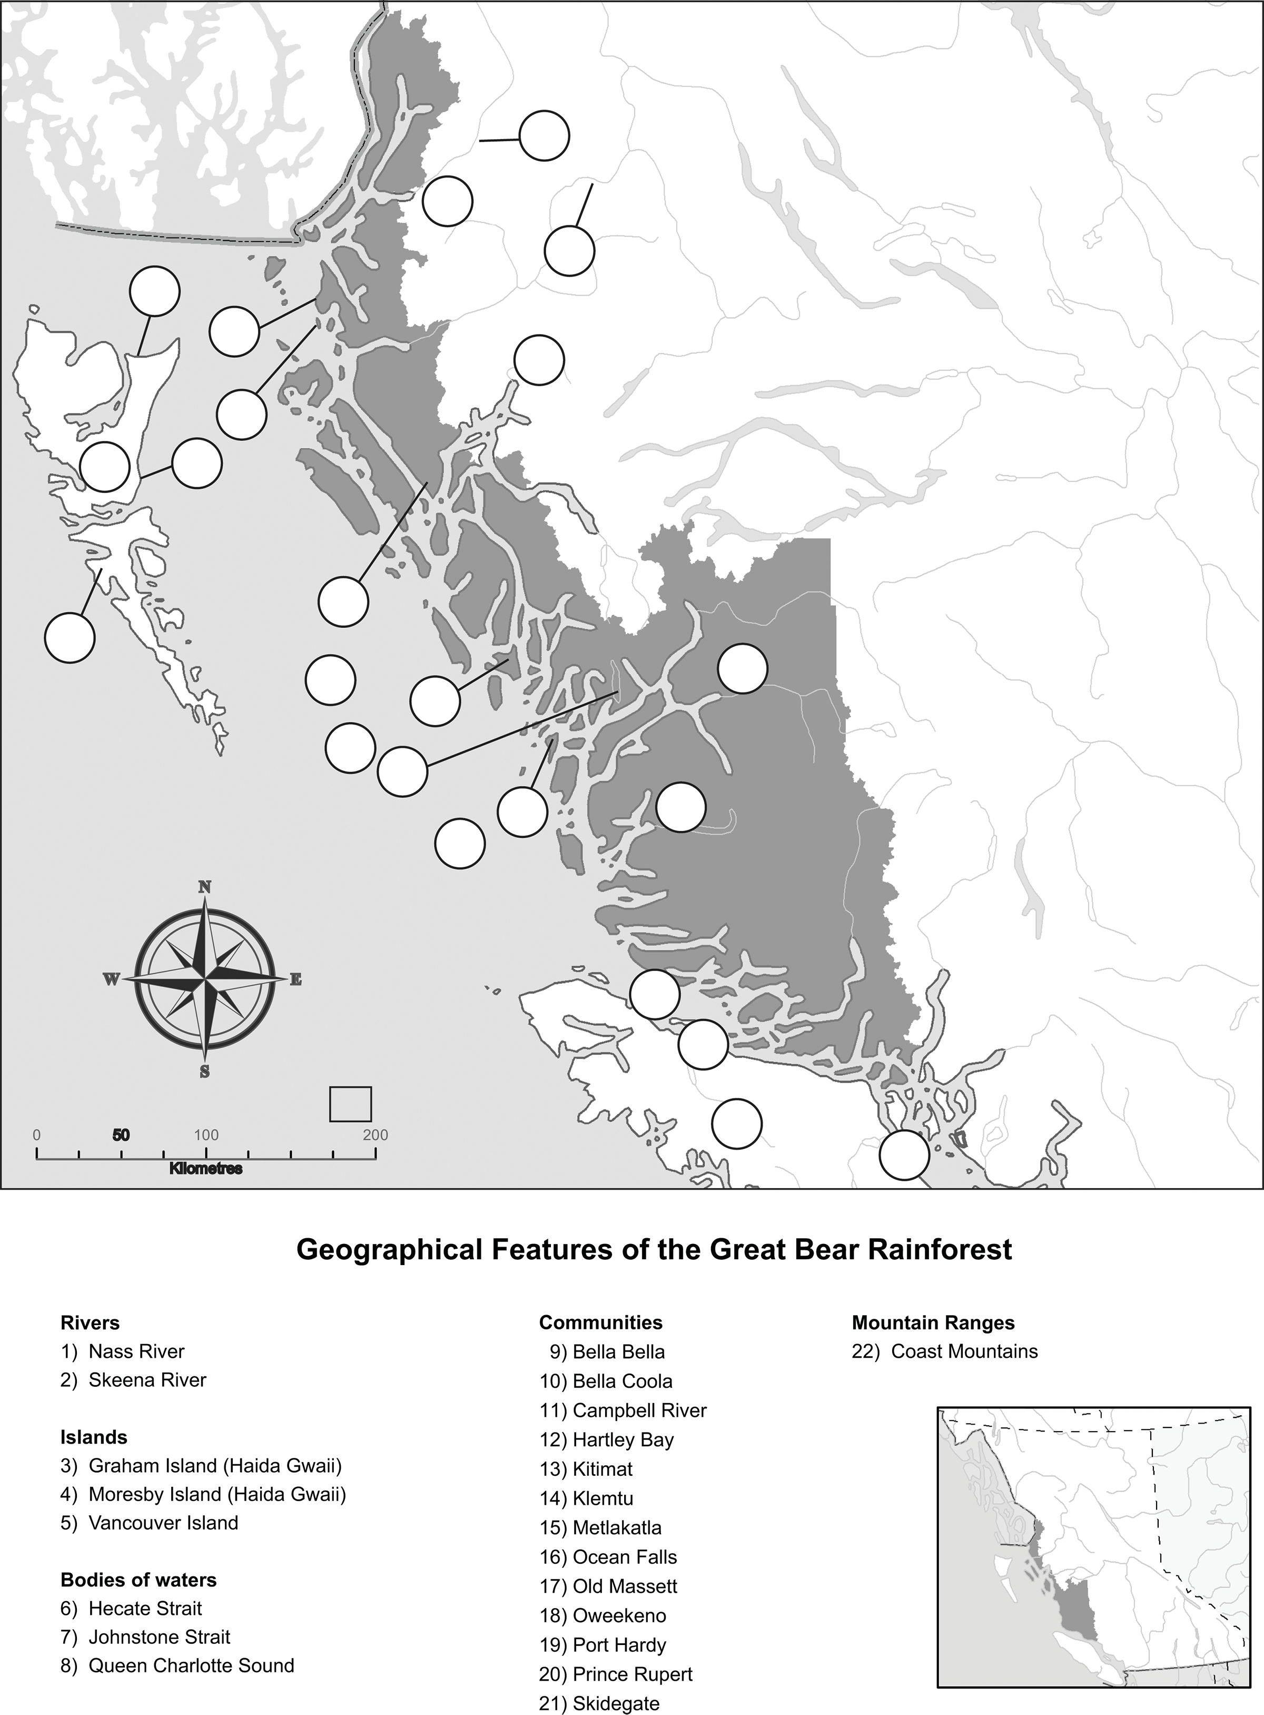

Consider: In what ways (economically, socially, politically, environmentally) has human activity left footprints in the ecology of your chosen species?

ECONOMIC IMPACT | SOCIAL IMPACT
POLITICAL IMPACT | ENVIRONMENTAL IMPACT

This work is licensed under a Creative Commons Attribution-NonCommercial-ShareAlike 4.0 International License unless otherwise indicated.

