Great Bear Rainforest Activity Plan

In what ways does location affect diversity of plant/algae species?

In this activity, students will survey the plants in their local area and then compare the diversity of the plants they find to diversity of plants in the Great Bear Rainforest. They will have the opportunity to experience their local environment and use technology to compare their local species to those of the Great Bear Rainforest.

Learning Objectives
Students will:
- Make observations aimed at identifying their own questions, including increasingly abstract ones, about the natural world
- Collaboratively and individually plan, select, and use appropriate investigation methods, including field work and lab experiments, to collect reliable data (qualitative and quantitative)
- Experience and interpret the local environment
- Cooperatively design projects with local and/or global connections and applications
- Learn about First Peoples knowledge and other traditional ecological knowledge related to sustaining biodiversity and ethnobotany
- Understand taxonomic principles for classifying organisms
- Understand the use of binomial nomenclature
- See how complex roles and relationships contribute to diversity of ecosystems
- Understand the levels of biotic diversity

Preparing for the Activity Plan
- Watch the videos and explore the websites listed below. Find a suitable area in your local community for students’ field research.

Materials
- computer and projector
- student computers / tablets/ devices
- access to the Internet
- tape or stakes and string to mark out plots
- Blackline Master 1: Diversity of Species
- Blackline Master 2: Assessment

Background Information and Resources

Videos

1000s of Bugs, 100 Islands, 1 Happy Entomologist (6:08)
This video shows entomologist Chris Ernst at work trying to catalogue all of the insects living around the Central Coast of British Columbia. https://www.youtube.com/watch?v=GV0xfPtW8BU&

Andy MacKinnon Presents Plants of the Bog (4:38)
This video explores plant life found in the Great Bear Rainforest, which includes century- old stunted shore pines, spongy mosses, and interesting plants with fragrant leaves and sticky stems.
https://www.youtube.com/watch?v=kzbhVhXul3E&

Lichens: Corals of the Forest (3:10)
This video discusses unique plants present in the Great Bear Rainforest, including devil’s matchstick, frog pelt, lungwort, and fairy barf. https://www.youtube.com/watch?v=21Pv1qkFk58&

What If We Could See Nature in Infrared (10:25)
This video uses infrared light to explain why trees and other plants are green. https://www.youtube.com/watch?v=srzniA8EKDk&

Articles

Biodiversity of the Central Coast
This website provides an interactive field guide that can help to identify the species of the many plants and animals found in the Great Bear Rainforest. https://www.centralcoastbiodiversity.org/

British Columbia plant Species Codes Version 10
This website provides a list of species found in British Columbia and identifies whether they are native or exotic species.
https://www.for.gov.bc.ca/hre/becweb/resources/codes-standards/standards-species.html

iNaturalist
iNaturalist is an online social network of people sharing biodiversity information to help each other learn about nature. Students must sign up for a free account. https://www.inaturalist.org/

eBird
eBird is an online database of bird observations providing scientists, researchers, and amateur naturalists with real-time data about bird distribution and abundance. Students must register for a free account to use this website.
https://ebird.org/home

Ethnobotany
In this learning experience, students practice ethnobotany. They choose a native plant to study, explore its traditional uses and inquire into ways in which the plant may be restored. Students may also explore sustainable practices that could ensure the plants continued use in the future.
https://curriculum.gov.bc.ca/instructional-samples/ethnobotany/

Delivering the Activity Plan

Access Prior Knowledge

Introduction to Stewardship
- Display two images for students: one of a bird’s eye view of your area, and a second bird’s eye view of the Great Bear Rainforest (examples are provided below).

Example: Bird’s eye view of Great Bear Rainforest (earth.google.com)
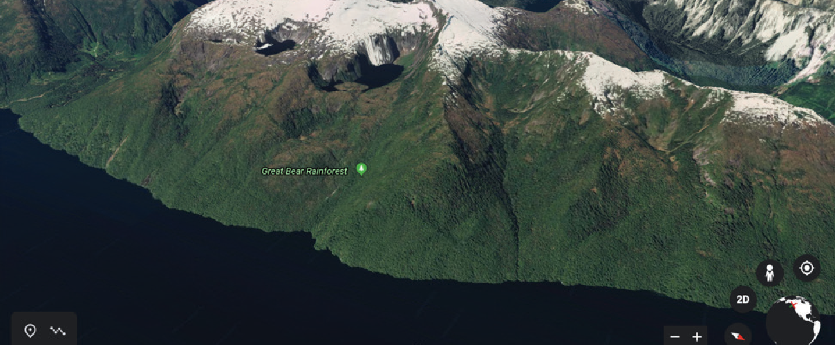

Example: Bird’s eye view of local community (earth.google.com)
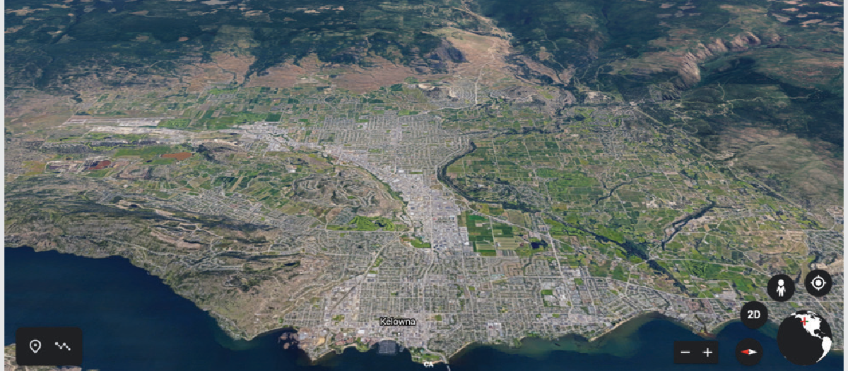

- Have students discuss the similarities and differences between the two.
- Bring up the term “diversity.” Have the students discuss what this means.
- Have students look at the images again, but this time ask them to think about the diversity in each. Do they notice any differences right away? Or do they look similar at first glance?

Inquire
- To give students more of a close-up look at the species in the Great Bear Rainforest rather than the bird’s eye view they previously saw, show the class the following videos:
» Andy MacKinnon Presents Plants of the Bog,
» Lichens: Corals of the Forest
» 1000s of Bugs, 100 Islands, 1 Happy Entomologist
- After viewing, discuss as a class how students think your local landscape compares to the Great Bear Rainforest. What areas of your landscape do they think are the most similar to the Great Bear Rainforest? Which are the least similar?

Experience

Stewardship in the Great Bear Rainforest
- Students will complete a survey of the biodiversity of their local landscape. This survey could include just trees or other groups of plants/animals.
- Divide the class into small groups to carry out field research.
- Take students out into the local environment and assign each group a plot of land. (For each group, you could tape off an area or plant a stake, attach a string, and delineate a perimeter by walking in a circle.)
- Have students record each different species they observe by taking photographs, and also count and record how many of each they see.
- Once back in the classroom, have students use iNaturalist to determine the species they photographed.
- Provide each student with Blackline Master 1: Diversity of Species (below). Have students record the names of the different species and how many of each were present in the area they examined.

Explore
- Have students conduct research to find out about the species present in the Great Bear Rainforest.
- Have students either use iNaturalist or go to Biodiversity of the Central Coast to determine whether the species they found in their plot are also present in the Great Bear Rainforest. Have students record this information on their data sheet.
- Next, have students determine whether the species they found in their plot are native or non-native to British Columbia, using the BC Flora Checklist 2016 available at British Columbia plant species codes Version 10. Have them add this information to their data sheet.
- Invite students to compare their findings with the rest of the class.
- Have students discuss in their small groups whether they think the Great Bear Rainforest is made up of more or fewer native species than their local area, and why that may be the case. If students live in the Great Bear Rainforest region, they may discuss the factors that contribute to the rich biodiversity of the area. Students will then share what they found with the rest of the class.

Assess
- Have students properly planned and conducted the investigation of their plot?
- Have students shown an understanding of diversity within different regions, and why diversity may differ based on location?

Go Beyond
- As a class, discuss the concept of ethnobotany and local implications for plants within the Great Bear Rainforest.
- If possible, consider inviting a local First Nations Elder to come in and speak about plant species native to your local area.
- Have students research uses of different plant species (medicinal, food, etc.).
- Have students find the taxonomic classifications of the plants that they found.
- See also the Grade 10–12 Activity Plan E, “How could you catalogue biodiversity in the Great Bear Rainforest?”

Blackline Master 1
Diversity of Species

Photograph | Species Name | Number in Plot | Present in GBR? | Native or  Non-native

Blackline Master 2

Assessment

Areas of Improvement | Criteria | Areas of Success
 | Planning and Conducting The student completed a well- thought out and organized survey of their area.
Processing and Analyzing The student used scientific knowledge to accurately identify the plants found in their surveyed area, and to determine whether the plants are present in the Great Bear Rainforest.
The student used reliable sources to determine whether the species found in their plot are native or non-native to their area.
Reflecting
The student used their understanding of diversity to reflect on differences in diversity between the Great
Bear Rainforest and their local area.
The student used critical thinking skills to reflect on the presence of native and non- native species in both the Great Bear Rainforest and their local community.
This work is licensed under a Creative Commons Attribution-NonCommercial-ShareAlike 4.0 International License unless otherwise indicated.

