In this activity, students will explore how scientists study past human activity. They will use these methods to learn about human activity in the Great Bear Rainforest and how it has changed over time.
How has human activity in the Great Bear Rainforest changed over time?
Great Bear Rainforest Activity Plan

Learning Objectives
Students will:
- Make observations aimed at identifying their own questions, including increasingly abstract ones, about the natural world
- Formulate multiple hypotheses and predict multiple outcomes
- Examine the history of First Peoples of the Great Bear Rainforest and compare with the experience of its current inhabitants
- Use knowledge of scientific concepts to draw conclusions that are consistent with evidence
- Consider the changes in knowledge over time as tools and technologies have developed
- Connect scientific explorations to careers in science
- Implement multiple strategies to solve problems in real-life, applied, and conceptual situations
- Express and reflect on a variety of experiences, perspectives, and worldviews through place
- Understand that fossils are evidence for evolution
- Understand how nuclear energy and radiation can be used to date rock layers

Preparing for the Activity Plan
- Familiarize yourself with the websites and videos listed below.
- Prepare sediment layer columns (instructions on Blackline Master 3: Creating Your Own Sediment Layer Column).

Materials
- computer and projector
- student computers / tablets/ devices
- access to the Internet
- Blackline Master 1: Project Reflection: Creating a Refuse Pile
- Blackline Master 2: Humans in the Great Bear Rainforest
- Blackline Master 3: Creating Your Own Sediment Layer Column
- Blackline Master 4: Great Bear Rainforest Archaeological Site
- Blackline Master 5: Examining Sediment Deposits in the Great Bear Rainforest
- optional: materials to make sediment layer columns

Background Information and Resources

Videos

The 6,000 Year Old Village (7:24)
This video explores the importance of the Great Bear Rainforest to the Heiltsuk, and tells the story of Hauyat, highlighting a collaborative project that combining traditional knowledge with Western science.
https://www.hakaimagazine.com/videos-visuals/6000-year-old-village/

A Wall Worth Building: Making Clam Habitat Great Again (3:55)
This video shows the work of a group of people who are rebuilding ancient clam gardens on a small island off Canada’s west coast. This is a great example of applying Indigenous knowledge of the environment.
https://www.youtube.com/watch?v=22Nytmxw2Z8

Clam Gardens: Filling in the Gaps (2:00)
This video discusses how scientists determined the age of clam gardens. https://www.youtube.com/watch?v=oJA3Erh81Oc&

Great Bear Wild—Dispatches from a Northern Rainforest (5:34)
Ian McAllister speaks about the amazing diversity in the oceans of the Great Bear Rainforest and why we need to protect it.
https://vimeo.com/108089318

The Story of The Great Bear Rainforest (3:02)
This video from Greenpeace International tells the story of the campaign to protect Canada’s Great Bear Rainforest. https://www.youtube.com/watch?v=OgN2PFAEtGM

Articles:

Did the First Americans Take a Ride on the Kelp Highway?
This article discusses how the first North American inhabitants may have arrived in the Great Bear Rainforest.
https://blog.education.nationalgeographic.org/2017/11/08/did-the-first-americans-take-a- ride-on-the-kelp-highway/

The Great Quake and the Great Drowning
This article discusses accounts of a large earthquake and tsunami that took place in the Pacific Northwest around the year 1700. https://www.hakaimagazine.com/features/great-quake-and-great-drowning/

Hauyat
This website explores Hauyat history, lifestyle, and stories. A virtual tour of the territory is available.
https://www.hauyat.ca/home.html

How British Columbia’s Coastal People Fertilized the Forest
This article discusses evidence of some of the first people to set foot in the Great Bear Rainforest.
https://www.hakaimagazine.com/news/how-british-columbias-coastal-people-fertilized- forest/

New World Encyclopedia—Midden
This website explains middens and how they can be useful in the research of human activities.
https://www.newworldencyclopedia.org/entry/Midden

The oldest footprints in North America are right where native historians said they should be
This article discusses the discovery of footprints on Calvert Island, British Columbia. https://www.washingtonpost.com/news/speaking-of-science/wp/2018/03/30/the-oldest- footprints-in-north-america-are-right-where-native-historians-said-they-should-be/

Save the Great Bear
This website gives short descriptions of the communities in the Great Bear Rainforest and the main economic activities that each depends on. http://www.savethegreatbear.org/region/communities

Time Travelers
This article and video discusses the discovery of footprints on Calvert Island, which were dated to being over 13 000 years old.
https://www.hakaimagazine.com/features/time-travelers/

Delivering the Activity Plan

Access Prior Knowledge

What is the Great Bear Rainforest?
- Share the videos The Story of the Great Bear Rainforest and Great Bear Wild— Dispatches from a Northern Rainforest to provide students with some background information on the Great Bear Rainforest and its history.
- Discuss with students how they think people in the Great Bear Rainforest may live differently/similarly to themselves.

Inquire

How are humans living in the Great Bear Rainforest today?
- Divide the class into small groups (3–4 students).
- Assign each group one of the main seven communities in the Great Bear Rainforest area: Bella Bella, Bella Coola, Hartley Bay, Kitimat, Klemtu, Ocean Falls, and Prince Rupert.
- Have the groups research and discuss how people are living in these communities live today.
- Students then conduct research to compare their findings to what the way of life was in Hauyat.
- Have each group create a short presentation on how people live in the present-day community they researched and compare it to the Hauyat way of life. Then have each group share their presentation with the class.
- Use what students learned about how communities in the Great Bear Rainforest live today to have a class discussion about how life would have been different for the first inhabitants of the region.

Experience
Examining sediment layers to infer human activities
- Provide students with a representation of sediment layers. You can build your own sediment layer column following the suggestions in Blackline Master 3: Creating Your Own Sediment Layer Column or use a copy of Blackline Master 4: Great Bear Rainforest Archaeological Site.
- Have students use what they see in each layer of the column to determine some aspects of human life during the time period in question.
- Have students record their observations of each layer and use critical thinking skills to propose what the items might be and what they might have been used for.
- Following the activity, students can research what they found in the sediment layers to see what it reveals about human activity during that period of time.

Explore
Making a refuse pile
- In this activity, students conduct research to find out more about daily life when one of the sedimentary layers they examined was formed. They use what they learned from their research and the sediment layers to make a refuse pile that reflects the human activity during that time period.
- Assign each small group a time period from the sedimentary layer column to research. They could use oral stories of historical events (some can be found on the website Hauyat or Hakai Magazine), and/or find out about diets and daily activities.
- Explain to students that they will be creating a refuse pile that contains items that reflect what life was like during the time period they researched. Examples of what could be included are food scraps, bones, burnt firewood/ash, clothing, tools, and shells.
- Once students complete their refuse pile, have them compare what they included to what might be found in a modern refuse pile. Discuss this as a class.

Assess
- Have students successfully formulated a hypothesis about human activity?
- Have students made conclusions based on evidence?
- Have students shown an understanding that fossils are evidence for evolution?

Go Beyond
- Have students use what they learned throughout the activity to document the history of the people in the Great Bear Rainforest over time, using a timeline, story, piece of art, or another way of their choosing.
- Provide students with information on isotopes found in each sedimentary layer so they may use dating techniques to determine the timeline of the core they’re studying.

Blackline Master 1
Project Reflection: Creating a Refuse Pile

- Explain how you and your group decided what to include in your refuse pile.

- What part of this project are you most proud of? Explain.

- If you could re-do this project, explain what you would do differently.

- What was the most interesting thing you learned through doing this project? Explain why this was interesting to you.

Blackline Master 2

Humans in the Great Bear Rainforest
I can apply First Peoples perspectives and knowledge, other ways of knowing, and local knowledge as sources of information.

Emerging/developing | Proficient | Extending
Minimal/ineffective use of different perspectives  Life in the Great Bear Rainforest is not clearly communicated | Effective use of a few different perspectives and sources to communicate about life in the Great Bear Rainforest | Extensive use of several sources and perspectives to communicate about life in the Great Bear Rainforest

Creating a Refuse Pile

I can use knowledge of scientific concepts to draw conclusions that are consistent with evidence.
I can consider the changes in knowledge over time as tools and technologies have developed.

Emerging/developing | Proficient | Extending
Shows a limited understanding of how refuse piles help us to understand human activities in the past  Little or no research completed to compile contents of refuse pile | Shows an informed understanding of how refuse piles help us to understand human activity in the past  Research completed to compile contents of refuse pile | Shows a thoughtful and comprehensive understanding of how refuse piles help us to  understand human activity in the past  Extensive research completed to compile contents of refuse pile

Areas of success:

Areas for improvement:

Blackline Master 3

Creating Your Own Sediment Layer Column

Below is a description of what archaeologists found at a site on Triquet island, along with suggestions for items you could include in your own sediment column.

Bottom layer (14 000 years ago)
Scientists found lithics such as stone tools on top of a rock (an anvil stone used to smash smaller rocks to produce stone tools). In your sediment column, you could include a sharp rock on top of a larger rock.

Second layer (9000 years ago)
Scientists found a wooden artifact, similar to a spear-thrower, or atlatl. These act as an extension to the arm to help propel a spear. In your sediment column, you could include a sharpened stick to represent a spear.

Third layer (7694–6000 years ago)
Scientists found the front and back of an obsidian flake tool, which was used as a cutting tool. In your sediment column, you could include a sample obsidian rock.

Fourth layer (5700–5690 years ago)
Scientists found a pile of animal bones, such as fish bones. In your sediment column, you could include plastic fish bones or printed pictures of bones.

Fifth layer (5675–5650 years ago)
Scientists found a needle made of bone. In your sediment column, you could include a plastic needle.

Sixth layer (5600–4577 years ago)
Scientists found evidence of large earthquakes or tsunamis. This is shown by a band of grey coloured sediment. Rather than including this layer, you could provide students with oral accounts of the disaster from the Hakai Magazine article, “The Great Quake and Great Drowning.”

Blackline Master 4

Great Bear Rainforest Archaeological Site

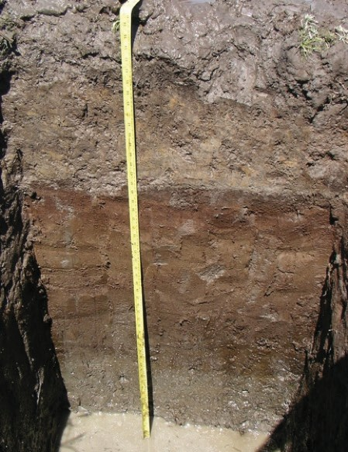5600–4577 years ago

Example of sediment at an archaeological dig site
Photo by Johanne Hammond, MA, RPCA, used with permission.

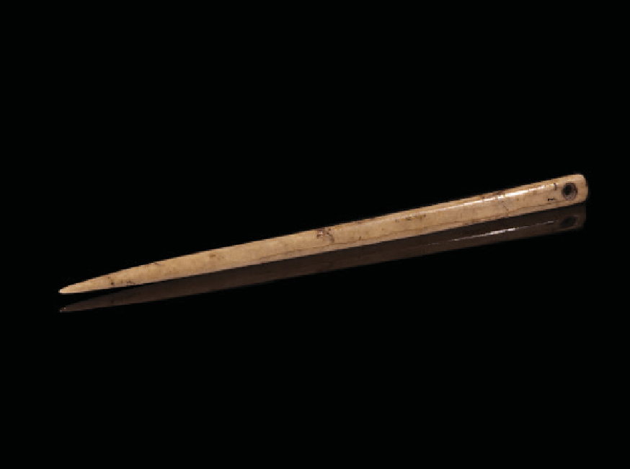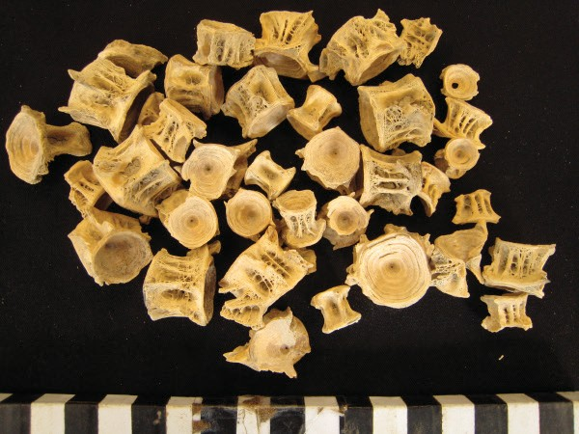5675–5650 years ago

Bone needle
Image in the public domain.

5700–5690 years ago

Fish vertebrae
Image courtesy of https://nottsarthistory.wordpress.com

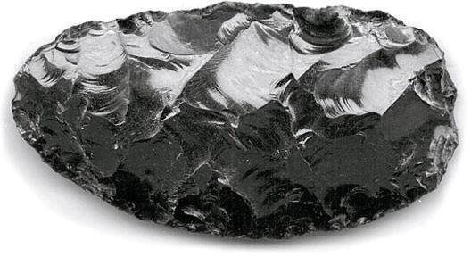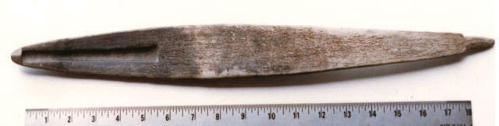7694–6000 years ago

Obsidian tool
Photo H1Tt21_1, courtesy of the Royal BC Museum and Archives.

9000 years ago

Atlatl (spear thrower)
Photo EcRg-Y-1, courtesy of the Royal BC Museum and Archives.

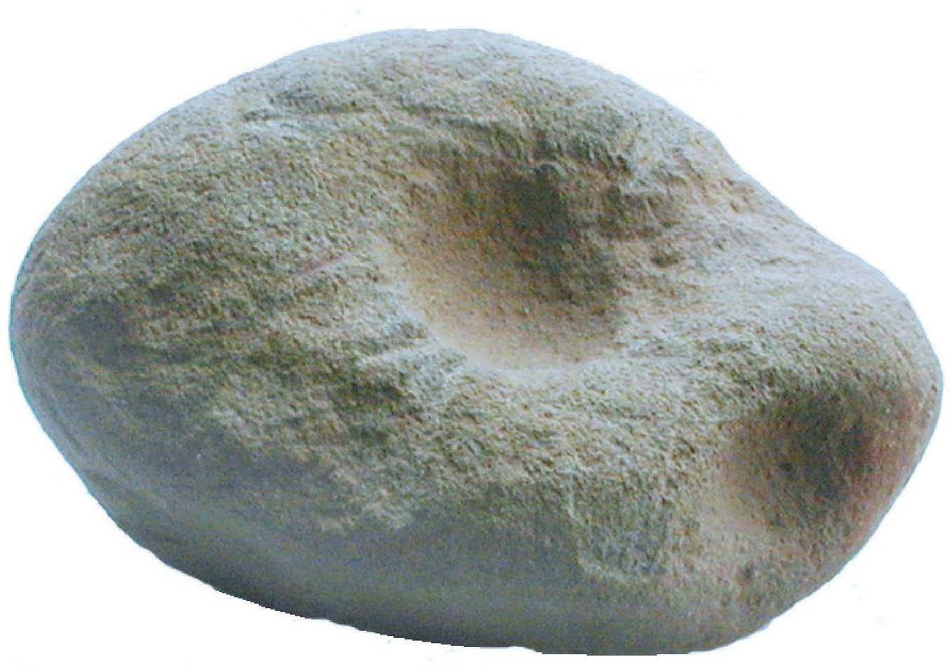
14 000 years ago

Anvil Stone
Image in the public domain

Blackline Master 5

Examining Sediment Deposits in the Great Bear Rainforest

Layer | What do you see? | What might this  mean? | Conclusions following  further research

This work is licensed under a Creative Commons Attribution-NonCommercial-ShareAlike 4.0 International License unless otherwise indicated.

