Great Bear Rainforest Activity Plan
What do we know about rocks?

Students explore the significance of rocks both past and present within the Great Bear Rainforest and the local communities.

Learning Intentions
- Have rocks always been here and why are there different kinds of rocks?
- What types of rocks are found in the Great Bear Rainforest?
- How have Indigenous Peoples used rocks over time?

Blackline Masters
  - Learning Intention 1: Creating a Rock Board Game
  - Learning Intention 1: Ideas and Information for Rock Game
  - Learning Intention 1: Rock Qualities
  - Learning Intention 2: Self-assessment for Groupwork
  - Learning Intention 2: What rocks do I see?

Curricular Connections
Refer to the “Curriculum” drop-down option under the “Learn” tab of the Great Bear Rainforest Education and Awareness website.

Curriculum Alignment: Great Bear Rainforest Education and Awareness Trust https://greatbearrainforesttrust.org/curriculum/

Learning Intention 1

Have rocks always been here and why are there different kinds of rocks?

Experiences and Observations
  - Read or view A Rock is Lively by Diana Hutts Aston:

A Rock is Lively (6:42)
https://www.youtube.com/watch?v=gAl5KsVWW-I&t=1s
  - Go on a rock walk—find a special rock, take it to your learning space.
  - Examine the rock’s qualities. Have students make notes on blackline master
Rock Qualities. (Will need porcelain tiles to do a streak test.)
  - Review the three types of rock and learn about the rock cycle by viewing Types of Rocks and the Rock Cycle. Inquire: Which type is the rock you found? How do you know?

Rock cycle video (2:57)
https://www.youtube.com/watch?v=jP1qbwSGmNs
  - Read or view Old Rock is Not Boring by Deb Pilluti

Old rock is not boring (4:43)
https://www.youtube.com/watch?v=gQwdXrFEGBA
  - Read or view Ishi: A Simple Tips from a Solid Friend by Akiko Yabuki:

Ishi: Simple Tips from a Solid Friend (3:24)
https://www.youtube.com/watch?v=UhM1HTgIjMs
  - Have students create stories of a rock on its journey. Purpose or conflict: Does the rock encounter several opportunities for change? Setting: Where does the rock come from and journey to? How does it get from one place to another? Characters: Who does the rock meet along the way?
  - Have students create games about what they have learned about rocks. They may choose to use the blackline master Creating a Rock Board Game. Some information they can use for question-and-answer cards is in the blackline master Ideas and Information for Rock Game.

Possible Topics/Key Vocabulary
  - Types of rocks: metamorphic, igneous, sedimentary
  - Rock cycle
  - Geology

Reflections on Learning
  - Blackline master: Rock Qualities
  - Story of rock journey
  - Rock games

Suggested Resources

4th grade - Streak Test for Minerals (3:22)
https://www.youtube.com/watch?v=Jj-yN_R3g7U

If You Find a Rock (3:35)
Print resource by Peggy Christian
https://www.youtube.com/watch?v=D1wBqs2aqPU

Rocking the Rock Cycle
Lesson plans with printable game board by NASA
https://www.nasa.gov/sites/default/files/rockingtherockcycle.pdf

Rocky Rock’s Cycle Game
Online game from the University of Oxford’ Museum of Natural History
https://learningzone.oumnh.ox.ac.uk/rockys-rock-cycle-game

Rocks
Fun Kids website
https://www.funkidslive.com/learn/top-10-facts/top-10-facts-about-rocks/

Three Types of Rocks and the Rock Cycle (4:12) Song about the three types of rocks. https://www.youtube.com/watch?v=jl1rQV8em9Q

Extensions
  - Read or view A Rock Can Be. Students can make their own books, write a poem, or create an art piece about what a rock can be.

A Rock Can Be (3:11)
https://www.youtube.com/watch?v=XkJDQaws05E
  - Rocks are landmarks around the world. Some have stories. Have students investigate these landmarks. Are there any local ones? Is there a story that goes with the landmark, and if so, what is it? Examples include:
    - Uluru or Ayers Rock (central Australia)
    - Balancing Rock (Kamloops, BC, Canada)
    - Stonehenge (Salisbury Plain in Wiltshire, England)
    - Horseshoe Bend (Glen/Canyon-Colorado River, Arizona, US)
    - Percé Rock (Gulf of Saint Lawrence, Gaspé Peninsula, Québec, Canada)

Rock Cycle Activity
Rock cycle game to reinforce topics and to help create stories about rocks
https://www.uen.org/lessonplan/view/36893

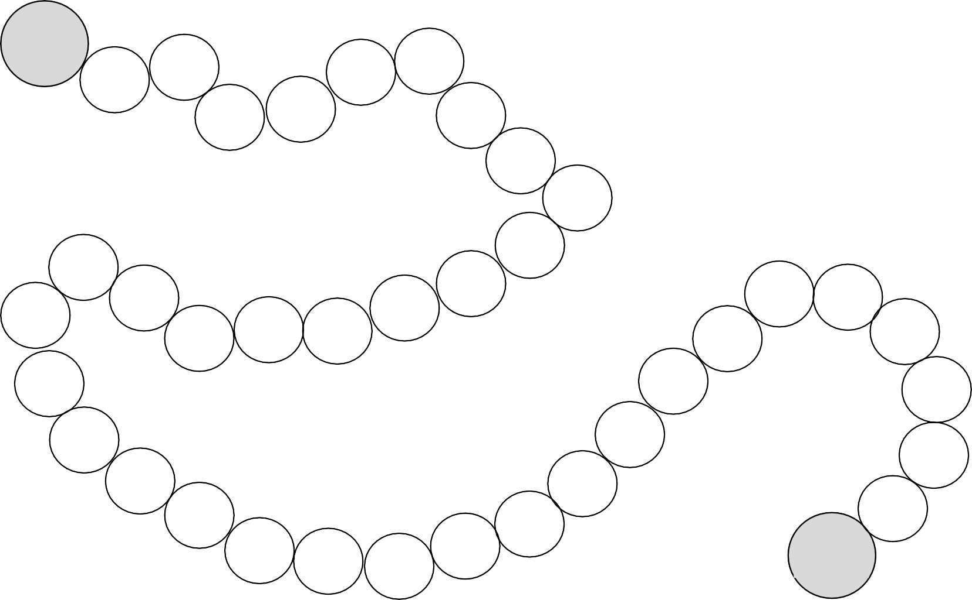
What do we know about rocks?
5
Name of the Game:
Directions

Start

End

Ideas and Information for Rock Game

Samples questions and answers for rock game board

Question | Answer
What are the 3 kinds of rocks? | igneous, sedimentary, metamorphic
Which rocks are formed from melted rock deep inside the earth? | igneous rocks
Which rocks are formed from layers of sand, dead plants, and animal skeletons? | sedimentary rocks
Which rocks are formed by other rocks that are changed by heat and other pressure underground? | metamorphic rocks
How are volcanic igneous rocks formed? | when molten hot materials cool and solidi es
What are rocks made from? | minerals
What is a rock from space called? | meteorite
What are ancient drawings carved in stone? | petroglyphs
What are ancient painted drawings on stone? | pictographs

Examples of rock words

gravel | mountain | slab | rubble
earth | lava | coal | mineral
boulder | stones | shale | sand
crystal | diamond | emerald | garnet
opal | gold | jade | obsidian
pumice | ruby | soapstone | turquoise

What do we know about rocks? 6

Does the rock have more than one colour? What shade is the colour?

Describe the colour.

Rock Qualities
No need for a hammer! Rocks have cleavage when they have smooth, flat edges. If all edges are jagged, then the rock breaks in fractures.

How does your mineral break?

Does your rock exhibit luster? Does your rock reﬂect light?
Use a large nail or penny to see how hard it is to scratch. Pour a bit of vinegar on it to see if it bubbles.
Perhaps use a magnifying glass.

How hard is your rock?
Are you able to do a streak test?
If so, what happens?
You will need a porcelain plate. Use a white one for a dark rock.

What do we know about rocks?
7

Learning Intention 2

What types of rocks are found in the Great Bear Rainforest?

Experiences and Observations
When learning about the Great Bear Rainforest we often focus on the animals and plants. Rocks are everywhere. Because these lands are protected, rocks are usually left alone within their environment.
- Have the students view Enter the Great Bear Rainforest and record what rocks they notice in the film and where they notice them. blackline master What Rocks do I see?

Enter the Great Bear Rainforest (4:36)
https://www.youtube.com/watch?v=js1rnKPAnE0&t=4s

Have students discuss their observations and create questions about rocks in the Great Bear Rainforest, then inquire into the questions in small groups and share with others. Sample questions may include:
  - What three types of rocks do you think are in the Great Bear Rainforest and why?
  - How are plants and rocks important to each other?
  - What do salmon use rocks for? What do bears use rocks for?
  - Why are rocks in the rivers smooth?
  - What can people in the Great Bear Rainforest use rocks for?

- Have students reflect on their group work using the student Self-assessment for Groupwork blackline master.

Possible Topics/Key Vocabulary
- Metamorphic
- Igneous
- Sedimentary
- Importance of rocks to animals, plants, and people

Reflections on Learning
- Blackline master: What Rocks Do I See?
- Blackline master: Self Assessment for Groupwork
- Questions generated and share-out participation

Extension
- Do you eat rocks? Have students explore what rocks are food minerals and which foods contain these minerals.

Did You Eat Your Rocks Today?
https://www.manitoba.ca/iem/min-ed/kidsrock/rocklore/food_minerals.html

Nature’s Art in the Great Bear Rainforest
Double Exposure Photography website.
https://www.doubleexposure.ca/beauty-great-bear-rainforest/

Self-assessment of Groupwork

Write a comment in each section and include:
1 Not at all 2 - Sometimes 3 - Most of the time 4 - All the time

Additional comments (optional):

What do we know about rocks?
11

What rocks do I see?
Enter the Great Bear Rainforest

Learning Intention 3

How have Indigenous Peoples used rocks over time?

Experiences and Observations
- For many Indigenous People in Canada, rocks are considered the wisest of all Mother Earth’s elements because they have been around for the longest time. They are old and have many stories.
- Students brainstorm possible past and present Indigenous uses for rocks. Invite them to investigate to find more. Include exploring how local First Nations use rocks.
- Rocks have had a variety of uses: to hold tipis on the ground (before stick pegs were used); to hold heat in underground ovens (pit cooking); and First Peoples on BC’s coast used rocks for clam gardens.

Clam Gardens: Filling in the Gaps
https://hakai.org/clam-gardens-filling-in-the-gaps/
- Rocks can be used as markers for ceremony.
- Flint was used to make cutting tools for such items as axes and arrowheads and is still used to strike to make a fire.
- Obsidian produces sharp edges, so it is used for making such things as arrowheads and knives. It was used to scrape hides and butcher meat.
- Hammerstone was used to make clubs and hammers.
- Inukshuks website:

Do you know what an inukshuk is?
https://www.cbc.ca/kids/articles/do-you-know-what-an-inukshuk-is

- Some Indigenous Peoples in the plains used rocks to create what is often referred to as Medicine Wheels which are large circles originally built outlined with rocks. (Example: Iniskim Umaapi, Majorville Medicine Wheel, Vulcan Alberta.)
- Petroglyphs—Note: Petroglyphs are carved into rock and pictographs are painted on paint.

Nuxalk Petroglyphs and Totems (4:06)
https://www.youtube.com/watch?v=9KgUShsSv9g
- Have students create posters of their learning.
- Invite students to think about why Indigenous Peoples carved petroglyphs or painted pictographs (to record history, pass on stories). To copy these pictures, people need to have permission from the First Nation, but students can be inspired to think about a symbol that might tell their story or express a value important to them. They can paint rocks with their symbol. (Best paint for rock is acrylic.)

Possible Topics/Key Vocabulary
- Indigenous uses of rocks over time
- Flint
- Obsidian
- Inukshuk and inunnguaq
- Medicine wheel (circle)
- Petroglyph and pictographs
- Symbolism

Reflections on Learning
- Posters
- Painted rocks

Suggested Resources

The Gnawer of the Rocks
Print resource written by Louise Flaherty, illustrated by Jim Nelson. Inuit story in graphic novel format for grades 6-9. https://inhabitmedia.com/2017/10/12/the-gnawer-of-rocks/

Nipin and the Rocks
Story by Victoria Bouvier, 2009 Indigenous Arts and stories writing winner
http://www.our-story.ca/winners/writing/145:nipin-and-the-rocks

Extensions
- Research how rocks have been and are now used by Indigenous Peoples around the world.
- Investigate what First Nations refer to as Grandfather Rocks.

This work is licensed under a Creative Commons Attribution-NonCommercial-ShareAlike 4.0 International License unless otherwise indicated.

