Great Bear Rainforest Activity Plan
How do trees communicate?

Students discover how trees communicate with each other in positive and negative ways.

Learning Intentions
- How do trees communicate?
- How do leaves know when to change colours? What “tells” them to change? What are other ways plants and other parts of the environment “speak” to each other?

Blackline Masters
  - Learning Intention 1: How Trees Communicate
  - Learning Intention 2: Changing Leaves

Curricular Connections
Refer to the “Curriculum” drop-down option under the “Learn” tab of the Great Bear Rainforest Education and Awareness website.

Curriculum Alignment: Great Bear Rainforest Education and Awareness Trust https://greatbearrainforesttrust.org/curriculum/

Learning Intention 1

How do trees communicate?

Experiences and Observations
  - Discuss: How do we communicate? How do animals and plants communicate?
  - Watch the video, “How Do Trees Communicate?” or “How trees secretly talk to each other.”

How Do Trees Communicate? (2:46)
https://www.youtube.com/watch?v=8uWzIxi6cIY

How Trees Talk to Each Other (1:47)
https://www.youtube.com/watch?v=yWOqeyPIVRo

  - Discuss: How do we know this? Then watch the video, “How Trees Talk to Each Other.”

How Trees Talk to Each Other (18:24)
https://www.youtube.com/watch?v=Un2yBgIAxYs
  - How might communication and cooperation be different in each season?
  - Blackline master: How Trees Communicate
  - Observe on a nature walk: Which trees live here? How do they help and harm each other?
  - For thousands of years, Indigenous Peoples have known that trees communicate. Indigenous Peoples live and have lived within interconnected relationships to all things of Mother Earth. Not only did they know trees communicated to each other, they understood about communicating with trees.
  - Take students outside and have them form a circle around a tree. It can be a tree in the schoolyard or a nearby forest. Ask why would talking with trees be important? Do any of your parents talk to their plants?”
  - Ask them what the tree is telling them. Accept that some may not feel comfortable as it may not be their belief and that’s okay but ask them to try to listen to the tree and let it speak to them.

  - Accept all answers. They may say things like “it needs water” or “we need to protect it.” If students use pronouns such as “it” or “we” rephrase the
statement back to them to say, “the tree says I need water” or “the tree says ‘I need protection.”
  - What meanings can students make from this experience?
  - Invite students to create artwork of trees or posters or collages of their learnings from this inquiry.

Possible Topics/Key Vocabulary
  - Fungi
  - Mycorrhizae
  - Symbiotic
  - “Wood Wide Web”
  - Trees that help each other and trees that hurt each other
  - Cooperation
  - Indigenous trees (originating in a particular place)
  - Invasive species – non-indigenous species that may cause harm to the environment they are introduce to
  - Symbiotic relationships and symbiosis
  - Ways Indigenous Peoples communicate with trees

Reflections on Learning
  - Blackline master: How Trees Communicate
  - Students demonstrate understanding by creating an artistic rendering of what the wood wide web may look like
  - Art activities that involve the creation of trees (drawing, painting, paper cutting or tearing) or posters or collages of their learnings

Suggested Resources
The Hidden Life of Trees: What They Feel, How They Communicate- Discoveries From a Secret World Print resource by Peter Wohlleben
https://greystonebooks.com/collections/all/products/the-hidden-life-of-trees

Plants Have Their Own Kind of Nervous System (1:43)
https://www.youtube.com/watch?v=LeLSyU_iI9o&t=20s

The Secret Language of Trees - Camille Defrenne and Suzanne Simard (4:33) https://www.youtube.com/watch?v=V4m9SefyRjg&t=15s

Extensions
  - Students measure trees, noticing signs of health and distress.
  - Students create signage about trees in their school yard to educate others.
  - Investigate: What are mycorrhizae and what is their connection to photosynthesis?
  - What is fungi’s role in the communication between trees?
  - Have students create poetic expressions about trees and how they communicate.
  - Plotting tree populations: Determine what trees grow locally and locate a plot of local land where students can count the numbers of various
trees and graph the tree populations. Or have students research different communities in BC and record their most common trees. Have students work together to build graphs that compare tree types.
  - Read aloud the novel: Wishtree by Katherine Applegate. This novel is a beautiful story narrated by a tree named Red, who is an important part of the community and sees the community change and grow over time. This is a story of friendship, interconnectedness, racism, and community coming together.

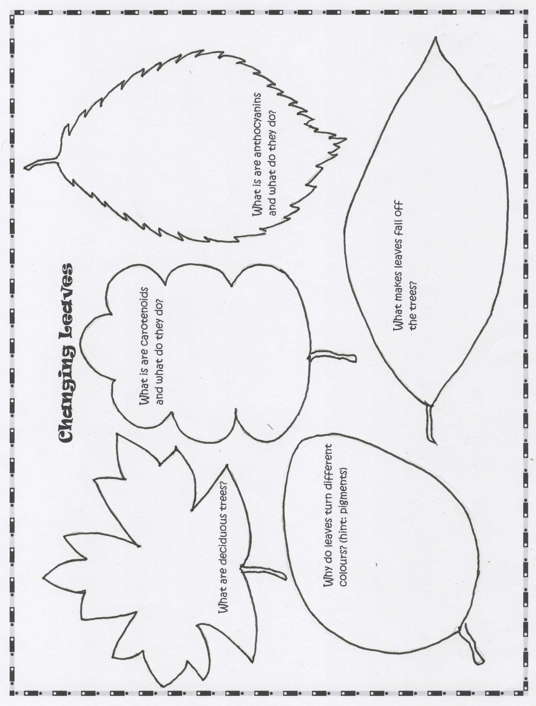

Learning Intention 2

How do leaves know when to change colours? What “tells” them to change? What are other ways plants and other parts of the environment speak to each other?

Experiences and Observations
  - Watch the video, “Why Do Leaves Change Color and Fall?” Use with the blackline master, Changing Leaves.

Why Do Leaves Change Color and Fall? (2:11)
https://www.youtube.com/watch?v=rwA1QVsbD6g
  - Watch the video, The Amazing Way Plants Defend Themselves.

The Amazing Way Plants Defend Themselves (6:11)
https://www.youtube.com/watch?v=Hja0SLs2kus

  - Have students investigate: What other ways do plants and other parts of the environment speak to each other?
  - Plants can:
    - Release pheromones to warn other plants of an insect infestation
    - React to environmental changes by angling their leaves
    - Sense when being eaten and release chemicals to make their leaves taste bad
  - Animals can:
    - Bark or make noise to tell humans they need something or that there is danger
    - Release pheromones to attract a mate, call for help when injured, or call their young to eat
    - Use sounds to attract mates (birds), defend their territories, or organize group behaviour
    - Use visual signs such as body gestures, facial expressions, and colouration (the poison dart frog changes colour to say “do not eat me” to ward off predators)

Reflections on Learning

  - Blackline master: Changing Leaves
  - Oral or written reflections or a poster about how plants and animals communicate

Suggested Resources

An Immense World: How Animal Senses Reveal the Hidden Realms Around Us
Print-based teacher resource by Ed Yong
https://www.penguinrandomhouse.ca/books/616914/an-immense-world-by-ed- yong/9781039003927

Nature is Never Silent: How Plants and Animals Communicate With Each Other
Print-based teacher resource by Madlen Ziege
https://scribepublications.com/books-authors/books/nature-is-never- silent-9781950354818

The Real Reason Leaves Change Color In the Fall (2:29)
https://www.youtube.com/watch?v=JWva5AaDkXw

Summer Green to Autumn Gold: Uncovering Leaves’ Hidden Colors Non-fiction picture book by Mia Posada https://www.youtube.com/watch?v=3R8gEN2KMk0

Extension
  - Investigate: How do plants and animals rely on each other to survive?

Plant Animal Interactions (13:14)
https://www.youtube.com/watch?v=kMBLMOmZvmo&t=483s

This work is licensed under a Creative Commons Attribution-NonCommercial-ShareAlike 4.0 International License unless otherwise indicated.

